INTRODUCTION I
The Personal Portfolio Website is a web-based project developed during our On-the-Job Training (OJT), with the primary goal of creating a professional and interactive platform to showcase the skills, projects, experience, and personal information of a Computer Engineering student. Instead of presenting technical abilities and completed projects through traditional documents, the portfolio provides a centralized digital platform where visitors can easily explore information about the developer, technical skills, featured projects, and contact details. The website is designed using HTML, CSS, and JavaScript, providing a responsive and visually engaging interface that can be accessed across different devices. It includes sections such as Home, About, Skills, Projects, and Contact, allowing users to navigate through the information in a simple and organized manner. The portfolio also highlights projects such as the Hospital Management System and the Portfolio Website Design, demonstrating practical experience in web development and system design.
The core objective of our OJT was to gain practical experience in designing and developing a complete web-based portfolio from the ground up. The website was structured into several interconnected sections, including a home page introducing the developer, an About section containing personal and educational information, a Skills section presenting programming and web development abilities, a Projects section displaying completed work, and a Contact section for communication. The portfolio also includes interactive features such as project filtering, project detail pop-ups, responsive layouts, animations, theme switching, and contact functionality. The technical skills presented in the portfolio include C, C++, C#, Java, JavaScript, Python, HTML, and CSS. Through this project, we were able to apply concepts of web design, frontend development, responsive design, JavaScript interaction, and user interface design in a practical environment. This report provides a detailed account of the portfolio's design, structure, features, technologies used, and the practical skills gained during its development.

PROJECT OBJECTIVE AND SCOPE I:

- To develop an attractive and professional personal portfolio website.
- To provide a clear home page that introduces the developer and their professional profile.
- To showcase technical skills and programming knowledge in an organized manner.
- To display completed projects with their technologies, descriptions, and details.
- To provide separate sections for About, Skills, Projects, and Contact information.
- To create a responsive website that can be accessed on both desktop and mobile devices.
- To implement interactive features such as project filtering, animations, and project detail pop-ups.
- To provide an easy-to-use contact section for communication and inquiries.
- To demonstrate practical knowledge of HTML, CSS, and JavaScript through the development of the website.
- To provide a centralized platform for presenting academic, technical, and OJT-related work.
- To create a portfolio that can be easily updated with new skills and projects.

BENEFITS TO THE USER I

  - Provides a professional online presence by allowing users to showcase their personal information, technical skills, and achievements in one organized platform.
  - Makes project presentation easier by displaying projects with their descriptions, technologies used, features, and development details.
  - Helps users showcase technical skills by presenting programming and web development skills such as C, C++, C#, Java, JavaScript, Python, HTML, and CSS in a structured format.
  - Provides easy project navigation through project categories such as OJT, Web, C/C++, Game, and Design, allowing visitors to find relevant projects quickly.
  - Improves user experience through interactive features such as project detail pop-ups, animations, responsive layouts, and organized navigation.
  - Allows easy communication through the contact section, enabling visitors to send messages directly to the portfolio owner.
  - Works across different devices with a responsive design, making the portfolio accessible from both

PERFORMANCE REQUIREMENT I

Only when the requirement specification is properly given, it is possible to design a system. Which will fit into required environment. It rests largely requirement with the users of the existing system to given the requirement specification because they are the people who finally use the system. This because the requirement has to be known during the initial stages so that the system can be designed according to those requirements. It is very difficult to change the system once it has been designed and on the other hand designing a system, which does no cater to the requirements of the requirements of the user, is of no use.
The minimum requirement specification for any system can be broadly stated as given below:

Hardware Requirement:
- Screen Resolution- WXGA (1366 x 768) minimum.
- ARM64 or x64 processor with at least 1.8 GHz.
- Memory-4GB or 8 GB RAM (Recommended)
- Free Storage-4GB
Software Requirements:
- Operating system-windows 8/8.1/10/11(64 bit)
- Browser

ER-Diagram of Portfolio

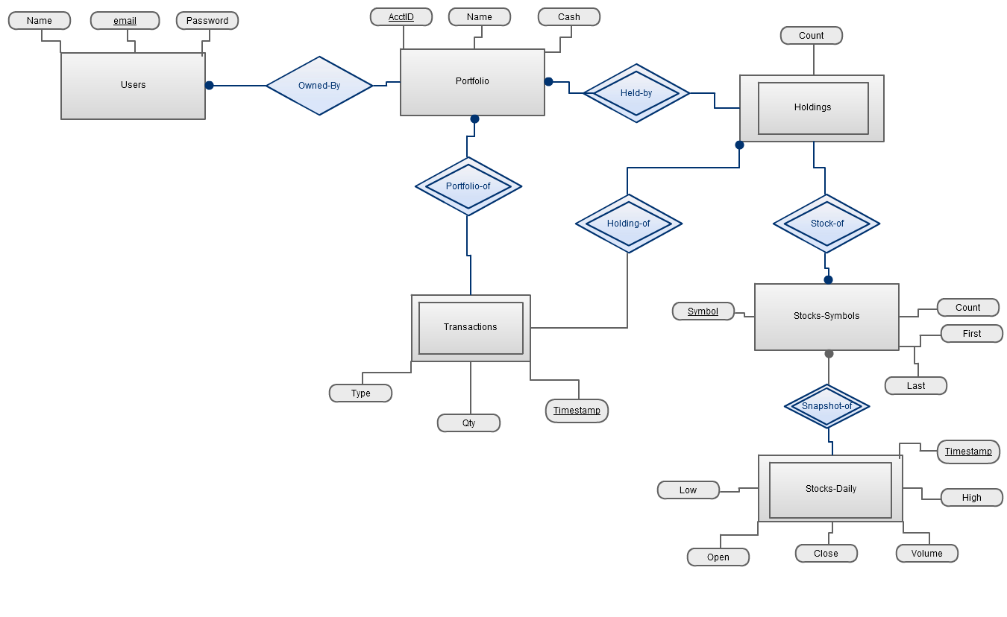

W3form Linking

Step 1 — Create your Web3Forms Access Key
Open:
Web3Forms
You should see an option to create an Access Key.
Enter the email address where you want to receive portfolio messages.
For example:
Your email:
padmabhujel6@gmail.com
Web3Forms will provide an Access Key similar to:
12345678-abcd-1234-abcd-123456789abc
Do not use my example key. Copy the actual key generated for your account.

Step 2 — Open your portfolio.html
Open the portfolio file in VS Code, Notepad++, or whatever editor you are using.
Your existing portfolio contains a Contact section with:
- Name
- Email
- Message
- Send Email button
The existing code also contains a JavaScript function called sendEmail() that opens the user's default email application.
We are going to change this so:
User fills form → clicks Send → Web3Forms receives it → message arrives in your email.

Step 3 — Find your contact form
Press:
Ctrl + F
and search for:
ef-name
or:
Your Message
Your existing form contains a message field similar to:
<textarea
class="ef-textarea"
id="ef-message"
placeholder="Tell me about yourself, your project, or opportunity. The more detail the better! 🚀"
></textarea>
Your portfolio also has a submit button connected to:
sendEmail()
according to the file.

Step 4 — Change the <form> opening tag
Find the opening form tag.
It may look something like:
<form id="emailForm">
or:
<form id="contactForm">
Change it to:
<form action="https://api.web3forms.com/submit" method="POST" id="contactForm">
The important parts are:
action="https://api.web3forms.com/submit"
and:
method="POST"
These tell the browser to send the form data to Web3Forms.

Step 5 — Add your Access Key
Immediately after the <form> opening tag, add:
<input type="hidden" name="access_key" value="YOUR_ACCESS_KEY">
For example:
<form action="https://api.web3forms.com/submit" method="POST" id="contactForm">

<input type="hidden" name="access_key" value="12345678-abcd-1234-abcd-123456789abc">
Replace the example key with your actual Web3Forms Access Key.
Why is it hidden?
Because the visitor does not need to see the Access Key.
The browser sends it to Web3Forms automatically.

Step 6 — Add an email subject
Under the Access Key, add:
<input type="hidden" name="subject" value="New Message From My Portfolio">
So the beginning of your form becomes:
<form action="https://api.web3forms.com/submit" method="POST" id="contactForm">

<input type="hidden" name="access_key" value="YOUR_ACCESS_KEY">

<input type="hidden" name="subject" value="New Message From My Portfolio">
When someone contacts you, you will receive an email with a subject similar to:
New Message From My Portfolio

Step 7 — Fix the Name field
Find your name input.
It might currently look like:
<input
type="text"
id="ef-name"
placeholder="Your Name"
>
Change it to:
<input
type="text"
id="ef-name"
name="name"
placeholder="Your Name"
required
>
The important addition is:
name="name"
Web3Forms uses the name attribute to identify the submitted information.

Step 8 — Fix the Email field
Find your email input.
Change it so it contains:
name="email"
For example:
<input
type="email"
id="ef-email"
name="email"
placeholder="Your Email"
required
>
Now Web3Forms knows that this value is the sender's email address.

Step 9 — Fix the Message field
Your existing portfolio has the message textarea.
Change it to:
<textarea
class="ef-textarea"
id="ef-message"
name="message"
placeholder="Tell me about yourself, your project, or opportunity. The more detail the better! 🚀"
required
></textarea>
The important part is:
name="message"

Step 10 — Change the Send button
Your current portfolio has:
<button
class="ef-submit-btn"
id="efSubmitBtn"
onclick="sendEmail()"
>
Send Email to My Inbox →
</button>
The problem is:
onclick="sendEmail()"
That calls your existing JavaScript function, which opens the user's email application rather than submitting the form to Web3Forms. Your portfolio's current JavaScript specifically contains this email-opening behavior.
Change it to:
<button
class="ef-submit-btn"
id="efSubmitBtn"
type="submit"
>
Send Message →
</button>
Notice that we removed:
onclick="sendEmail()"
and added:
type="submit"

Step 11 — Your complete basic form
After making those changes, your form should have this basic structure:
<form action="https://api.web3forms.com/submit" method="POST" id="contactForm">

<input
type="hidden"
name="access_key"
value="YOUR_ACCESS_KEY"
>

<input
type="hidden"
name="subject"
value="New Message From My Portfolio"
>

<input
type="text"
id="ef-name"
name="name"
placeholder="Your Name"
required
>

<input
type="email"
id="ef-email"
name="email"
placeholder="Your Email"
required
>

<textarea
class="ef-textarea"
id="ef-message"
name="message"
placeholder="Tell me about yourself, your project, or opportunity."
required
></textarea>

<button
class="ef-submit-btn"
id="efSubmitBtn"
type="submit"
>
Send Message →
</button>

</form>

Step 12 — What happens now?
The process will be:
YOUR PORTFOLIO
│
▼
User fills the form
│
▼
Name / Email / Message
│
▼
Send Message
│
▼
Web3Forms
│
▼
Your registered email
So the visitor does not need Gmail, Outlook, or another email application installed.

Step 13 — Important: remove the old JavaScript
Your portfolio currently has:
function sendEmail()
and the function opens the user's default email application.
After switching to Web3Forms, you should not call that function from the Send button.
At minimum, remove:
onclick="sendEmail()"
from the button.
If the rest of your JavaScript is still using sendEmail() or efSubmitBtn, don't immediately delete the entire function. First test the Web3Forms submission.

Step 14 — Test the form
Save your file:
Ctrl + S
Then open your portfolio.
Go to:
Contact → Send Message
Enter:
Name
Test User
Email
yourtestemail@gmail.com
Message
This is a test message from my portfolio.
Click:
Send Message
Then check the email inbox you registered with Web3Forms.
Also check your Spam/Junk folder if you don't see the message.

Step 15 — If you want to keep your existing design
You do not need to redesign your Contact section.
Your existing portfolio already has a styled contact form and success interface.
You only need to change the form submission logic.
In other words:
Keep
class="ef-label"
class="ef-input"
class="ef-textarea"
class="ef-submit-btn"
and your existing CSS.
Change
onclick="sendEmail()"
to:
type="submit"
and add:
action="https://api.web3forms.com/submit"
method="POST"
plus:
<input type="hidden" name="access_key" value="YOUR_ACCESS_KEY">
and the appropriate name attributes.
One important issue with your current portfolio
Your existing Contact section has custom JavaScript for validation, character counting, success messages, and opening the email client.

Domain Registration

Step-by-Step Procedure to Register a .com.np Domain
1. Visit the official .np domain registration website
Open the official Nepal .np registry website:
register.com.np
The .np domain registration service is operated by Mercantile Communication Pvt. Ltd., and .np registrations are currently free of charge.

2. Choose the appropriate domain extension
For a general-purpose website, .com.np is usually the appropriate extension.
Examples:
myname.com.np
mybusiness.com.np
myportfolio.com.np
.com.np is an open extension, while extensions such as .edu.np, .gov.np, .org.np, and .mil.np have specific eligibility requirements.

3. Check whether your domain name is available
On the official website, use the Check Domain Availability section.
Enter only the name, without:
www.
http://
.com.np
For example, if you want:
padmabhujel.com.np
enter:
padmabhujel
The registry will show whether the requested name is available.

4. Make sure the domain name is eligible
Before applying, make sure the name follows the .np rules.
The registry states that:
- The requested name must contain at least 3 characters.
- Letters, numbers, and hyphens are accepted.
- A hyphen cannot be the first or last character.
- Names beginning with xn-- are not accepted.
- Offensive, generic, or inflammatory names may be rejected.
- The domain should have a relationship with the registrant's name, trademark, company, product, or service.
For a personal domain, the domain name should be based on the applicant's name as shown on the identity document.

5. Prepare the required documents
If you are registering a personal .com.np domain, prepare a clear scanned copy/photo of one valid identification document:
Accepted personal identification
- Nepalese Citizenship Certificate
- Passport
- Driving License
- Voter's Card
- Non-Resident-Nepalese (NRN) ID Card
- Nepalese Resident Visa for foreign nationals
For a normal Nepali student applying for a personal domain, the easiest option is usually:
Nepalese Citizenship Certificate
Important
Make sure the uploaded document is:
- Clear
- Complete
- Readable
- Not blurry
- Showing the applicant's name clearly
Unclear or incomplete documents can result in rejection.

6. Prepare additional documents if registering for an organization
If the domain is for a company, firm, partnership, or organization, the requirements are different.
For a local entity, the registry requires:
Certificate of registration of the company/firm/partnership/organization.
For organizational applications, an official request letter may also be required. The registry's rejection guidance says the request letter should be on official letterhead and contain the authorized signature and organization stamp.
So for a company application, prepare:
1. Company/Organization Registration Certificate
2. Official Request Letter
3. Authorized Signature
4. Organization Stamp
Additional documents can be required depending on the organization and domain name.

7. Create an account
Go to the Create User page:
Create `.np` account
The current registration page asks for:
Full Name
Email
Password
Confirm Password
The full name should match the name on your identification document. Your email becomes the default username.
Password requirement
The current page requires a password containing:
- At least one uppercase letter
- At least one number
- At least seven characters
Then click:
Create Account

8. Log in to your account
After creating the account, go to:
`.np` Login
Enter:
Email
Password
Then click Login.

9. Start the domain registration
After logging in, choose the option for registering/applying for a new domain.
Enter your desired domain name and select the appropriate extension.
For example:
Domain Name: Padma Bhujel
Extension: .com.np
The resulting domain will be:
Padmabhujel.com.np

10. Enter the applicant information
Fill in the applicant/administrative information carefully.
Typical information includes:
Full Name
Address
Phone Number
Email Address
The administrative contact must be the actual owner of the domain, not simply the technical person managing the website.
Very important
Use the same personal information that appears on your identity document.
For example:
Name: Your actual legal name
Email: Your active email
Phone: Your active phone number
Address: Your actual address
Incorrect or incomplete applicant information can cause rejection.

11. Upload your identification document
Find the document-upload section.
Upload your scanned citizenship certificate or other accepted identification document.
For example:
Citizenship.jpg
or:
Citizenship.pdf
Make sure the document is readable before submitting.
The registry specifically states that scanned copies of original documents are required for verification.

12. Enter the nameservers
This is the part you need when you want the domain to actually point toward your website.
A nameserver tells the Internet where your domain's DNS information is managed.
For example, your hosting provider might give you:
ns1.examplehosting.com
ns2.examplehosting.com
Enter those nameservers in the DNS/name-server fields.
Do NOT enter an IP address
For example, don't enter:
192.168.1.10
The registry requires a fully qualified domain name (FQDN) for nameservers.
If you don't have hosting yet, follow your hosting provider's instructions for the nameservers. Don't invent nameservers.

13. Review all information
Before submitting, carefully check:
Domain
yourname.com.np
Personal information
Name
Email
Phone
Address
Documents
Citizenship / Passport / Other valid ID
DNS
Nameserver 1
Nameserver 2
The registry specifically recommends reviewing the information for accuracy before submission.

14. Submit the application
After checking everything, submit the registration request.
The registry will verify the submitted information and documents. It may request original documents for further verification if necessary.

15. Wait for verification
The official FAQ says .np registration normally takes around 3–4 business days or longer, depending on the registration backlog and document verification.
The registry's policy also notes that processing can sometimes take longer depending on pending requests.
Therefore, don't expect the domain to become active immediately.

16. Check your application status
Log back into your register.com.np account and check your dashboard.
Watch for notifications or status changes.
If the registry finds a problem with your application, it may provide a rejection reason or request additional information/documents.
Common rejection causes include:
- Missing applicant information
- Missing documents
- Unreadable citizenship/ID
- Domain name not matching the identity
- Incorrect extension
- Missing organization documents
- Invalid DNS configuration

Use of Cloudfare.com
Your PC → cPanel → File Manager → website folder → upload files → domain opens portfolio
For a normal cPanel setup, the main domain's website files are normally placed in public_html, and the homepage should normally be named index.html or index.php.
1. First prepare your portfolio files
On your computer, make sure you have the complete portfolio, not just portfolio.html.
For example:
Portfolio/
│
├── index.html
├── style.css
├── script.js
├── images/
│ ├── profile.jpg
│ ├── project1.jpg
│ └── project2.jpg
│
└── other-files/
From the portfolio file you gave me earlier, your website uses HTML, CSS, JavaScript and project images, so all referenced files need to be uploaded, not just the HTML file.
Important: rename your homepage
If your current file is:
portfolio.html
rename it to:
index.html
Why?
When someone visits:
https://caudefare.com
the server looks for its default homepage, commonly index.html or index.php.
So you should have:
index.html
instead of:
portfolio.html

2. Check your file paths before uploading
Open index.html and check things such as:
<link rel="stylesheet" href="style.css">
and:
<script src="script.js"></script>
and:
<img src="images/profile.jpg">
The folder structure on the server must match these paths.
For example:
public_html/
│
├── index.html
├── style.css
├── script.js
│
└── images/
├── profile.jpg
└── project1.jpg
If you upload style.css somewhere else, your website may appear without its design.

3. Create a ZIP file
This is the easiest way to upload your entire portfolio.
On Windows:
- Open your Portfolio folder.
- Select all the website files.
- Right-click.
- Select Compress to ZIP file.
- Give it a name such as:
portfolio.zip
Your ZIP should contain:
portfolio.zip
├── index.html
├── style.css
├── script.js
└── images/
Be careful: ideally, when you open the ZIP, index.html should be directly inside it—not buried inside another Portfolio folder.

4. Log in to your hosting/cPanel
You need the hosting account login, not just the domain-registration account.
If your hosting provider uses cPanel, it is commonly accessible through something like:
https://caudefare.com:2083
or a provider-specific cPanel URL. cPanel documents port 2083 as the standard secure cPanel interface.
Enter:
Username
Password
Then click Log in.
If you don't know the cPanel username/password, you need to get it from whoever provided your hosting.

5. Open File Manager
After logging into cPanel, look for:
Files → File Manager
Click:
File Manager
cPanel hosting commonly provides File Manager for uploading and managing website files.

6. Open public_html
In File Manager, look for:
public_html
Click it.
For a typical main-domain cPanel setup, this is the web root where your website files are placed.
You should now be looking at something like:
/home/yourusername/public_html/

7. Check what's already inside
You might see files such as:
public_html/
│
├── index.html
├── .htaccess
└── other files
Important
Don't delete everything immediately.
If this is an existing website, first check what is there.
If it's a new/empty hosting account, you may see a default page.
If you are unsure about an existing file, tell me its name before deleting it.

8. Upload your portfolio ZIP
Inside public_html, click:
Upload
Then select:
portfolio.zip
Wait until the upload reaches 100%. Uploading a ZIP and extracting it on the server is a standard way to move an entire site efficiently.

9. Extract the ZIP
After the upload finishes, return to:
public_html
You should see:
portfolio.zip
Right-click it.
Select:
Extract
You should get your website files.

10. Make sure the files are in the correct location
This is very important.
You want:
public_html/
│
├── index.html
├── style.css
├── script.js
└── images/
NOT this:
public_html/
│
└── Portfolio/
├── index.html
├── style.css
└── script.js
If index.html is inside Portfolio, then:
caudefare.com
may not display your portfolio.
If that happens, open the Portfolio folder, select the website files, and move them directly into:
public_html

11. Delete/rename the old default index
If public_html already contains:
index.html
and it's the hosting provider's default page, your portfolio won't replace it unless you replace that file.
Before deleting it, make sure it is not an existing website you need.
If it is only the default hosting page, remove/rename it and make sure your portfolio's file is:
public_html/index.html

12. Your final server structure should look like this
For your portfolio, aim for:
public_html
│
├── index.html
├── style.css
├── script.js
│
├── images
│ ├── profile.jpg
│ ├── hospital.jpg
│ └── portfolio.jpg
│
└── other assets
Your earlier portfolio has project information and external image references, so some images may already load from external URLs; however, any local image/CSS/JS files referenced by relative paths must also be uploaded.

13. Open your domain
Now open:
https://caudefare.com
You should see your portfolio.
If it shows:
Your portfolio → SUCCESS
If it shows:
Index of / → files are probably in the wrong location or there is no default index file.
If it shows:
404 → check the domain's document root and index.html.
If it shows:
Old/default website → the old index.html is probably still being served.

14. If your domain doesn't open
There is another important part:
Domain → Hosting
Your domain must point to the hosting server.
The connection looks like:
caudefare.com
↓
DNS / Nameservers
↓
Your Hosting Server
↓
public_html
↓
index.html
↓
Your Portfolio
If the domain isn't pointing to your hosting account, uploading files won't make them appear at the domain.
Your hosting provider should give you nameservers such as:
ns1.examplehost.com
ns2.examplehost.com
You would configure those at your domain registrar/DNS provider.

15. If caudefare.com is an addon domain
If caudefare.com is not the main domain on your cPanel account, don't automatically upload into public_html.
An addon domain can have its own document root. cPanel/hosting setups can assign a separate directory for that domain.
For example:
/home/user/
│
├── public_html/
│
└── caudefare.com/
├── index.html
├── style.css
└── script.js
In that situation, your portfolio belongs in the document root assigned to caudefare.com.

16. Connect your Web3Forms contact form
Since you were asking about Web3Forms earlier, once the portfolio is uploaded, your contact form can submit to Web3Forms.
Your HTML would contain something like:
<form action="https://api.web3forms.com/submit" method="POST">

<input
type="hidden"
name="access_key"
value="YOUR_WEB3FORMS_ACCESS_KEY"
>

<input
type="text"
name="name"
placeholder="Your Name"
required
>

<input
type="email"
name="email"
placeholder="Your Email"
required
>

<textarea
name="message"
placeholder="Your Message"
required
></textarea>

<button type="submit">
Send Message
</button>

</form>
Then:
Visitor
↓
caudefare.com
↓
Contact form
↓
Web3Forms
↓
Your email

17. Enable HTTPS/SSL
After the domain is connected to the hosting, make sure SSL is enabled.
You want your portfolio to open as:
https://caudefare.com
rather than:
http://caudefare.com
Most cPanel hosting environments provide SSL management, often through AutoSSL or Let's Encrypt depending on the host.

18. Test everything
Once the site loads, test:
Home
https://caudefare.com
Navigation
Click:
Home
About
Skills
Projects
Contact
Projects
Check that your project cards and details work. Your portfolio has project filtering and project-detail functionality.
Images
Make sure every image loads.
Mobile
Open the site on your phone.
Contact
Send a test message through Web3Forms.

GitHub Push

Here is the complete beginner-friendly method to push your portfolio folder to GitHub using GitHub Desktop, which is easier on Windows.

Method 1 — GitHub Desktop (Recommended)
Step 1: Create a GitHub account
Go to GitHub and sign in.
If you don't have an account:
- Click Sign up
- Enter your email.
- Create a password.
- Choose your username.
- Verify your account.

Step 2: Download GitHub Desktop
Download and install GitHub Desktop.
Install it normally.
After installation, open GitHub Desktop.

Step 3: Sign in to GitHub Desktop
When GitHub Desktop opens:
- Select Sign in to GitHub.com
- Your browser will open.
- Sign in to your GitHub account.
- Authorize GitHub Desktop.
- Return to GitHub Desktop.
You should now see your GitHub username.

Step 4: Create your repository
In GitHub Desktop:
- Click File
- Select New repository
You will see fields such as:
Name:
Description:
Local path:
For example:
Name:
my-portfolio
You can write:
Personal portfolio website
for the description.

Step 5: Select the location
This is important.
Suppose your portfolio is currently here:
C:\Users\YourName\Desktop\Portfolio
Don't create another repository inside it accidentally.
You can either:
Option A — Create repository using your existing folder
Use the existing portfolio folder as the Local path if GitHub Desktop allows it.
Option B — Create a new repository folder
For example:
C:\Users\YourName\Documents\GitHub\my-portfolio
Then copy your portfolio files into that folder.
Your folder should look like:
my-portfolio
│
├── index.html
├── style.css
├── script.js
│
├── images
│ ├── profile.jpg
│ ├── project1.jpg
│ └── project2.jpg
│
└── other files

Step 6: Create the repository
Click:
Create repository
GitHub Desktop will initialize a Git repository in that folder.

Step 7: Put your actual portfolio files inside
If you created a new empty repository, open the repository folder.
Copy your portfolio files into it.
For example:
my-portfolio/
│
├── index.html
├── style.css
├── script.js
└── images/
Important
Your main page should preferably be:
index.html
not:
portfolio.html
This will make GitHub Pages easier to configure later.

Step 8: Return to GitHub Desktop
Open GitHub Desktop again.
You should now see something like:
Changes

index.html
style.css
script.js
images/...
This means GitHub Desktop detected your files.

Step 9: Review the changes
On the left side, GitHub Desktop will show the files that are going to be committed.
For example:
☑ index.html
☑ style.css
☑ script.js
☑ images/profile.jpg
☑ images/project1.jpg
Make sure the files you want are checked.

Step 10: Write a commit message
At the bottom-left, you'll see a field for the commit message.
Write:
Initial portfolio website
For example:
Summary:
Initial portfolio website
Then click:
Commit to main

Step 11: Publish the repository
After committing, you'll see a button such as:
Publish repository
Click it.
You will see options such as:
Name:
my-portfolio

Description:
Personal portfolio website

Keep this code private
If you want your portfolio to be public
Make sure:
Keep this code private
is unchecked.
Then click:
Publish repository

Step 12: Wait for the upload
GitHub Desktop will upload your repository.
When finished, you should see something similar to:
Current repository: my-portfolio
Current branch: main
Your files are now on GitHub.

Step 13: Open your GitHub repository
Go to:
GitHub
Click your profile → Your repositories.
You should see:
my-portfolio
Click it.
You should see:
index.html
style.css
script.js
images
Your portfolio folder has now been pushed to GitHub.

Step 14 — Enable GitHub Pages
If you want your portfolio to actually open as a website, you can enable GitHub Pages.
Open your repository.
Go to:
Settings
Then find:
Pages
Under Build and deployment, select:
Source: Deploy from a branch
Then select:
Branch: main
Folder: / (root)
Click:
Save
GitHub will build and publish your website.

Step 15 — Get your website URL
After GitHub Pages finishes deploying, GitHub will show a URL similar to:
https://yourusername.github.io/my-portfolio/
For example, if your GitHub username is:
padmabhujel
your URL could be:
https://padmabhujel.github.io/my-portfolio/
The exact URL depends on your GitHub username and repository name.

Method 2 — Using Git commands
If you want to learn the actual Git method instead of GitHub Desktop, open Command Prompt or PowerShell.
Go to your portfolio folder:
cd "C:\Users\YourName\Desktop\Portfolio"
Then initialize Git:
git init
Add your files:
git add .
Create your first commit:
git commit -m "Initial portfolio website"
Rename the branch to main:
git branch -M main
Then create an empty repository on GitHub called:
my-portfolio
GitHub will give you a repository address. Then connect your local folder to it:
git remote add origin YOUR_REPOSITORY_URL
Finally:
git push -u origin main
Your folder will be uploaded to GitHub.

Index.html

<!DOCTYPE html>
<html lang="en">
<head>
<meta charset="UTF-8"/>
<meta name="viewport" content="width=device-width, initial-scale=1.0"/>
<title>Portfolio</title>
<link href="https://fonts.googleapis.com/css2?family=Space+Mono:ital,wght@0,400;0,700;1,400&family=Syne:wght@400;700;800;900&display=swap" rel="stylesheet"/>
<style>
*,*::before,*::after{box-sizing:border-box;margin:0;padding:0}
:root{
--bg:#060608;--surface:#0d0d14;--surface2:#13131e;
--accent:#00ffb3;--accent2:#7c3aed;--accent3:#f59e0b;
--text:#eeeef5;--muted:#55556a;--border:rgba(0,255,179,0.12);
--card-bg:rgba(13,13,20,0.9);
--nav-bg:rgba(6,6,8,.88);
--input-bg:#060608;
--shadow:0 8px 32px rgba(0,0,0,.45);
--transition-theme: background .3s ease, color .3s ease, border-color .3s ease;
}
body.light{
--bg:#f0f2f5;--surface:#ffffff;--surface2:#e8eaf0;
--text:#111118;--muted:#6b6b80;--border:rgba(0,180,120,0.18);
--card-bg:rgba(255,255,255,0.95);
--nav-bg:rgba(240,242,245,.92);
--input-bg:#f0f2f5;
--shadow:0 8px 32px rgba(0,0,0,.12);
--accent:#00b87a;--accent2:#6d28d9;
}
body.light .outline-text{-webkit-text-stroke-color:var(--accent)}
body.light .grid-bg{background-image:linear-gradient(rgba(0,180,120,.06) 1px,transparent 1px),linear-gradient(90deg,rgba(0,180,120,.06) 1px,transparent 1px)}
body.light .proj-thumb img{filter:saturate(.85) brightness(.92)}
body.light .hero-img-frame img,.light .about-img-main img,.light .about-img-sec img,.light .skills-img-card img,.light .modal-hero-img{filter:saturate(.9) brightness(.9)}
body.light .proj-thumb-overlay{background:linear-gradient(to bottom,transparent 40%,rgba(240,242,245,.9))}
body.light footer{background:var(--surface)}
body.light .modal-overlay{background:rgba(240,242,245,.97)}
body.light .skills-img-caption{background:linear-gradient(transparent,rgba(240,242,245,.95))}
body.light .img-label{background:linear-gradient(transparent,rgba(240,242,245,.9))}
body.light nav{background:var(--nav-bg)}
body.light .tag{background:rgba(0,180,120,.08);border-color:rgba(0,180,120,.25)}
body.light .status-pill{background:rgba(0,180,120,.07)}
body.light .dot{background:var(--accent);box-shadow:0 0 8px var(--accent)}
body.light .skill-bar-bg{background:rgba(0,0,0,.08)}
body.light .cursor-ring{border-color:rgba(0,180,120,.6)}
html{scroll-behavior:smooth}
body{background:var(--bg);color:var(--text);font-family:'Space Mono',monospace;overflow-x:hidden;cursor:none;transition:var(--transition-theme)}

/* ─── CURSOR ─── */
.cursor,.cursor-ring{position:fixed;top:0;left:0;pointer-events:none;z-index:9999;border-radius:50%}
.cursor{width:10px;height:10px;background:var(--accent);mix-blend-mode:difference;transition:transform .08s}
.cursor-ring{width:34px;height:34px;border:1.5px solid rgba(0,255,179,.5);z-index:9998;transition:transform .16s ease,width .2s,height .2s}

/* ─── NAV ─── */
nav{position:fixed;top:0;left:0;right:0;z-index:200;display:flex;justify-content:space-between;align-items:center;padding:1.2rem 4rem;border-bottom:1px solid var(--border);background:rgba(6,6,8,.88);backdrop-filter:blur(16px)}
.logo{font-family:'Syne',sans-serif;font-weight:900;font-size:1.3rem;letter-spacing:-.04em;color:var(--accent);cursor:none}
.logo span{color:var(--text);opacity:.6}
nav ul{list-style:none;display:flex;gap:2rem}
nav a{color:var(--muted);text-decoration:none;font-size:.72rem;letter-spacing:.14em;text-transform:uppercase;transition:color .2s;cursor:none;position:relative}
nav a::after{content:'';position:absolute;bottom:-4px;left:0;width:0;height:1px;background:var(--accent);transition:width .25s}
nav a:hover,nav a.active{color:var(--accent)}
nav a:hover::after,nav a.active::after{width:100%}
.nav-cta{background:var(--accent)!important;color:var(--bg)!important;padding:.45rem 1.1rem;border-radius:2px;font-weight:700}
.nav-cta::after{display:none}

/* ─── PAGES ─── */
.page{display:none;min-height:100vh;padding-top:72px;animation:pageIn .45s ease both}
.page.active{display:block}
@keyframes pageIn{from{opacity:0;transform:translateY(16px)}to{opacity:1;transform:translateY(0)}}

/* ─── NOISE ─── */
body::before{content:'';position:fixed;inset:0;background-image:url("data:image/svg+xml,%3Csvg viewBox='0 0 200 200' xmlns='http://www.w3.org/2000/svg'%3E%3Cfilter id='n'%3E%3CfeTurbulence type='fractalNoise' baseFrequency='.85' numOctaves='4' stitchTiles='stitch'/%3E%3C/filter%3E%3Crect width='100%25' height='100%25' filter='url(%23n)' opacity='.035'/%3E%3C/svg%3E");pointer-events:none;z-index:1;opacity:.5}
section,header,.modal-overlay{position:relative;z-index:2}

/* ─── GRID BG ─── */
.grid-bg{position:absolute;inset:0;pointer-events:none;background-image:linear-gradient(rgba(0,255,179,.035) 1px,transparent 1px),linear-gradient(90deg,rgba(0,255,179,.035) 1px,transparent 1px);background-size:55px 55px;mask-image:radial-gradient(ellipse 90% 70% at 50% 40%,black 20%,transparent 100%)}

/* ─── HERO ─── */
#page-home .hero{min-height:calc(100vh - 72px);display:flex;flex-direction:column;justify-content:center;padding:4rem 4rem 4rem;position:relative;overflow:hidden}
.hero-split{display:grid;grid-template-columns:1fr 1fr;gap:4rem;align-items:center}
.hero-left{}
.status-pill{display:inline-flex;align-items:center;gap:.5rem;font-size:.68rem;color:var(--accent);border:1px solid var(--border);padding:.35rem .9rem;border-radius:100px;margin-bottom:1.5rem;background:rgba(0,255,179,.05)}
.dot{width:6px;height:6px;border-radius:50%;background:var(--accent);box-shadow:0 0 8px var(--accent);animation:pulse 2s infinite}
.hero-name-greeting{font-family:'Syne',sans-serif;font-size:clamp(1.1rem,2.2vw,1.5rem);font-weight:700;color:var(--text);margin-bottom:.6rem;opacity:.9;letter-spacing:-.01em}
.hero-name-greeting span{color:var(--accent);position:relative}
.hero-name-greeting span::after{content:'';position:absolute;bottom:-2px;left:0;width:100%;height:2px;background:var(--accent);border-radius:2px}
h1{font-family:'Syne',sans-serif;font-weight:900;font-size:clamp(2.8rem,6vw,5.5rem);line-height:.93;letter-spacing:-.05em;margin-bottom:1.5rem}
.outline-text{-webkit-text-stroke:1.5px var(--accent);color:transparent}
.hero-desc{color:var(--muted);line-height:1.8;font-size:.82rem;max-width:440px;margin-bottom:2rem}
.hero-actions{display:flex;gap:1rem;flex-wrap:wrap}
.btn{padding:.75rem 1.8rem;font-family:'Space Mono',monospace;font-size:.75rem;letter-spacing:.1em;text-transform:uppercase;text-decoration:none;border-radius:2px;transition:all .22s;cursor:none;border:none}
.btn-primary{background:var(--accent);color:var(--bg);font-weight:700}
.btn-primary:hover{background:transparent;color:var(--accent);box-shadow:inset 0 0 0 1.5px var(--accent);transform:translateY(-2px)}
.btn-outline{background:transparent;color:var(--text);box-shadow:inset 0 0 0 1.5px var(--border)}
.btn-outline:hover{box-shadow:inset 0 0 0 1.5px var(--accent);color:var(--accent);transform:translateY(-2px)}
.hero-right{position:relative}
.hero-img-frame{position:relative;border-radius:4px;overflow:hidden;aspect-ratio:4/3}
.hero-img-frame img{width:100%;height:100%;object-fit:cover;filter:saturate(.7) brightness(.75);transition:filter .4s}
.hero-img-frame:hover img{filter:saturate(.9) brightness(.85)}
.hero-img-frame::before{content:'';position:absolute;inset:0;background:linear-gradient(135deg,rgba(0,255,179,.15) 0%,transparent 60%);z-index:1}
.hero-img-frame::after{content:'';position:absolute;top:12px;left:12px;right:-12px;bottom:-12px;border:1px solid rgba(0,255,179,.2);border-radius:4px;z-index:-1}
.img-label{position:absolute;bottom:0;left:0;right:0;padding:.8rem 1rem;background:linear-gradient(transparent,rgba(6,6,8,.9));font-size:.65rem;letter-spacing:.15em;text-transform:uppercase;color:var(--accent);z-index:2}
.hero-stats{display:grid;grid-template-columns:repeat(3,1fr);gap:1px;background:var(--border);border:1px solid var(--border);border-radius:4px;margin-top:2rem;overflow:hidden}
.h-stat{background:var(--surface);padding:1rem;text-align:center}
.h-stat-num{font-family:'Syne',sans-serif;font-weight:900;font-size:1.6rem;color:var(--accent);letter-spacing:-.04em}
.h-stat-lbl{font-size:.6rem;color:var(--muted);text-transform:uppercase;letter-spacing:.12em;margin-top:.2rem}

/* ─── SCROLL MARQUEE ─── */
.marquee-wrap{border-top:1px solid var(--border);border-bottom:1px solid var(--border);padding:.8rem 0;overflow:hidden;background:var(--surface)}
.marquee-inner{display:flex;gap:3rem;white-space:nowrap;animation:marquee 22s linear infinite}
.marquee-item{font-size:.68rem;letter-spacing:.2em;text-transform:uppercase;color:var(--muted)}
.marquee-item span{color:var(--accent);margin-right:3rem}
@keyframes marquee{from{transform:translateX(0)}to{transform:translateX(-50%)}}

/* ─── SECTION COMMON ─── */
.section{padding:6rem 4rem}
.section-tag{font-size:.66rem;letter-spacing:.2em;text-transform:uppercase;color:var(--accent);margin-bottom:.8rem}
.section-tag::before{content:'// '}
h2{font-family:'Syne',sans-serif;font-weight:900;font-size:clamp(1.6rem,3vw,2.8rem);letter-spacing:-.04em;line-height:1.05;margin-bottom:2.5rem}
h3{font-family:'Syne',sans-serif;font-weight:700}

/* ─── FEATURED PROJECTS (home) ─── */
.projects-masonry{display:grid;grid-template-columns:1fr 1fr;gap:1.5rem}
.proj-card{background:var(--surface);border:1px solid var(--border);border-radius:4px;overflow:hidden;cursor:none;transition:all .3s;position:relative}
.proj-card:hover{transform:translateY(-6px);border-color:rgba(0,255,179,.35)}
.proj-card.large{grid-row:span 2}
.proj-thumb{width:100%;overflow:hidden;position:relative}
.proj-card.large .proj-thumb{height:280px}
.proj-card:not(.large) .proj-thumb{height:180px}
.proj-thumb img{width:100%;height:100%;object-fit:cover;filter:saturate(.6) brightness(.7);transition:all .5s}
.proj-card:hover .proj-thumb img{filter:saturate(.85) brightness(.85);transform:scale(1.04)}
.proj-thumb-overlay{position:absolute;inset:0;background:linear-gradient(to bottom,transparent 40%,rgba(6,6,8,.95));z-index:1}
.proj-num{position:absolute;top:1rem;right:1rem;font-family:'Syne',sans-serif;font-weight:900;font-size:2.5rem;color:rgba(0,255,179,.1);z-index:2;letter-spacing:-.06em}
.proj-body{padding:1.4rem}
.proj-tags{display:flex;flex-wrap:wrap;gap:.35rem;margin-bottom:.8rem}
.tag{font-size:.6rem;letter-spacing:.08em;padding:.22rem .55rem;border-radius:2px;background:rgba(0,255,179,.07);border:1px solid rgba(0,255,179,.18);color:var(--accent)}
.proj-title{font-family:'Syne',sans-serif;font-weight:700;font-size:1.05rem;margin-bottom:.4rem}
.proj-desc{font-size:.75rem;color:var(--muted);line-height:1.7;margin-bottom:1rem}
.proj-footer{display:flex;justify-content:space-between;align-items:center}
.proj-link-btn{font-size:.68rem;color:var(--accent);text-decoration:none;letter-spacing:.1em;text-transform:uppercase;transition:opacity .2s;cursor:none}
.proj-link-btn:hover{opacity:.65}
.view-detail-btn{font-size:.68rem;background:var(--accent);color:var(--bg);padding:.3rem .75rem;border:none;border-radius:2px;font-family:'Space Mono',monospace;font-weight:700;text-transform:uppercase;letter-spacing:.08em;cursor:none;transition:all .2s}
.view-detail-btn:hover{background:transparent;color:var(--accent);box-shadow:inset 0 0 0 1px var(--accent)}

/* ─── SKILLS SECTION ─── */
.skills-layout{display:grid;grid-template-columns:1fr 2fr;gap:4rem;align-items:start}
.skills-intro p{color:var(--muted);font-size:.8rem;line-height:1.85;margin-bottom:1.5rem}
.skill-bars{display:flex;flex-direction:column;gap:1.2rem}
.skill-row{}
.skill-label{display:flex;justify-content:space-between;font-size:.72rem;margin-bottom:.45rem;color:var(--text)}
.skill-pct{color:var(--accent)}
.skill-bar-bg{height:3px;background:rgba(255,255,255,.06);border-radius:2px;overflow:hidden}
.skill-bar-fill{height:100%;background:linear-gradient(90deg,var(--accent),var(--accent2));border-radius:2px;width:0;transition:width 1.2s cubic-bezier(.4,0,.2,1)}
.skills-cards{display:grid;grid-template-columns:repeat(3,1fr);gap:1rem}
.sk-card{padding:1.4rem;border:1px solid var(--border);background:var(--surface);border-radius:4px;transition:all .25s;position:relative;overflow:hidden}
.sk-card::before{content:'';position:absolute;top:0;left:0;right:0;height:2px;background:linear-gradient(90deg,var(--accent),var(--accent2));transform:scaleX(0);transform-origin:left;transition:transform .3s}
.sk-card:hover::before{transform:scaleX(1)}
.sk-card:hover{transform:translateY(-3px);border-color:rgba(0,255,179,.25)}
.sk-icon{font-size:1.6rem;margin-bottom:.7rem}
.sk-title{font-family:'Syne',sans-serif;font-weight:700;font-size:.9rem;margin-bottom:.4rem}
.sk-desc{font-size:.72rem;color:var(--muted);line-height:1.6}

/* ─── ABOUT PAGE ─── */
.about-hero{display:grid;grid-template-columns:1fr 1fr;gap:4rem;align-items:center;padding:4rem 4rem 0}
.about-img-stack{position:relative;height:480px}
.about-img-main{position:absolute;top:0;left:0;width:75%;height:360px;border-radius:4px;overflow:hidden;border:1px solid var(--border)}
.about-img-main img{width:100%;height:100%;object-fit:cover;filter:saturate(.7) brightness(.75)}
.about-img-sec{position:absolute;bottom:0;right:0;width:55%;height:220px;border-radius:4px;overflow:hidden;border:1px solid var(--border)}
.about-img-sec img{width:100%;height:100%;object-fit:cover;filter:saturate(.6) brightness(.7)}
.about-img-badge{position:absolute;top:50%;left:70%;transform:translate(-50%,-50%);background:var(--bg);border:1px solid var(--border);padding:.8rem 1rem;border-radius:4px;text-align:center;font-size:.65rem;color:var(--muted)}
.about-img-badge strong{display:block;font-family:'Syne',sans-serif;font-size:1.4rem;color:var(--accent);font-weight:900}
.about-text h2{margin-bottom:1rem}
.about-text p{color:var(--muted);font-size:.8rem;line-height:1.85;margin-bottom:1rem}
.timeline{margin-top:3rem;padding:0 4rem 4rem}
.timeline h3{margin-bottom:2rem;font-family:'Syne',sans-serif;font-size:1.4rem}
.tl-items{position:relative;padding-left:2rem}
.tl-items::before{content:'';position:absolute;left:0;top:0;bottom:0;width:1px;background:var(--border)}
.tl-item{position:relative;padding:0 0 2.5rem 2rem}
.tl-dot{position:absolute;left:-6.5px;top:4px;width:13px;height:13px;border-radius:50%;border:2px solid var(--accent);background:var(--bg)}
.tl-year{font-size:.65rem;color:var(--accent);letter-spacing:.15em;text-transform:uppercase;margin-bottom:.3rem}
.tl-title{font-family:'Syne',sans-serif;font-weight:700;font-size:1rem;margin-bottom:.3rem}
.tl-desc{font-size:.75rem;color:var(--muted);line-height:1.7}
.interests-grid{display:grid;grid-template-columns:repeat(4,1fr);gap:1rem;padding:0 4rem 4rem}
.int-card{padding:1.5rem;border:1px solid var(--border);background:var(--surface);border-radius:4px;text-align:center;transition:all .25s}
.int-card:hover{border-color:rgba(0,255,179,.3);transform:translateY(-3px)}
.int-icon{font-size:2rem;margin-bottom:.6rem}
.int-title{font-family:'Syne',sans-serif;font-weight:700;font-size:.85rem;margin-bottom:.3rem}
.int-desc{font-size:.7rem;color:var(--muted)}

/* ─── PROJECTS PAGE ─── */
.projects-filter{display:flex;gap:.7rem;margin-bottom:2.5rem;flex-wrap:wrap}
.filter-btn{font-family:'Space Mono',monospace;font-size:.68rem;letter-spacing:.1em;text-transform:uppercase;padding:.4rem 1rem;border:1px solid var(--border);background:transparent;color:var(--muted);border-radius:2px;cursor:none;transition:all .2s}
.filter-btn.active,.filter-btn:hover{border-color:var(--accent);color:var(--accent);background:rgba(0,255,179,.06)}
.projects-full-grid{display:grid;grid-template-columns:repeat(3,1fr);gap:1.5rem}

/* ─── SKILLS PAGE ─── */
.skills-page-grid{display:grid;grid-template-columns:1fr 1fr;gap:2rem;margin-bottom:3rem}
.skills-img-card{border-radius:4px;overflow:hidden;position:relative;height:300px;border:1px solid var(--border)}
.skills-img-card img{width:100%;height:100%;object-fit:cover;filter:saturate(.6) brightness(.7)}
.skills-img-caption{position:absolute;bottom:0;left:0;right:0;padding:1rem;background:linear-gradient(transparent,rgba(6,6,8,.95));font-size:.7rem;color:var(--accent);letter-spacing:.12em;text-transform:uppercase}
.proficiency-section{padding-top:2rem}
.prof-grid{display:grid;grid-template-columns:repeat(2,1fr);gap:3rem}

/* ─── CONTACT PAGE ─── */
.contact-layout{display:grid;grid-template-columns:1fr 1fr;gap:4rem;align-items:start}
.contact-info h2{margin-bottom:1rem}
.contact-info p{color:var(--muted);font-size:.8rem;line-height:1.85;margin-bottom:2rem}
.contact-items{display:flex;flex-direction:column;gap:1rem}
.contact-item{display:flex;align-items:center;gap:1rem;padding:1rem 1.2rem;border:1px solid var(--border);background:var(--surface);border-radius:4px;text-decoration:none;color:var(--text);transition:all .25s;cursor:none}
.contact-item:hover{border-color:rgba(0,255,179,.3);transform:translateX(4px)}
.c-icon{font-size:1.2rem;width:36px;text-align:center}
.c-label{font-size:.65rem;color:var(--muted);text-transform:uppercase;letter-spacing:.12em}
.c-val{font-size:.82rem;color:var(--text);margin-top:.15rem}
.contact-form{background:var(--surface);border:1px solid var(--border);border-radius:4px;padding:2rem}
.form-title{font-family:'Syne',sans-serif;font-weight:700;font-size:1.2rem;margin-bottom:1.5rem}
.form-group{margin-bottom:1.2rem}
.form-group label{display:block;font-size:.66rem;letter-spacing:.14em;text-transform:uppercase;color:var(--muted);margin-bottom:.5rem}
.form-group input,.form-group textarea{width:100%;background:var(--bg);border:1px solid var(--border);border-radius:2px;padding:.75rem 1rem;color:var(--text);font-family:'Space Mono',monospace;font-size:.78rem;outline:none;transition:border-color .2s;resize:none}
.form-group input:focus,.form-group textarea:focus{border-color:var(--accent)}
.form-group textarea{height:120px}
.form-row{display:grid;grid-template-columns:1fr 1fr;gap:1rem}
.submit-btn{width:100%;background:var(--accent);color:var(--bg);border:none;padding:.85rem;font-family:'Space Mono',monospace;font-weight:700;font-size:.8rem;letter-spacing:.12em;text-transform:uppercase;border-radius:2px;cursor:none;transition:all .2s}
.submit-btn:hover{background:transparent;color:var(--accent);box-shadow:inset 0 0 0 1.5px var(--accent)}
.map-placeholder{margin-top:2rem;height:220px;background:var(--surface);border:1px solid var(--border);border-radius:4px;display:flex;align-items:center;justify-content:center;color:var(--muted);font-size:.75rem;flex-direction:column;gap:.5rem}
.map-placeholder span{font-size:2rem}

/* ─── PROJECT MODAL ─── */
.modal-overlay{position:fixed;inset:0;background:rgba(6,6,8,.95);z-index:500;display:none;overflow-y:auto;backdrop-filter:blur(8px)}
.modal-overlay.open{display:block;animation:pageIn .3s ease both}
.modal-inner{max-width:900px;margin:0 auto;padding:5rem 2rem 4rem}
.modal-back{display:inline-flex;align-items:center;gap:.5rem;font-size:.72rem;color:var(--muted);text-transform:uppercase;letter-spacing:.12em;margin-bottom:2rem;cursor:none;transition:color .2s;background:none;border:none;font-family:'Space Mono',monospace}
.modal-back:hover{color:var(--accent)}
.modal-hero-img{width:100%;height:360px;object-fit:cover;border-radius:4px;margin-bottom:2.5rem;filter:saturate(.8) brightness(.8);border:1px solid var(--border)}
.modal-header{margin-bottom:2rem}
.modal-title{font-family:'Syne',sans-serif;font-weight:900;font-size:2.4rem;letter-spacing:-.04em;margin-bottom:.8rem}
.modal-meta{display:flex;gap:1rem;flex-wrap:wrap;align-items:center}
.modal-tag{font-size:.65rem;letter-spacing:.1em;padding:.25rem .65rem;border-radius:2px;background:rgba(0,255,179,.08);border:1px solid rgba(0,255,179,.2);color:var(--accent)}
.modal-body{display:grid;grid-template-columns:2fr 1fr;gap:3rem}
.modal-content h3{font-family:'Syne',sans-serif;font-size:1.1rem;margin-bottom:.8rem;color:var(--text)}
.modal-content p{color:var(--muted);font-size:.8rem;line-height:1.85;margin-bottom:1.2rem}
.modal-content ul{list-style:none;padding:0;margin-bottom:1.5rem}
.modal-content ul li{font-size:.78rem;color:var(--muted);line-height:1.7;padding:.3rem 0;padding-left:1rem;position:relative}
.modal-content ul li::before{content:'→';position:absolute;left:0;color:var(--accent)}
.modal-gallery{display:grid;grid-template-columns:1fr 1fr;gap:.8rem;margin-top:1.5rem}
.modal-gallery img{width:100%;height:120px;object-fit:cover;border-radius:4px;filter:saturate(.6) brightness(.75);border:1px solid var(--border);transition:filter .3s}
.modal-gallery img:hover{filter:saturate(.9) brightness(.9)}
.modal-sidebar{}
.sidebar-card{background:var(--surface);border:1px solid var(--border);border-radius:4px;padding:1.5rem;margin-bottom:1rem}
.sidebar-card h4{font-family:'Syne',sans-serif;font-size:.85rem;font-weight:700;margin-bottom:.8rem;color:var(--accent)}
.sidebar-item{display:flex;justify-content:space-between;font-size:.72rem;padding:.4rem 0;border-bottom:1px solid rgba(255,255,255,.04)}
.sidebar-item:last-child{border-bottom:none}
.sidebar-item span:first-child{color:var(--muted)}
.sidebar-item span:last-child{color:var(--text)}
.modal-links{display:flex;flex-direction:column;gap:.6rem}
.modal-link{display:flex;align-items:center;gap:.6rem;padding:.7rem 1rem;border:1px solid var(--border);border-radius:2px;text-decoration:none;color:var(--text);font-size:.75rem;transition:all .2s;cursor:none}
.modal-link:hover{border-color:var(--accent);color:var(--accent)}

/* ─── FOOTER ─── */
footer{border-top:1px solid var(--border);padding:1.8rem 4rem;display:flex;justify-content:space-between;align-items:center;font-size:.68rem;color:var(--muted);position:relative;z-index:2}
footer a{color:var(--accent);text-decoration:none}

/* ─── UTILS ─── */
@keyframes pulse{0%,100%{opacity:1;box-shadow:0 0 8px var(--accent)}50%{opacity:.4;box-shadow:0 0 2px var(--accent)}}
@keyframes blink{0%,100%{opacity:1}50%{opacity:0}}
.blink{animation:blink 1s step-end infinite}
.reveal{opacity:0;transform:translateY(22px);transition:opacity .55s ease,transform .55s ease}
.reveal.visible{opacity:1;transform:translateY(0)}
::-webkit-scrollbar{width:3px}
::-webkit-scrollbar-track{background:var(--bg)}
::-webkit-scrollbar-thumb{background:var(--accent);border-radius:2px}

/* ─── PHOTO INTRO SECTION ─── */
.photo-intro{padding:5rem 4rem;border-top:1px solid var(--border);display:grid;grid-template-columns:1fr 1fr;gap:5rem;align-items:center}
.photo-intro-visual{position:relative;display:flex;justify-content:center;align-items:center}
.photo-frame-outer{position:relative;width:320px;height:380px}
.photo-frame-bg{position:absolute;top:18px;left:18px;right:-18px;bottom:-18px;border:1.5px solid rgba(0,255,179,.2);border-radius:16px;background:linear-gradient(135deg,rgba(0,255,179,.04),rgba(124,58,237,.04))}
.photo-frame{width:100%;height:100%;border-radius:16px;overflow:hidden;border:2px solid var(--border);position:relative;background:var(--surface);transition:border-color .3s}
.photo-frame:hover{border-color:var(--accent)}
.photo-frame img{width:100%;height:100%;object-fit:cover;object-position:top center;display:block;transition:transform .4s ease}
.photo-frame:hover img{transform:scale(1.03)}
#photo-real{display:none}
.photo-badge-1{position:absolute;top:-20px;right:-20px;background:var(--surface);border:1px solid var(--border);border-radius:12px;padding:.7rem 1rem;font-size:.7rem;color:var(--text);box-shadow:0 4px 20px rgba(0,0,0,.3);white-space:nowrap;animation:floatBadge 3s ease-in-out infinite}
.photo-badge-2{position:absolute;bottom:30px;left:-30px;background:var(--surface);border:1px solid var(--border);border-radius:12px;padding:.7rem 1rem;font-size:.7rem;color:var(--text);box-shadow:0 4px 20px rgba(0,0,0,.3);white-space:nowrap;animation:floatBadge 3s ease-in-out infinite .8s}
.photo-badge-3{position:absolute;bottom:-10px;right:-10px;width:52px;height:52px;background:linear-gradient(135deg,var(--accent2),#4f46e5);border-radius:50%;display:flex;align-items:center;justify-content:center;font-size:1.4rem;box-shadow:0 4px 20px rgba(124,58,237,.4);animation:floatBadge 3s ease-in-out infinite 1.4s}
.badge-emoji{margin-right:.3rem}
@keyframes floatBadge{0%,100%{transform:translateY(0)}50%{transform:translateY(-6px)}}
.photo-intro-text{}
.intro-greeting{font-size:.7rem;letter-spacing:.2em;text-transform:uppercase;color:var(--accent);margin-bottom:.6rem}
.intro-greeting::before{content:'// '}
.intro-name{font-family:'Syne',sans-serif;font-weight:900;font-size:clamp(2rem,3.5vw,3rem);letter-spacing:-.04em;line-height:1.05;margin-bottom:1.2rem}
.intro-name .name-accent{color:var(--accent)}
.intro-bio{font-size:.82rem;color:var(--muted);line-height:1.9;margin-bottom:1.5rem}
.intro-bio p{margin-bottom:.8rem}
.intro-details{display:grid;grid-template-columns:1fr 1fr;gap:.8rem;margin-bottom:1.8rem}
.intro-detail-item{display:flex;align-items:center;gap:.6rem;font-size:.74rem}
.id-icon{font-size:1rem;width:28px;text-align:center;flex-shrink:0}
.id-label{color:var(--muted);font-size:.62rem;text-transform:uppercase;letter-spacing:.1em}
.id-val{color:var(--text);font-size:.78rem;margin-top:.05rem}
.intro-actions{display:flex;gap:.8rem;flex-wrap:wrap}
@media(max-width:900px){.photo-intro{grid-template-columns:1fr;padding:3rem 1.5rem;gap:3rem}.photo-frame-outer{width:260px;height:310px}.photo-badge-1,.photo-badge-2{display:none}}

/* ─── PERSONAL INFO SECTION ─── */
.personal-info-section{padding:3rem 4rem 1rem}
.pi-header{margin-bottom:2rem}
.pi-title{font-family:'Syne',sans-serif;font-weight:800;font-size:1.5rem;letter-spacing:-.03em;margin-top:.4rem}
.pi-grid{display:grid;grid-template-columns:repeat(3,1fr);gap:1rem}
.pi-card{display:flex;align-items:flex-start;gap:1rem;padding:1.2rem 1.4rem;background:var(--surface);border:1px solid var(--border);border-radius:8px;transition:all .25s;position:relative;overflow:hidden}
.pi-card::before{content:'';position:absolute;left:0;top:0;bottom:0;width:3px;background:linear-gradient(180deg,var(--accent),var(--accent2));transform:scaleY(0);transform-origin:top;transition:transform .3s ease;border-radius:0 2px 2px 0}
.pi-card:hover{border-color:rgba(0,255,179,.28);transform:translateY(-2px)}
.pi-card:hover::before{transform:scaleY(1)}
.pi-icon{font-size:1.3rem;width:36px;height:36px;background:rgba(0,255,179,.07);border:1px solid var(--border);border-radius:8px;display:flex;align-items:center;justify-content:center;flex-shrink:0}
.pi-label{font-size:.6rem;letter-spacing:.15em;text-transform:uppercase;color:var(--muted);margin-bottom:.25rem}
.pi-value{font-size:.82rem;color:var(--text);line-height:1.5;font-weight:500}
@media(max-width:900px){.personal-info-section{padding:2rem 1.5rem}.pi-grid{grid-template-columns:1fr 1fr}}
@media(max-width:560px){.pi-grid{grid-template-columns:1fr}}

.theme-toggle{position:fixed;bottom:2rem;right:2rem;z-index:300;width:48px;height:48px;border-radius:50%;border:1.5px solid var(--border);background:var(--surface);cursor:none;display:flex;align-items:center;justify-content:center;font-size:1.1rem;transition:all .25s;box-shadow:var(--shadow,0 4px 16px rgba(0,0,0,.3))}
.theme-toggle:hover{border-color:var(--accent);transform:scale(1.1) rotate(15deg)}

/* ─── MESSAGING WIDGET ─── */
.msg-fab{position:fixed;bottom:2rem;right:5.5rem;z-index:300;width:48px;height:48px;border-radius:50%;background:var(--accent);border:none;cursor:none;display:flex;align-items:center;justify-content:center;font-size:1.15rem;box-shadow:0 4px 20px rgba(0,255,179,.35);transition:all .25s}
.msg-fab:hover{transform:scale(1.12);box-shadow:0 6px 28px rgba(0,255,179,.5)}
.msg-badge-dot{position:absolute;top:-3px;right:-3px;width:14px;height:14px;border-radius:50%;background:#ef4444;border:2px solid var(--bg);font-size:.5rem;color:#fff;display:flex;align-items:center;justify-content:center;font-weight:700;animation:pulse-red 2s infinite}
@keyframes pulse-red{0%,100%{box-shadow:0 0 0 0 rgba(239,68,68,.5)}50%{box-shadow:0 0 0 6px rgba(239,68,68,0)}}
.msg-panel{position:fixed;bottom:5.5rem;right:2rem;z-index:299;width:340px;background:var(--surface);border:1px solid var(--border);border-radius:12px;box-shadow:0 8px 40px rgba(0,0,0,.4);display:none;flex-direction:column;overflow:hidden}
.msg-panel.open{display:flex;animation:msgSlide .25s ease both}
@keyframes msgSlide{from{opacity:0;transform:translateY(16px) scale(.97)}to{opacity:1;transform:translateY(0) scale(1)}}
.msg-header{padding:1rem 1.2rem;background:linear-gradient(135deg,var(--accent2),#4f46e5);display:flex;justify-content:space-between;align-items:center}
.msg-header-left{display:flex;align-items:center;gap:.75rem}
.msg-avatar{width:36px;height:36px;border-radius:50%;background:rgba(255,255,255,.2);display:flex;align-items:center;justify-content:center;font-size:1rem;border:2px solid rgba(255,255,255,.3)}
.msg-name{font-family:'Syne',sans-serif;font-weight:700;font-size:.9rem;color:#fff}
.msg-status-txt{font-size:.62rem;color:rgba(255,255,255,.7);display:flex;align-items:center;gap:.3rem}
.msg-online-dot{width:5px;height:5px;border-radius:50%;background:#4ade80;display:inline-block;animation:pulse 2s infinite}
.msg-close-btn{background:none;border:none;color:rgba(255,255,255,.7);font-size:1.1rem;cursor:none;transition:color .2s;line-height:1;padding:.2rem}
.msg-close-btn:hover{color:#fff}
.msg-body{padding:1rem;height:260px;overflow-y:auto;display:flex;flex-direction:column;gap:.75rem}
.msg-body::-webkit-scrollbar{width:3px}
.msg-body::-webkit-scrollbar-thumb{background:var(--accent);border-radius:2px}
.msg-bubble{max-width:82%;padding:.65rem .9rem;border-radius:12px;font-size:.75rem;line-height:1.6;animation:bubbleIn .2s ease both}
@keyframes bubbleIn{from{opacity:0;transform:translateY(8px)}to{opacity:1;transform:translateY(0)}}
.msg-bubble.recv{background:var(--surface2,#1a1a28);color:var(--text);border-bottom-left-radius:3px;align-self:flex-start;border:1px solid var(--border)}
.msg-bubble.sent{background:var(--accent);color:#060608;border-bottom-right-radius:3px;align-self:flex-end;font-weight:600}
.msg-time-label{font-size:.58rem;color:var(--muted);text-align:center}
.msg-typing-indicator{display:flex;align-items:center;gap:.3rem;padding:.5rem .9rem;background:var(--surface2,#1a1a28);border-radius:12px;border-bottom-left-radius:3px;width:fit-content;border:1px solid var(--border)}
.msg-typing-indicator span{width:6px;height:6px;border-radius:50%;background:var(--muted);animation:typingBounce .9s infinite}
.msg-typing-indicator span:nth-child(2){animation-delay:.2s}
.msg-typing-indicator span:nth-child(3){animation-delay:.4s}
@keyframes typingBounce{0%,60%,100%{transform:translateY(0)}30%{transform:translateY(-5px)}}
.msg-quick-wrap{display:flex;flex-wrap:wrap;gap:.4rem;padding:.4rem 1rem .2rem}
.qr-chip{font-family:'Space Mono',monospace;font-size:.62rem;padding:.3rem .75rem;border:1px solid var(--border);background:transparent;color:var(--accent);border-radius:100px;cursor:none;transition:all .2s}
.qr-chip:hover{background:rgba(0,255,179,.08);border-color:var(--accent)}
.msg-input-area{display:flex;gap:.5rem;padding:.75rem 1rem;border-top:1px solid var(--border);align-items:center}
.msg-txt-input{flex:1;background:var(--input-bg,var(--bg));border:1px solid var(--border);border-radius:20px;padding:.5rem 1rem;color:var(--text);font-family:'Space Mono',monospace;font-size:.75rem;outline:none;transition:border-color .2s}
.msg-txt-input:focus{border-color:var(--accent)}
.msg-send-btn{width:34px;height:34px;border-radius:50%;background:var(--accent);border:none;cursor:none;font-size:.85rem;display:flex;align-items:center;justify-content:center;flex-shrink:0;transition:all .2s;color:#060608}
.msg-send-btn:hover{background:var(--accent2);transform:scale(1.1)}
.msg-footer-note{font-size:.58rem;color:var(--muted);text-align:center;padding:.3rem 1rem .65rem}

/* ─── RESPONSIVE ─── */
@media(max-width:900px){
nav{padding:1rem 1.5rem}
nav ul{gap:1rem}
.hero-split,.about-hero,.contact-layout,.modal-body,.skills-layout{grid-template-columns:1fr}
.hero-right,.about-img-stack{display:none}
.section,#page-about .about-hero,#page-contact .section{padding-left:1.5rem;padding-right:1.5rem}
.projects-masonry,.projects-full-grid,.skills-page-grid{grid-template-columns:1fr}
.proj-card.large{grid-row:span 1}
.skills-cards,.skills-cards,.interests-grid{grid-template-columns:repeat(2,1fr)}
.prof-grid{grid-template-columns:1fr}
.modal-inner{padding:4rem 1.5rem}
footer{flex-direction:column;gap:.5rem;text-align:center}
}

/* ─── AVAILABILITY CARD ─── */
.avail-card{margin-top:1.5rem;padding:1.2rem 1.4rem;border:1px solid var(--border);background:var(--surface);border-radius:8px}
.avail-header{display:flex;align-items:center;gap:.5rem;margin-bottom:.5rem}
.avail-dot{width:8px;height:8px;border-radius:50%;background:#4ade80;box-shadow:0 0 8px #4ade80;animation:pulse 2s infinite;flex-shrink:0}
.avail-title{font-family:'Syne',sans-serif;font-weight:700;font-size:.9rem;color:var(--text)}
.avail-desc{font-size:.75rem;color:var(--muted);line-height:1.7;margin-bottom:.8rem}
.avail-tags{display:flex;flex-wrap:wrap;gap:.4rem}

/* ─── EMAIL FORM CARD ─── */
.email-form-card{background:var(--surface);border:1px solid var(--border);border-radius:12px;padding:2rem;position:relative;overflow:hidden}
.email-form-card::before{content:'';position:absolute;top:0;left:0;right:0;height:3px;background:linear-gradient(90deg,var(--accent),var(--accent2),var(--accent3))}
.form-card-header{display:flex;align-items:center;gap:1rem;margin-bottom:1.8rem;padding-bottom:1.2rem;border-bottom:1px solid var(--border)}
.form-card-icon{font-size:2rem;width:52px;height:52px;background:rgba(0,255,179,.08);border:1px solid var(--border);border-radius:10px;display:flex;align-items:center;justify-content:center;flex-shrink:0}
.form-card-title{font-family:'Syne',sans-serif;font-weight:800;font-size:1.15rem;color:var(--text)}
.form-card-sub{font-size:.7rem;color:var(--muted);margin-top:.2rem}
.ef-group{margin-bottom:1.2rem}
.ef-label{display:block;font-size:.65rem;letter-spacing:.15em;text-transform:uppercase;color:var(--muted);margin-bottom:.5rem;font-weight:600}
.ef-req{color:var(--accent)}
.ef-input-wrap{position:relative;display:flex;align-items:center}
.ef-icon{position:absolute;left:.85rem;font-size:.9rem;pointer-events:none;z-index:1}
.ef-input{width:100%;background:var(--input-bg,var(--bg));border:1.5px solid var(--border);border-radius:6px;padding:.7rem 1rem .7rem 2.6rem;color:var(--text);font-family:'Space Mono',monospace;font-size:.78rem;outline:none;transition:border-color .2s,box-shadow .2s}
.ef-input:focus{border-color:var(--accent);box-shadow:0 0 0 3px rgba(0,255,179,.1)}
.ef-input.error{border-color:#ef4444}
.ef-textarea{width:100%;background:var(--input-bg,var(--bg));border:1.5px solid var(--border);border-radius:6px;padding:.75rem 1rem;color:var(--text);font-family:'Space Mono',monospace;font-size:.78rem;outline:none;transition:border-color .2s,box-shadow .2s;resize:vertical;min-height:130px;line-height:1.6}
.ef-textarea:focus{border-color:var(--accent);box-shadow:0 0 0 3px rgba(0,255,179,.1)}
.ef-textarea.error{border-color:#ef4444}
.ef-char-count{font-size:.62rem;color:var(--muted);text-align:right;margin-top:.3rem}
.ef-error{font-size:.65rem;color:#ef4444;margin-top:.35rem;display:none}
.ef-error.show{display:block}
.ef-quick-subjects{display:flex;flex-wrap:wrap;gap:.4rem;margin-bottom:1rem;align-items:center}
.ef-qs-label{font-size:.62rem;color:var(--muted);letter-spacing:.08em;text-transform:uppercase;margin-right:.2rem}
.ef-qs-btn{font-family:'Space Mono',monospace;font-size:.62rem;padding:.25rem .65rem;border:1px solid var(--border);background:transparent;color:var(--muted);border-radius:100px;cursor:none;transition:all .2s}
.ef-qs-btn:hover{border-color:var(--accent);color:var(--accent);background:rgba(0,255,179,.06)}
.ef-submit-btn{width:100%;background:var(--accent);color:var(--bg);border:none;padding:.9rem;font-family:'Space Mono',monospace;font-weight:700;font-size:.82rem;letter-spacing:.12em;text-transform:uppercase;border-radius:6px;cursor:none;transition:all .25s;margin-top:.5rem}
.ef-submit-btn:hover{background:transparent;color:var(--accent);box-shadow:inset 0 0 0 2px var(--accent)}
.ef-submit-btn:disabled{opacity:.5;pointer-events:none}
.ef-note{font-size:.68rem;color:var(--muted);text-align:center;margin-top:.9rem;line-height:1.6;padding:.6rem;background:rgba(0,255,179,.04);border-radius:4px;border:1px solid var(--border)}
.ef-success{text-align:center;padding:2rem 1rem}
.ef-success-icon{font-size:3.5rem;margin-bottom:1rem;animation:successBounce .5s ease}
@keyframes successBounce{0%{transform:scale(0)}70%{transform:scale(1.2)}100%{transform:scale(1)}}
.ef-success-title{font-family:'Syne',sans-serif;font-weight:900;font-size:1.6rem;color:var(--accent);margin-bottom:.6rem}
.ef-success-msg{font-size:.8rem;color:var(--muted);line-height:1.7;margin-bottom:.8rem}
.ef-success-detail{font-size:.72rem;color:var(--text);background:var(--surface2,rgba(255,255,255,.05));padding:.8rem 1rem;border-radius:6px;border:1px solid var(--border);text-align:left;line-height:1.8}
</style>
</head>
<body>

<div class="cursor" id="cursor"></div>
<div class="cursor-ring" id="cursorRing"></div>

<!-- ═══════════════════════ NAV ═══════════════════════ -->
<nav>
<div class="logo" onclick="showPage('home')">⟨<span>LUNAR</span>⟩</div>
<ul>
<li><a href="#" onclick="showPage('home')" id="nav-home" class="active">Home</a></li>
<li><a href="#" onclick="showPage('about')" id="nav-about">About</a></li>
<li><a href="#" onclick="showPage('skills')" id="nav-skills">Skills</a></li>
<li><a href="#" onclick="showPage('projects')" id="nav-projects">Projects</a></li>
<li><a href="#" onclick="showPage('contact')" id="nav-contact" class="nav-cta">Contact</a></li>
</ul>
</nav>

<!-- ═══════════════════════ THEME TOGGLE ═══════════════════════ -->
<button class="theme-toggle" id="themeToggle" title="Toggle theme">🌙</button>

<!-- ═══════════════════════ MESSAGING WIDGET ═══════════════════════ -->
<button class="msg-fab" id="msgFab" title="Send me a message">
💬
<span class="msg-badge-dot" id="msgBadge">1</span>
</button>

<div class="msg-panel" id="msgPanel">
<div class="msg-header">
<div class="msg-header-left">
<div class="msg-avatar">👨‍💻</div>
<div>
<div class="msg-name">Lunar Shreesh</div>
<div class="msg-status-txt"><span class="msg-online-dot"></span> Usually replies in minutes</div>
</div>
</div>
<button class="msg-close-btn" id="msgClose">✕</button>
</div>
<div class="msg-body" id="msgBody">
<div class="msg-time-label">Today</div>
<div class="msg-bubble recv">👋 Hey! Thanks for stopping by my portfolio.</div>
<div class="msg-bubble recv">I'm a Computer Engineering student open to internships and collaborations. What can I help you with?</div>
</div>
<div class="msg-quick-wrap" id="quickReplies">
<button class="qr-chip" onclick="sendQuick('I\'m interested in working with you 🤝')">Work together</button>
<button class="qr-chip" onclick="sendQuick('Tell me more about your projects')">Your projects</button>
<button class="qr-chip" onclick="sendQuick('Is this internship position still open?')">Internship?</button>
<button class="qr-chip" onclick="sendQuick('Just saying hi! 👋')">Just saying hi</button>
</div>
<div class="msg-input-area">
<input class="msg-txt-input" id="msgInput" type="text" placeholder="Type a message..." onkeydown="if(event.key==='Enter')sendMessage()"/>
<button class="msg-send-btn" onclick="sendMessage()">➤</button>
</div>
<div class="msg-footer-note">Messages go to padmabhujel6@gmail.com · Powered by 💚</div>
</div>

<!-- ═══════════════════════ PROJECT DETAIL MODAL ═══════════════════════ -->
<div class="modal-overlay" id="modal">
<div class="modal-inner" id="modal-inner"></div>
</div>

<!-- ═══════════════════════ PAGE: HOME ═══════════════════════ -->
<div class="page active" id="page-home">

<!-- HERO -->
<section class="hero">
<div class="grid-bg"></div>
<div class="hero-split">
<div class="hero-left">
<div class="status-pill"><span class="dot"></span> Open to internships · 2025</div>
<div class="hero-name-greeting">Hello, I am <span>Lunar</span> 👋</div>
<h1>+12 Computer<br/><span class="outline-text">Engineering student</span><br/>& Builder<span class="blink">_</span></h1>
<p class="hero-desc">I design systems where hardware meets software — from FPGA processors to full-stack web apps. Passionate about embedded systems, AI, and building things that actually work.</p>
<div class="hero-actions">
<button class="btn btn-primary" onclick="showPage('projects')">View Projects</button>
<button class="btn btn-outline" onclick="showPage('contact')">Hire Me</button>
</div>
<div class="hero-stats">
<div class="h-stat"><div class="h-stat-num">6+</div><div class="h-stat-lbl">Projects</div></div>
<div class="h-stat"><div class="h-stat-num">4+</div><div class="h-stat-lbl">Yrs Coding</div></div>
<div class="h-stat"><div class="h-stat-num">2+</div><div class="h-stat-lbl">Tech Stacks</div></div>
</div>
</div>
<div class="hero-right">
<div class="hero-img-frame">
<img src="https://images.unsplash.com/photo-1518770660439-4636190af475?w=700&q=80" alt="Circuit board closeup"/>
<div class="img-label">Hardware · Software · Everything in between</div>
</div>
</div>
</div>
</section>

<!-- MARQUEE -->
<div class="marquee-wrap">
<div class="marquee-inner">
<span class="marquee-item"><span>⬡</span> C</span>
<span class="marquee-item"><span>⬡</span> Python</span>
<span class="marquee-item"><span>⬡</span> Java</span>
<span class="marquee-item"><span>⬡</span> C++</span>
<span class="marquee-item"><span>⬡</span> C#</span>
<span class="marquee-item"><span>⬡</span> HTML</span>
<span class="marquee-item"><span>⬡</span> CSS</span>
<span class="marquee-item"><span>⬡</span> Linux</span>
<span class="marquee-item"><span>⬡</span> Git</span>
<!-- dup for seamless loop -->
<span class="marquee-item"><span>⬡</span> C</span>
<span class="marquee-item"><span>⬡</span> Python</span>
<span class="marquee-item"><span>⬡</span> Java</span>
<span class="marquee-item"><span>⬡</span> C++</span>
<span class="marquee-item"><span>⬡</span> C#</span>
<span class="marquee-item"><span>⬡</span> HTML</span>
<span class="marquee-item"><span>⬡</span> CSS</span>
<span class="marquee-item"><span>⬡</span> Linux</span>
<span class="marquee-item"><span>⬡</span> Git</span>
</div>
</div>

<!-- ═══ PHOTO INTRO SECTION ═══ -->
<section class="photo-intro">

<!-- LEFT: PHOTO FRAME -->
<div class="photo-intro-visual reveal">
<div class="photo-frame-outer">
<!-- Decorative shadow frame -->
<div class="photo-frame-bg"></div>

<div class="photo-frame">
<!-- =====================================================
👇 TO ADD YOUR PHOTO: replace the src value below
with the path to your image file, for example:
src="images/lunar.jpg" ← local file
src="https://i.imgur.com/xxx.jpg" ← online link
===================================================== -->
<img
src="IMG-20251023-WA0017.jpg"
alt="Lunar — Computer Engineering Student"
id="my-photo"
/>
</div>

<!-- Floating badges -->
<div class="photo-badge-1"><span class="badge-emoji">💻</span> CE Student</div>
<div class="photo-badge-2"><span class="badge-emoji">🚀</span> class-11 Graduate</div>
<div class="photo-badge-3">👾</div>
</div>
</div>

<!-- RIGHT: BIO TEXT -->
<div class="photo-intro-text reveal">
<p class="intro-greeting">Meet the developer</p>
<h2 class="intro-name">Hi, I'm <span class="name-accent">Lunar</span> —<br/>nice to meet you!</h2>
<div class="intro-bio">
<p>I'm a Computer Engineering student passionate about building things that live at the intersection of hardware and software. From coding my first C++ calculator in class to deploying a full hospital system for my OJT — I love turning ideas into working software.</p>
<p>When I'm not debugging code, you'll find me designing layouts, learning new frameworks, or working on side projects just for the fun of it. I believe in building first and perfecting later.</p>
</div>
<div class="intro-details">
<div class="intro-detail-item">
<span class="id-icon">🎓</span>
<div><div class="id-label">Gradutation</div><div class="id-val">Class 11</div></div>
</div>
<div class="intro-detail-item">
<span class="id-icon">📍</span>
<div><div class="id-label">Location</div><div class="id-val">Gulmi, Khaireni</div></div>
</div>
<div class="intro-detail-item">
<span class="id-icon">💼</span>
<div><div class="id-label">Status</div><div class="id-val">Student</div></div>
</div>
<div class="intro-detail-item">
<span class="id-icon">🌐</span>
<div><div class="id-label">Languages</div><div class="id-val">Nepali, English, Hindi</div></div>
</div>
<div class="intro-detail-item">
<span class="id-icon">⚡</span>
<div><div class="id-label">Specialty</div><div class="id-val">Web Dev · System Design · UI/UX design</div></div>
</div>
<div class="intro-detail-item">
<span class="id-icon">✉️</span>
<div><div class="id-label">Email</div><div class="id-val">padmabhujel6@gmail.com</div></div>
</div>
</div>
<div class="intro-actions">
<button class="btn btn-primary" onclick="showPage('about')">More About Me →</button>
<button class="btn btn-outline" onclick="showPage('contact')">Get In Touch</button>
</div>
</div>

</section>

<!-- FEATURED PROJECTS -->
<section class="section">
<p class="section-tag">Selected Work</p>
<h2>Featured Projects</h2>
<div class="projects-masonry">
<div class="proj-card large reveal" onclick="openModal('hospital')">
<div class="proj-thumb">
<img src="https://images.unsplash.com/photo-1576091160550-2173dba999ef?w=600&q=80" alt="Hospital Management System"/>
<div class="proj-thumb-overlay"></div>
<div class="proj-num">01</div>
</div>
<div class="proj-body">
<div class="proj-tags"><span class="tag">PHP</span><span class="tag">MySQL</span><span class="tag">Bootstrap</span><span class="tag">OJT</span></div>
<div class="proj-title">Hospital Management System</div>
<div class="proj-desc">Full-stack web system for managing patients, appointments, doctors & billing — built as OJT capstone project.</div>
<div class="proj-footer">
<span class="proj-link-btn">↗ GitHub</span>
<button class="view-detail-btn" onclick="event.stopPropagation();openModal('hospital')">View Details →</button>
</div>
</div>
</div>

<div class="proj-card reveal" onclick="openModal('portfolio')">
<div class="proj-thumb">
<img src="https://images.unsplash.com/photo-1467232004584-a241de8bcf5d?w=600&q=80" alt="Portfolio Website"/>
<div class="proj-thumb-overlay"></div>
<div class="proj-num">02</div>
</div>
<div class="proj-body">
<div class="proj-tags"><span class="tag">HTML</span><span class="tag">CSS</span><span class="tag">JavaScript</span><span class="tag">OJT</span></div>
<div class="proj-title">Portfolio Website Design</div>
<div class="proj-desc">Personal portfolio site designed and built from scratch during OJT — responsive, animated, and fully static.</div>
<div class="proj-footer">
<span class="proj-link-btn">↗ GitHub</span>
<button class="view-detail-btn" onclick="event.stopPropagation();openModal('portfolio')">View Details →</button>
</div>
</div>
</div>

<div class="proj-card reveal" onclick="openModal('calculator')">
<div class="proj-thumb">
<img src="https://images.unsplash.com/photo-1515879218367-8466d910aaa4?w=600&q=80" alt="C++ Calculator"/>
<div class="proj-thumb-overlay"></div>
<div class="proj-num">03</div>
</div>
<div class="proj-body">
<div class="proj-tags"><span class="tag">C++</span><span class="tag">Console App</span><span class="tag">Class Project</span></div>
<div class="proj-title">Calculator in C++</div>
<div class="proj-desc">Console-based calculator with arithmetic, scientific functions & history — built as a 2nd year class project.</div>
<div class="proj-footer">
<span class="proj-link-btn">↗ GitHub</span>
<button class="view-detail-btn" onclick="event.stopPropagation();openModal('calculator')">View Details →</button>
</div>
</div>
</div>
</div>
<div style="text-align:center;margin-top:2.5rem">
<button class="btn btn-outline" onclick="showPage('projects')">View All Projects →</button>
</div>
</section>

<!-- SKILLS TEASER -->
<section class="section" style="border-top:1px solid var(--border);padding-top:5rem">
<div class="skills-layout">
<div class="skills-intro">
<p class="section-tag">Capabilities</p>
<h2>What I bring to the table</h2>
<p>From writing assembly on microcontrollers to deploying ML models in the cloud — I work across the full stack of computing.</p>
<button class="btn btn-outline" onclick="showPage('skills')" style="margin-top:1rem">Explore Skills →</button>
</div>
<div class="skill-bars">
<div class="skill-row reveal">
<div class="skill-label"><span>HTML/CSS</span><span class="skill-pct">90%</span></div>
<div class="skill-bar-bg"><div class="skill-bar-fill" data-width="90"></div></div>
</div>
<div class="skill-row reveal">
<div class="skill-label"><span>C++</span><span class="skill-pct">85%</span></div>
<div class="skill-bar-bg"><div class="skill-bar-fill" data-width="85"></div></div>
</div>
<div class="skill-row reveal">
<div class="skill-label"><span>Java</span><span class="skill-pct">78%</span></div>
<div class="skill-bar-bg"><div class="skill-bar-fill" data-width="78"></div></div>
</div>
<div class="skill-row reveal">
<div class="skill-label"><span>C#</span><span class="skill-pct">80%</span></div>
<div class="skill-bar-bg"><div class="skill-bar-fill" data-width="80"></div></div>
</div>
<div class="skill-row reveal">
<div class="skill-label"><span>Linux / Python</span><span class="skill-pct">75%</span></div>
<div class="skill-bar-bg"><div class="skill-bar-fill" data-width="75"></div></div>
</div>
</div>
</div>
</section>

<footer>
<span>© 2025 Padma Bhujel — Computer Engineering Student</span>
<span>Built with HTML · CSS · JS · <a href="#"></a></span>
</footer>
</div>

<!-- ═══════════════════════ PAGE: ABOUT ═══════════════════════ -->
<div class="page" id="page-about">
<div class="about-hero">
<div class="about-img-stack">
<div class="about-img-main">
<img src="https://images.unsplash.com/photo-1555066931-4365d14bab8c?w=600&q=80" alt="Coding"/>
</div>
<div class="about-img-sec">
<img src="https://images.unsplash.com/photo-1518770660439-4636190af475?w=400&q=80" alt="Hardware"/>
</div>
<div class="about-img-badge"><strong>4+</strong>years coding</div>
</div>
<div class="about-text">
<p class="section-tag">About Me</p>
<h2>Future Engineer by logic,<br/>creator by instinct</h2>
<p>Hi! I'm a Computer Engineering student with a deep obsession for understanding how things work — all the way from transistors up to distributed cloud systems.</p>
<p>I love the boundary between hardware and software. There's something magical about writing code that directly controls physical systems. </p>
<p>Outside of engineering, I'm into open source, competitive programming, and tinkering with single-board computers. But at the moment I'm jist focousing on my 12th board exam.</p>
<div style="display:flex;gap:1rem;margin-top:1.5rem">
<button class="btn btn-primary" onclick="showPage('contact')">Get In Touch</button>
<a href="#" class="btn btn-outline">Download CV</a>
</div>
</div>
</div>

<!-- PERSONAL INFO -->
<div class="personal-info-section">
<div class="pi-header">
<p class="section-tag">Personal Information</p>
<h3 class="pi-title">About me</h3>
</div>
<div class="pi-grid">

<div class="pi-card reveal">
<div class="pi-icon">👤</div>
<div class="pi-content">
<div class="pi-label">Full Name</div>
<!-- ✏️ Change your full name here -->
<div class="pi-value">Lunar Shreesh</div>
</div>
</div>

<div class="pi-card reveal">
<div class="pi-icon">🎂</div>
<div class="pi-content">
<div class="pi-label">Date of Birth</div>
<!-- ✏️ Change your birthday here -->
<div class="pi-value">June 29, 2008</div>
</div>
</div>

<div class="pi-card reveal">
<div class="pi-icon">🧬</div>
<div class="pi-content">
<div class="pi-label">Age</div>
<!-- ✏️ Change your age here -->
<div class="pi-value">17 years old</div>
</div>
</div>

<div class="pi-card reveal">
<div class="pi-icon">⚧️</div>
<div class="pi-content">
<div class="pi-label">Gender</div>
<!-- ✏️ Change your gender here -->
<div class="pi-value">Male</div>
</div>
</div>

<div class="pi-card reveal">
<div class="pi-icon">🏠</div>
<div class="pi-content">
<div class="pi-label">Home Address</div>
<!-- ✏️ Change your address here -->
<div class="pi-value">Satyawati-4, Gulmi, Nepal</div>
</div>
</div>

<div class="pi-card reveal">
<div class="pi-icon">📞</div>
<div class="pi-content">
<div class="pi-label">Contact Number</div>
<!-- ✏️ Change your phone number here -->
<div class="pi-value">+977 9847200676</div>
</div>
</div>

<div class="pi-card reveal">
<div class="pi-icon">✉️</div>
<div class="pi-content">
<div class="pi-label">Email Address</div>
<!-- ✏️ Change your email here -->
<div class="pi-value">padmabhujel6@gmail.com</div>
</div>
</div>

<div class="pi-card reveal">
<div class="pi-icon">Np</div>
<div class="pi-content">
<div class="pi-label">Nationality</div>
<!-- ✏️ Change your nationality here -->
<div class="pi-value">Nepalese</div>
</div>
</div>

<div class="pi-card reveal">
<div class="pi-icon">💍</div>
<div class="pi-content">
<div class="pi-label">Civil Status</div>
<!-- ✏️ Change your civil status here -->
<div class="pi-value">Single</div>
</div>
</div>

<div class="pi-card reveal">
<div class="pi-icon">⛪</div>
<div class="pi-content">
<div class="pi-label">Religion</div>
<!-- ✏️ Change your religion here -->
<div class="pi-value">Hindu</div>
</div>
</div>

<div class="pi-card reveal">
<div class="pi-icon">🎓</div>
<div class="pi-content">
<div class="pi-label">Course</div>
<!-- ✏️ Change your course / degree here -->
<div class="pi-value">+12 in Computer Engineering</div>
</div>
</div>

<div class="pi-card reveal">
<div class="pi-icon">🏫</div>
<div class="pi-content">
<div class="pi-label">School</div>
<!-- ✏️ Change your school name here -->
<div class="pi-value">Shree Saraswati Secondary School, Satyawati-5, Gulmi</div>
</div>
</div>

</div>
</div>

<!-- TIMELINE -->
<div class="timeline">
<p class="section-tag">Journey</p>
<h3>Education & Experience</h3>
<div class="tl-items">
<div class="tl-item reveal">
<div class="tl-dot"></div>
<div class="tl-year">2021 – Present</div>
<div class="tl-title">+12 Computer Engineering</div>
<div class="tl-desc">Studying different programming languages and a lot</div>
</div>
<div class="tl-item reveal">
<div class="tl-dot"></div>
<div class="tl-year">2022 SEE</div>
<div class="tl-title">Class 10 SEE result</div>
<div class="tl-desc">scored 3.56 GPA in the toughest papers of decade</div>
</div>
<div class="tl-item reveal">
<div class="tl-dot"></div>
<div class="tl-year">2020</div>
<div class="tl-title">class 8 BLE result</div>
<div class="tl-desc">scored 3.60 GPA</div>
</div>
<div class="tl-item reveal">
<div class="tl-dot"></div>
<div class="tl-year">2022</div>
<div class="tl-title">First Line of Code</div>
<div class="tl-desc">Started learning C++ at age 16. Built a basic calculator, got hooked, and never looked back.</div>
</div>
</div>
</div>

<!-- INTERESTS -->
<div style="padding:0 4rem">
<p class="section-tag">Interests</p>
<h3 style="font-family:'Syne',sans-serif;font-size:1.4rem;margin-bottom:1.5rem">What drives me</h3>
</div>
<div class="interests-grid">
<div class="int-card reveal"><div class="int-icon">⚙️</div><div class="int-title">Embedded Systems</div><div class="int-desc">Microcontrollers, RTOS, bare-metal programming</div></div>
<div class="int-card reveal"><div class="int-icon">🧠</div><div class="int-title">Artificial Intelligence</div><div class="int-desc">Neural networks, edge AI, inference optimization</div></div>
<div class="int-card reveal"><div class="int-icon">🔌</div><div class="int-title">Hardware Design</div><div class="int-desc">FPGA, PCB layout, digital logic</div></div>
<div class="int-card reveal"><div class="int-icon">🌐</div><div class="int-title">Open Source</div><div class="int-desc">Contributing to OSS, building in public</div></div>
</div>

<footer style="margin-top:3rem">
<span>© 2025 Lunar Shreesh — Computer Engineering Student</span>
<span>Built with HTML · CSS · JS</span>
</footer>
</div>

<!-- ═══════════════════════ PAGE: SKILLS ═══════════════════════ -->
<div class="page" id="page-skills">
<section class="section">
<p class="section-tag">Expertise</p>
<h2>Technical Skills</h2>

<div class="skills-page-grid">
<div class="skills-img-card reveal">
<img src="https://images.unsplash.com/photo-1518770660439-4636190af475?w=700&q=80" alt="Circuit Board"/>
<div class="skills-img-caption">Hardware & Embedded Systems</div>
</div>
<div class="skills-img-card reveal">
<img src="https://images.unsplash.com/photo-1461749280684-dccba630e2f6?w=700&q=80" alt="Code on Screen"/>
<div class="skills-img-caption">Software Development</div>
</div>
</div>

<div class="skills-cards" style="display:grid;grid-template-columns:repeat(3,1fr);gap:1rem;margin-bottom:3rem">
<div class="sk-card reveal"><div class="sk-icon">⚙️</div><div class="sk-title">Systems & Embedded</div><div class="sk-desc">C, C++, Assembly, RTOS, microcontrollers, hardware-software integration</div><div class="proj-tags" style="margin-top:.8rem"><span class="tag">Arduino</span><span class="tag">STM32</span><span class="tag">FreeRTOS</span></div></div>
<div class="sk-card reveal"><div class="sk-icon">🔌</div><div class="sk-title">Hardware Design</div><div class="sk-desc">Digital logic, FPGA programming, PCB layout, circuit simulation</div><div class="proj-tags" style="margin-top:.8rem"><span class="tag">Verilog</span><span class="tag">VHDL</span><span class="tag">KiCad</span></div></div>
<div class="sk-card reveal"><div class="sk-icon">🧠</div><div class="sk-title">AI / Machine Learning</div><div class="sk-desc">CNNs, data pipelines, model training, edge inference deployment</div><div class="proj-tags" style="margin-top:.8rem"><span class="tag">Python</span><span class="tag">TensorFlow</span><span class="tag">PyTorch</span></div></div>
<div class="sk-card reveal"><div class="sk-icon">🌐</div><div class="sk-title">Web Development</div><div class="sk-desc">Full-stack apps with modern JS frameworks and RESTful APIs</div><div class="proj-tags" style="margin-top:.8rem"><span class="tag">React</span><span class="tag">Node.js</span><span class="tag">MongoDB</span></div></div>
<div class="sk-card reveal"><div class="sk-icon">🛠️</div><div class="sk-title">Dev Tools & DevOps</div><div class="sk-desc">Version control, containerization, CI/CD, Linux administration</div><div class="proj-tags" style="margin-top:.8rem"><span class="tag">Git</span><span class="tag">Docker</span><span class="tag">Linux</span></div></div>
<div class="sk-card reveal"><div class="sk-icon">📡</div><div class="sk-title">Networking & Protocols</div><div class="sk-desc">TCP/IP, I2C, SPI, UART, socket programming, IoT protocols</div><div class="proj-tags" style="margin-top:.8rem"><span class="tag">MQTT</span><span class="tag">BLE</span><span class="tag">WiFi</span></div></div>
</div>

<!-- PROFICIENCY BARS -->
<div class="proficiency-section">
<p class="section-tag">Proficiency</p>
<h3 style="font-family:'Syne',sans-serif;font-size:1.4rem;margin-bottom:2rem">Skill levels</h3>
<div class="prof-grid">
<div>
<div class="skill-row reveal" style="margin-bottom:1.2rem"><div class="skill-label"><span>HTML</span><span class="skill-pct">90%</span></div><div class="skill-bar-bg"><div class="skill-bar-fill" data-width="90"></div></div></div>
<div class="skill-row reveal" style="margin-bottom:1.2rem"><div class="skill-label"><span>CSS</span><span class="skill-pct">88%</span></div><div class="skill-bar-bg"><div class="skill-bar-fill" data-width="88"></div></div></div>
<div class="skill-row reveal" style="margin-bottom:1.2rem"><div class="skill-label"><span>C++</span><span class="skill-pct">78%</span></div><div class="skill-bar-bg"><div class="skill-bar-fill" data-width="78"></div></div></div>
<div class="skill-row reveal" style="margin-bottom:1.2rem"><div class="skill-label"><span>C#</span><span class="skill-pct">80%</span></div><div class="skill-bar-bg"><div class="skill-bar-fill" data-width="80"></div></div></div>
</div>
<div>
<div class="skill-row reveal" style="margin-bottom:1.2rem"><div class="skill-label"><span>Java</span><span class="skill-pct">75%</span></div><div class="skill-bar-bg"><div class="skill-bar-fill" data-width="75"></div></div></div>
<div class="skill-row reveal" style="margin-bottom:1.2rem"><div class="skill-label"><span>C</span><span class="skill-pct">82%</span></div><div class="skill-bar-bg"><div class="skill-bar-fill" data-width="82"></div></div></div>
<div class="skill-row reveal" style="margin-bottom:1.2rem"><div class="skill-label"><span>JS</span><span class="skill-pct">70%</span></div><div class="skill-bar-bg"><div class="skill-bar-fill" data-width="70"></div></div></div>
<div class="skill-row reveal" style="margin-bottom:1.2rem"><div class="skill-label"><span>Python</span><span class="skill-pct">65%</span></div><div class="skill-bar-bg"><div class="skill-bar-fill" data-width="65"></div></div></div>
</div>
</div>
</div>
</section>
<footer>
<span>© 2025 Lunar Shreesh — Computer Engineering Student</span>
<span>Built with HTML · CSS · JS</span>
</footer>
</div>

<!-- ═══════════════════════ PAGE: PROJECTS ═══════════════════════ -->
<div class="page" id="page-projects">
<section class="section">
<p class="section-tag">Portfolio</p>
<h2>All Projects</h2>
<div class="projects-filter">
<button class="filter-btn active" data-filter="all">All</button>
<button class="filter-btn" data-filter="ojt">OJT</button>
<button class="filter-btn" data-filter="web">Web</button>
<button class="filter-btn" data-filter="cpp">C / C++</button>
<button class="filter-btn" data-filter="game">Game</button>
<button class="filter-btn" data-filter="design">Design</button>
</div>
<div class="projects-full-grid">

<div class="proj-card reveal" data-cat="ojt web" onclick="openModal('hospital')">
<div class="proj-thumb"><img src="https://images.unsplash.com/photo-1576091160550-2173dba999ef?w=600&q=80" alt="Hospital"/><div class="proj-thumb-overlay"></div><div class="proj-num">01</div></div>
<div class="proj-body">
<div class="proj-tags"><span class="tag">PHP</span><span class="tag">MySQL</span><span class="tag">Bootstrap</span><span class="tag">OJT</span></div>
<div class="proj-title">Hospital Management System</div>
<div class="proj-desc">Full-stack web system for patients, appointments, doctors & billing — OJT capstone.</div>
<div class="proj-footer"><span class="proj-link-btn">↗ GitHub</span><button class="view-detail-btn" onclick="event.stopPropagation();openModal('hospital')">Details →</button></div>
</div>
</div>

<div class="proj-card reveal" data-cat="ojt web" onclick="openModal('portfolio')">
<div class="proj-thumb"><img src="https://images.unsplash.com/photo-1467232004584-a241de8bcf5d?w=600&q=80" alt="Portfolio"/><div class="proj-thumb-overlay"></div><div class="proj-num">02</div></div>
<div class="proj-body">
<div class="proj-tags"><span class="tag">HTML</span><span class="tag">CSS</span><span class="tag">JavaScript</span><span class="tag">OJT</span></div>
<div class="proj-title">Portfolio Website Design</div>
<div class="proj-desc">Personal portfolio site built from scratch during OJT — responsive and fully static.</div>
<div class="proj-footer"><span class="proj-link-btn">↗ GitHub</span><button class="view-detail-btn" onclick="event.stopPropagation();openModal('portfolio')">Details →</button></div>
</div>
</div>

<div class="proj-card reveal" data-cat="cpp" onclick="openModal('calculator')">
<div class="proj-thumb"><img src="https://images.unsplash.com/photo-1515879218367-8466d910aaa4?w=600&q=80" alt="Calculator"/><div class="proj-thumb-overlay"></div><div class="proj-num">03</div></div>
<div class="proj-body">
<div class="proj-tags"><span class="tag">C++</span><span class="tag">Console</span><span class="tag">Class Project</span></div>
<div class="proj-title">Calculator in C++</div>
<div class="proj-desc">Console calculator with arithmetic, scientific functions & history — class-10 project.</div>
<div class="proj-footer"><span class="proj-link-btn">↗ GitHub</span><button class="view-detail-btn" onclick="event.stopPropagation();openModal('calculator')">Details →</button></div>
</div>
</div>

<div class="proj-card reveal" data-cat="design" onclick="openModal('newspaper')">
<div class="proj-thumb"><img src="https://images.unsplash.com/photo-1504711434969-e33886168f5c?w=600&q=80" alt="Newspaper"/><div class="proj-thumb-overlay"></div><div class="proj-num">04</div></div>
<div class="proj-body">
<div class="proj-tags"><span class="tag">Canva</span><span class="tag">MS Publisher</span><span class="tag">Layout Design</span></div>
<div class="proj-title">School Newspaper Design</div>
<div class="proj-desc">Designed the layout and typography for a school newspaper using free design tools.</div>
<div class="proj-footer"><span class="proj-link-btn">↗ Behance</span><button class="view-detail-btn" onclick="event.stopPropagation();openModal('newspaper')">Details →</button></div>
</div>
</div>

<div class="proj-card reveal" data-cat="game" onclick="openModal('snake')">
<div class="proj-thumb"><img src="https://images.unsplash.com/photo-1550745165-9bc0b252726f?w=600&q=80" alt="Snake Game"/><div class="proj-thumb-overlay"></div><div class="proj-num">05</div></div>
<div class="proj-body">
<div class="proj-tags"><span class="tag">C#</span><span class="tag">Windows Forms</span><span class="tag">.NET</span></div>
<div class="proj-title">Snake Game in C#</div>
<div class="proj-desc">Classic Snake game with score tracking, speed levels & game over screen — built with Windows Forms.</div>
<div class="proj-footer"><span class="proj-link-btn">↗ GitHub</span><button class="view-detail-btn" onclick="event.stopPropagation();openModal('snake')">Details →</button></div>
</div>
</div>

</div>
</section>
<footer>
<span>© 2025 Lunar Shreesh — Computer Engineering Student</span>
<span>Built with HTML · CSS · JS</span>
</footer>
</div>

<!-- ═══════════════════════ PAGE: CONTACT<!-- ═══════════════════════ PAGE: CONTACT ═══════════════════════ -->
<div class="page" id="page-contact">
<section class="section">
<div class="contact-layout">

<!-- LEFT: INFO -->
<div class="contact-info">
<p class="section-tag">Let's Talk</p>
<h2>Open to new<br/>opportunities</h2>
<p>Whether you have an internship opening, a project to collaborate on, or just want to talk about computers and engineering — my inbox is always open.</p>
<div class="contact-items">
<a href="mailto:padmabhujel6@gmail.com" class="contact-item">
<span class="c-icon">✉️</span>
<div><div class="c-label">Email</div><div class="c-val">padmabhujel6@gmail.com</div></div>
</a>
<a href="https://www.linkedin.com/" class="contact-item">
<span class="c-icon">💼</span>
<div><div class="c-label">LinkedIn</div><div class="c-val">afwkingod</div></div>
</a>
<a href="https://github.com/padmabhujel6-code" class="contact-item">
<span class="c-icon">🐙</span>
<div><div class="c-label">GitHub</div><div class="c-val">afwkingod
</div></div>
</a>
<a href="https://x.com/" class="contact-item">
<span class="c-icon">🐦</span>
<div><div class="c-label">Twitter / X</div><div class="c-val">@Ghyampe</div></div>
</a>
</div>
<div class="avail-card">
<div class="avail-header">
<span class="avail-dot"></span>
<span class="avail-title">Currently Available</span>
</div>
<p class="avail-desc">Open to summer internships, part-time roles, and interesting side projects. Response time: usually within 24 hours.</p>
<div class="avail-tags">
<span class="tag">Internships</span><span class="tag">Freelance</span><span class="tag">Collaborations</span><span class="tag">Open Source</span>
</div>
</div>
</div>

<!-- RIGHT: EMAIL FORM -->
<div class="email-form-card" id="emailFormCard">
<div id="formState">
<div class="form-card-header">
<div class="form-card-icon">📨</div>
<div>
<div class="form-card-title">Send Me a Direct Email</div>
<div class="form-card-sub">Fills in your email client — quick and easy</div>
</div>
</div>
<div class="ef-group">
<label class="ef-label">Your Full Name <span class="ef-req">*</span></label>
<div class="ef-input-wrap">
<span class="ef-icon">👤</span>
<input class="ef-input" id="ef-name" type="text" placeholder="e.g. Jane Smith"/>
</div>
<div class="ef-error" id="err-name">Please enter your name</div>
</div>
<div class="ef-group">
<label class="ef-label">Your Email Address <span class="ef-req">*</span></label>
<div class="ef-input-wrap">
<span class="ef-icon">✉️</span>
<input class="ef-input" id="ef-email" type="email" placeholder="you@example.com"/>
</div>
<div class="ef-error" id="err-email">Please enter a valid email</div>
</div>
<div class="ef-group">
<label class="ef-label">Subject</label>
<div class="ef-input-wrap">
<span class="ef-icon">📌</span>
<input class="ef-input" id="ef-subject" type="text" placeholder="Internship Opportunity / Collaboration / Hello!"/>
</div>
</div>
<div class="ef-quick-subjects">
<span class="ef-qs-label">Quick pick:</span>
<button class="ef-qs-btn" onclick="setSubject('Internship Opportunity')">Internship</button>
<button class="ef-qs-btn" onclick="setSubject('Project Collaboration')">Collaboration</button>
<button class="ef-qs-btn" onclick="setSubject('Freelance Project')">Freelance</button>
<button class="ef-qs-btn" onclick="setSubject('Just Saying Hi!')">Just hi 👋</button>
</div>
<div class="ef-group">
<label class="ef-label">Your Message <span class="ef-req">*</span></label>
<textarea class="ef-textarea" id="ef-message" placeholder="Tell me about yourself, your project, or opportunity. The more detail the better! 🚀" oninput="updateCharCount(this)"></textarea>
<div class="ef-char-count"><span id="ef-char-num">0</span> / 1000</div>
<div class="ef-error" id="err-message">Please write a message</div>
</div>
<button class="ef-submit-btn" id="efSubmitBtn" onclick="sendEmail()">Send Email to My Inbox →</button>
<div class="ef-note">⚡ Opens your default email app with everything pre-filled — just hit Send!</div>
</div>
<div id="successState" style="display:none">
<div class="ef-success">
<div class="ef-success-icon">🎉</div>
<div class="ef-success-title">Email Client Opened!</div>
<div class="ef-success-msg">Your message has been pre-filled in your email app. Just hit <strong>Send</strong> to deliver it to my inbox!</div>
<div class="ef-success-detail" id="ef-success-detail"></div>
<button class="ef-submit-btn" style="margin-top:1.5rem" onclick="resetForm()">← Send Another Message</button>
</div>
</div>
</div>

</div>
</section>
<footer>
<span>© 2025 Lunar Shreesh — Computer Engineering Student</span>
<span>Built with HTML · CSS · JS</span>
</footer>
</div>

<!-- ═══════════════════════ SCRIPT ═══════════════════════ -->
<script>
// ─── PROJECT DATA ───
const projects = {
hospital: {
title: 'Hospital Management System',
tags: ['PHP','MySQL','Bootstrap 5','JavaScript','XAMPP','OJT'],
img: 'https://images.unsplash.com/photo-1576091160550-2173dba999ef?w=900&q=80',
overview: 'A full-stack Hospital Management Web System built during my OJT (On-the-Job Training) at a local clinic. It handles everything from patient registration and doctor scheduling to billing and medicine inventory — all in one web interface accessible from any browser on the clinic network.',
problem: 'The clinic was using paper logbooks and Excel files to track patients and appointments, causing frequent errors and wasted staff time. I was assigned to build a centralized digital system using only free tools available to a student.',
features: [
'Patient registration with complete medical history records',
'Doctor & staff scheduling with conflict detection',
'Appointment booking with real-time status: Pending / Confirmed / Done',
'Prescription management and low-stock medicine alerts',
'Billing & payment records with printable receipts (PDF)',
'Admin dashboard with daily and weekly statistics',
'Role-based login system: Admin, Doctor, Nurse, Receptionist',
'Built entirely on XAMPP (Apache + MySQL) — zero hosting cost'
],
gallery: [
'https://images.unsplash.com/photo-1519494026892-80bbd2d6fd0d?w=400&q=70',
'https://images.unsplash.com/photo-1504868584819-f8e8b4b6d7e3?w=400&q=70',
],
details: { Type: 'OJT Capstone', Timeline: '10 weeks', Role: 'Solo Developer', Stack: 'PHP / MySQL / Bootstrap 5', Hosting: 'XAMPP Local (Free)', Year: '2024' },
github: '#', demo: '#'
},
portfolio: {
title: 'Portfolio Website Design',
tags: ['HTML5','CSS3','JavaScript','GitHub Pages','OJT'],
img: 'https://images.unsplash.com/photo-1467232004584-a241de8bcf5d?w=900&q=80',
overview: 'A personal portfolio website designed and coded from scratch as part of my OJT requirements. The site showcases my projects, skills, and contact details with smooth scroll animations and a fully responsive layout that works on mobile and desktop. Hosted for free on GitHub Pages.',
problem: 'My OJT supervisor required me to submit an online portfolio as part of the program. Rather than using a drag-and-drop builder, I hand-coded the entire site to demonstrate my HTML, CSS, and JavaScript skills.',
features: [
'Fully responsive layout built with CSS Flexbox and Grid',
'Smooth scroll animations using Intersection Observer API',
'Mobile hamburger menu with slide-in navigation',
'Project cards with hover effects and modal pop-ups',
'Contact section with mailto: email link',
'CSS custom properties for easy color theming',
'Deployed free on GitHub Pages — no domain cost',
'Passed W3C HTML & CSS validation'
],
gallery: [
'https://images.unsplash.com/photo-1461749280684-dccba630e2f6?w=400&q=70',
'https://images.unsplash.com/photo-1555066931-4365d14bab8c?w=400&q=70',
],
details: { Type: 'OJT Requirement', Timeline: '2 weeks', Role: 'Solo', Stack: 'HTML / CSS / Vanilla JS', Hosting: 'GitHub Pages (Free)', Year: '2024' },
github: '#', demo: '#'
},
calculator: {
title: 'Calculator Design in C++',
tags: ['C++','Console App','Dev-C++','Class Project','2nd Year'],
img: 'https://images.unsplash.com/photo-1515879218367-8466d910aaa4?w=900&q=80',
overview: 'A console-based calculator application written in C++ as a 2nd-year class programming project. The program runs in the terminal and supports basic arithmetic, scientific functions, and stores a history of past calculations during the session. Built using Dev-C++ (free IDE).',
problem: 'Our professor assigned us to build a working calculator in C++ as our midterm project, covering concepts like functions, loops, switch-case, and input validation — topics we had just learned in class.',
features: [
'Basic operations: Addition, Subtraction, Multiplication, Division',
'Scientific functions: Square root, Power, Modulo',
'Input validation — catches division by zero and invalid input',
'Calculation history stored in an array during runtime',
'Color-coded terminal output using Windows console API',
'Looping menu — user can perform multiple calculations without restarting',
'Built and compiled with Dev-C++ (free, no IDE license needed)',
'Submitted as midterm project with full documentation'
],
gallery: [
'https://images.unsplash.com/photo-1629654297299-c8506221ca97?w=400&q=70',
'https://images.unsplash.com/photo-1518770660439-4636190af475?w=400&q=70',
],
details: { Type: 'Class Midterm Project', Timeline: '1 week', Role: 'Solo', Stack: 'C++ / Dev-C++', IDE: 'Dev-C++ (Free)', Year: '2023' },
github: '#', demo: null
},
newspaper: {
title: 'School Newspaper Design',
tags: ['Canva','MS Publisher','Typography','Layout Design','Print'],
img: 'https://images.unsplash.com/photo-1504711434969-e33886168f5c?w=900&q=80',
overview: 'Designed the full layout of a 4-page school newspaper as part of a journalism elective class. Handled everything from typography choices, column grids, photo placement, and headlines to the front-page masthead — all using Canva (free) and Microsoft Publisher.',
problem: 'Our class newspaper committee needed a student to handle layout since nobody had design experience. I volunteered and taught myself Canva and MS Publisher over a weekend to produce a print-ready newspaper design.',
features: [
'4-page broadsheet layout: Front page, News, Features, Sports/Lifestyle',
'Custom masthead and logo designed in Canva (free)',
'Multi-column grid layout following standard newspaper conventions',
'Typography hierarchy: Headlines, subheadings, bylines, body text',
'Photo editing and cropping to fit editorial layout',
'Pull quotes and callout boxes for visual interest',
'Print-ready PDF export at 300 DPI from MS Publisher',
'Final output printed and distributed to the whole department'
],
gallery: [
'https://images.unsplash.com/photo-1585776245991-cf89dd7fc73a?w=400&q=70',
'https://images.unsplash.com/photo-1572949645841-094f3a9c4c5a?w=400&q=70',
],
details: { Type: 'Elective Class Project', Timeline: '1 week', Role: 'Layout Designer', Stack: 'Canva (Free) / MS Publisher', Output: 'Printed 4-page Broadsheet', Year: '2023' },
github: null, demo: '#'
},
snake: {
title: 'Snake Game in C#',
tags: ['C#','Windows Forms','.NET Framework','Visual Studio','Game Dev'],
img: 'https://images.unsplash.com/photo-1550745165-9bc0b252726f?w=900&q=80',
overview: 'A classic Snake game built in C# using Windows Forms and the free Visual Studio Community IDE. The snake moves around the grid eating food to grow longer, with increasing speed per level. Includes a high score tracker saved to a local text file and a proper game-over screen.',
problem: 'For our Object-Oriented Programming subject, we were asked to build a simple game in C# using Windows Forms to demonstrate class design, event handling, and game loop logic — concepts we had just studied.',
features: [
'Smooth snake movement using a Timer control for the game loop',
'Food spawns randomly on empty grid cells',
'Snake grows on eating food — collision with walls or self ends game',
'Score display: current score and all-time high score',
'Speed increases every 5 points for rising difficulty',
'High score saved to a .txt file and loaded on startup',
'Colorful grid rendering using GDI+ Graphics in C#',
'Game Over screen with restart button and final score'
],
gallery: [
'https://images.unsplash.com/photo-1493711662062-fa541adb3fc8?w=400&q=70',
'https://images.unsplash.com/photo-1556438064-2d7646166914?w=400&q=70',
],
details: { Type: 'OOP Class Project', Timeline: '1 week', Role: 'Solo', Stack: 'C# / Windows Forms / .NET', IDE: 'Visual Studio Community (Free)', Year: '2024' },
github: '#', demo: null
}
};

// ─── MODAL ───
function openModal(id) {
const p = projects[id];
if (!p) return;
const mi = document.getElementById('modal-inner');
mi.innerHTML = `
<button class="modal-back" onclick="closeModal()">← Back to Projects</button>
<img class="modal-hero-img" src="${p.img}" alt="${p.title}"/>
<div class="modal-header">
<div class="modal-title">${p.title}</div>
<div class="modal-meta">${p.tags.map(t=>`<span class="modal-tag">${t}</span>`).join('')}</div>
</div>
<div class="modal-body">
<div class="modal-content">
<h3>Overview</h3>
<p>${p.overview}</p>
<h3>The Challenge</h3>
<p>${p.problem}</p>
<h3>Key Features</h3>
<ul>${p.features.map(f=>`<li>${f}</li>`).join('')}</ul>
<h3>Gallery</h3>
<div class="modal-gallery">
${p.gallery.map(g=>`<img src="${g}" alt="Project image"/>`).join('')}
</div>
</div>
<div class="modal-sidebar">
<div class="sidebar-card">
<h4>Project Details</h4>
${Object.entries(p.details).map(([k,v])=>`<div class="sidebar-item"><span>${k}</span><span>${v}</span></div>`).join('')}
</div>
<div class="sidebar-card">
<h4>Links</h4>
<div class="modal-links">
${p.github ? `<a href="${p.github}" class="modal-link">🐙 View on GitHub</a>` : ''}
${p.demo ? `<a href="${p.demo}" class="modal-link">🚀 Live Demo</a>` : ''}
</div>
</div>
</div>
</div>
`;
document.getElementById('modal').classList.add('open');
document.body.style.overflow = 'hidden';
}
function closeModal() {
document.getElementById('modal').classList.remove('open');
document.body.style.overflow = '';
}
document.getElementById('modal').addEventListener('click', e => {
if (e.target === document.getElementById('modal')) closeModal();
});

// ─── PAGE SWITCHING ───
function showPage(name) {
document.querySelectorAll('.page').forEach(p => p.classList.remove('active'));
document.querySelectorAll('nav a').forEach(a => a.classList.remove('active'));
document.getElementById('page-' + name).classList.add('active');
document.getElementById('nav-' + name).classList.add('active');
window.scrollTo(0, 0);
setTimeout(initReveal, 100);
setTimeout(animateBars, 300);
}

// ─── FILTER ───
document.querySelectorAll('.filter-btn').forEach(btn => {
btn.addEventListener('click', () => {
document.querySelectorAll('.filter-btn').forEach(b => b.classList.remove('active'));
btn.classList.add('active');
const f = btn.dataset.filter;
document.querySelectorAll('.proj-card[data-cat]').forEach(c => {
c.style.display = (f === 'all' || c.dataset.cat.split(' ').includes(f)) ? '' : 'none';
});
});
});

// ─── SCROLL REVEAL ───
function initReveal() {
const obs = new IntersectionObserver((entries) => {
entries.forEach(e => { if (e.isIntersecting) e.target.classList.add('visible'); });
}, { threshold: 0.08 });
document.querySelectorAll('#page-' + getCurrentPage() + ' .reveal').forEach(el => obs.observe(el));
}
function getCurrentPage() {
const p = document.querySelector('.page.active');
return p ? p.id.replace('page-', '') : 'home';
}

// ─── SKILL BARS ───
function animateBars() {
document.querySelectorAll('#page-' + getCurrentPage() + ' .skill-bar-fill').forEach(bar => {
bar.style.width = bar.dataset.width + '%';
});
}

// ─── CURSOR ───
const cursor = document.getElementById('cursor');
const ring = document.getElementById('cursorRing');
let mx=0,my=0,rx=0,ry=0;
document.addEventListener('mousemove', e => { mx=e.clientX; my=e.clientY; });
(function loop() {
rx += (mx-rx)*.15; ry += (my-ry)*.15;
cursor.style.transform = `translate(${mx-5}px,${my-5}px)`;
ring.style.transform = `translate(${rx-17}px,${ry-17}px)`;
requestAnimationFrame(loop);
})();
document.querySelectorAll('a,button,.proj-card,.sk-card,.int-card,.contact-item,.stat-card').forEach(el => {
el.addEventListener('mouseenter', () => { ring.style.width='52px'; ring.style.height='52px'; });
el.addEventListener('mouseleave', () => { ring.style.width='34px'; ring.style.height='34px'; });
});

// ─── INIT ───
initReveal();
animateBars();

// ─── THEME TOGGLE ───
const themeBtn = document.getElementById('themeToggle');
let isDark = true;
themeBtn.addEventListener('click', () => {
isDark = !isDark;
document.body.classList.toggle('light', !isDark);
themeBtn.textContent = isDark ? '🌙' : '☀️';
themeBtn.title = isDark ? 'Switch to Light Mode' : 'Switch to Dark Mode';
});

// ─── MESSAGING WIDGET ───
const msgFab = document.getElementById('msgFab');
const msgPanel = document.getElementById('msgPanel');
const msgClose = document.getElementById('msgClose');
const msgBody = document.getElementById('msgBody');
const msgBadge = document.getElementById('msgBadge');
const msgInput = document.getElementById('msgInput');
const quickWrap = document.getElementById('quickReplies');

const botReplies = [
"Thanks for reaching out! I'll get back to you at padmabhujel6@gmail.com 📬",
"Great question! Feel free to also check out my GitHub for more details.",
"Awesome! Let's connect on LinkedIn too — link is in my contact page.",
"I'd love to collaborate! Drop me your email and I'll reach out soon 🚀",
"Thanks! I'm currently looking for summer 2025 internships, so great timing!",
"That means a lot! I put a lot of work into these projects 💪",
];
let replyIdx = 0;

function openMsgPanel() {
msgPanel.classList.add('open');
msgBadge.style.display = 'none';
msgInput.focus();
}
function closeMsgPanel() {
msgPanel.classList.remove('open');
}

msgFab.addEventListener('click', () => {
msgPanel.classList.contains('open') ? closeMsgPanel() : openMsgPanel();
});
msgClose.addEventListener('click', closeMsgPanel);

function appendBubble(text, type, animate=true) {
const b = document.createElement('div');
b.className = `msg-bubble ${type}`;
b.textContent = text;
if (!animate) b.style.animation = 'none';
msgBody.appendChild(b);
msgBody.scrollTop = msgBody.scrollHeight;
}

function showTyping() {
const t = document.createElement('div');
t.className = 'msg-typing-indicator';
t.id = 'typingIndicator';
t.innerHTML = '<span></span><span></span><span></span>';
msgBody.appendChild(t);
msgBody.scrollTop = msgBody.scrollHeight;
}

function removeTyping() {
const t = document.getElementById('typingIndicator');
if (t) t.remove();
}

function botRespond() {
showTyping();
setTimeout(() => {
removeTyping();
const reply = botReplies[replyIdx % botReplies.length];
replyIdx++;
appendBubble(reply, 'recv');
}, 1200 + Math.random() * 800);
}

function sendMessage() {
const txt = msgInput.value.trim();
if (!txt) return;
quickWrap.style.display = 'none';
appendBubble(txt, 'sent');
msgInput.value = '';
botRespond();
}

function sendQuick(text) {
quickWrap.style.display = 'none';
appendBubble(text, 'sent');
botRespond();
}

// Show badge after 3s to draw attention
setTimeout(() => {
if (!msgPanel.classList.contains('open')) {
msgBadge.style.display = 'flex';
}
}, 3000);

// ─── EMAIL FORM ───
function setSubject(val) {
document.getElementById('ef-subject').value = val;
}

function updateCharCount(el) {
const count = el.value.length;
document.getElementById('ef-char-num').textContent = count;
if (count > 1000) el.value = el.value.substring(0, 1000);
}

function validateEmailForm() {
let valid = true;
const name = document.getElementById('ef-name');
const email = document.getElementById('ef-email');
const message = document.getElementById('ef-message');

// Reset errors
['ef-name','ef-email','ef-message'].forEach(id => {
document.getElementById(id).classList.remove('error');
});
['err-name','err-email','err-message'].forEach(id => {
document.getElementById(id).classList.remove('show');
});

if (!name.value.trim()) {
name.classList.add('error');
document.getElementById('err-name').classList.add('show');
valid = false;
}
const emailRegex = /^[^\s@]+@[^\s@]+\.[^\s@]+$/;
if (!email.value.trim() || !emailRegex.test(email.value)) {
email.classList.add('error');
document.getElementById('err-email').classList.add('show');
valid = false;
}
if (!message.value.trim()) {
message.classList.add('error');
document.getElementById('err-message').classList.add('show');
valid = false;
}
return valid;
}

function sendEmail() {
if (!validateEmailForm()) return;

const name = document.getElementById('ef-name').value.trim();
const email = document.getElementById('ef-email').value.trim();
const subject = document.getElementById('ef-subject').value.trim() || 'Portfolio Contact';
const message = document.getElementById('ef-message').value.trim();

const body = `Hi! I'm ${name}.

${message}

---
My email: ${email}
(Sent from your portfolio contact form)`;

const mailto = `mailto:padmabhujel6@gmail.com?subject=${encodeURIComponent(subject)}&body=${encodeURIComponent(body)}`;
window.location.href = mailto;

// Show success state
document.getElementById('formState').style.display = 'none';
document.getElementById('successState').style.display = 'block';
document.getElementById('ef-success-detail').innerHTML =
`<strong>To:</strong> padmabhujel6@gmail.com<br>
<strong>From:</strong> ${name} &lt;${email}&gt;<br>
<strong>Subject:</strong> ${subject}<br>
<strong>Message:</strong> ${message.substring(0, 80)}${message.length > 80 ? '…' : ''}`;
}

function resetForm() {
document.getElementById('formState').style.display = 'block';
document.getElementById('successState').style.display = 'none';
['ef-name','ef-email','ef-subject'].forEach(id => document.getElementById(id).value = '');
document.getElementById('ef-message').value = '';
document.getElementById('ef-char-num').textContent = '0';
['ef-name','ef-email','ef-message'].forEach(id => document.getElementById(id).classList.remove('error'));
['err-name','err-email','err-message'].forEach(id => document.getElementById(id).classList.remove('show'));
}

</script>
</body>
</html>

Screenshot I:

Home page

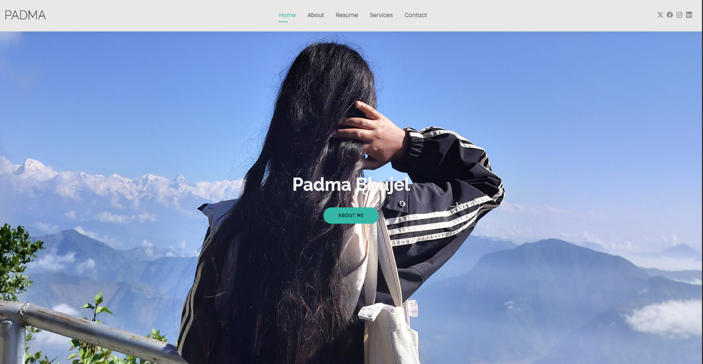

Skill page
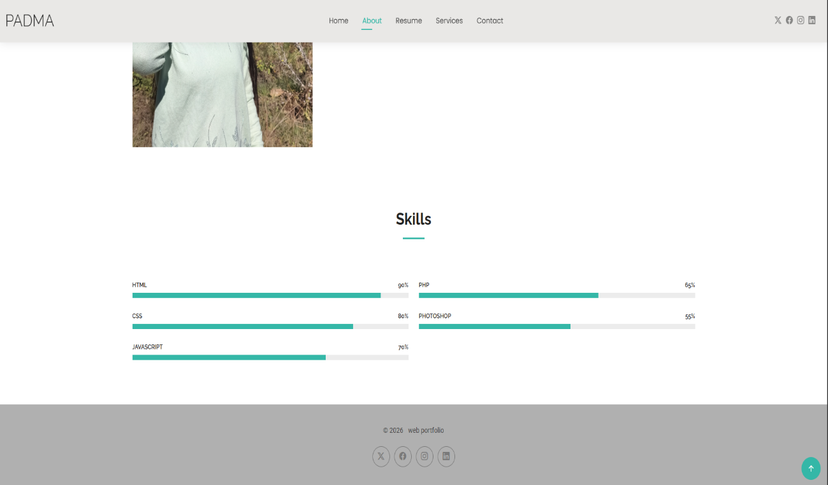
Resume page
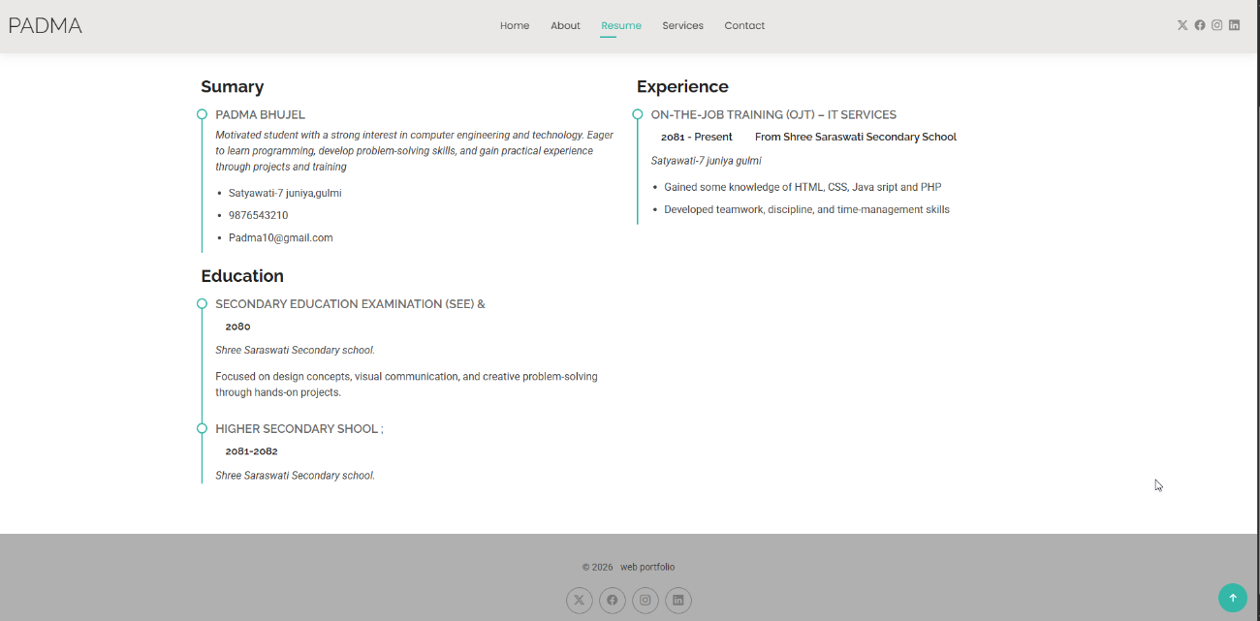

Services page

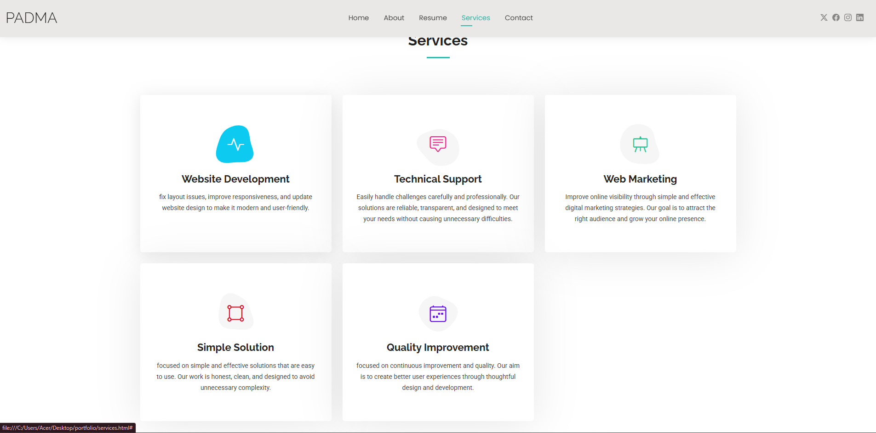

Resume page
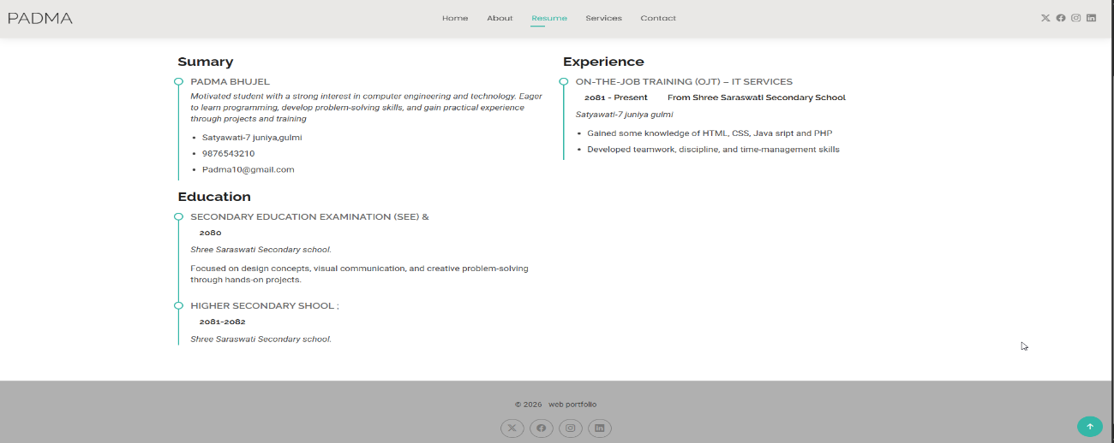

Contact page
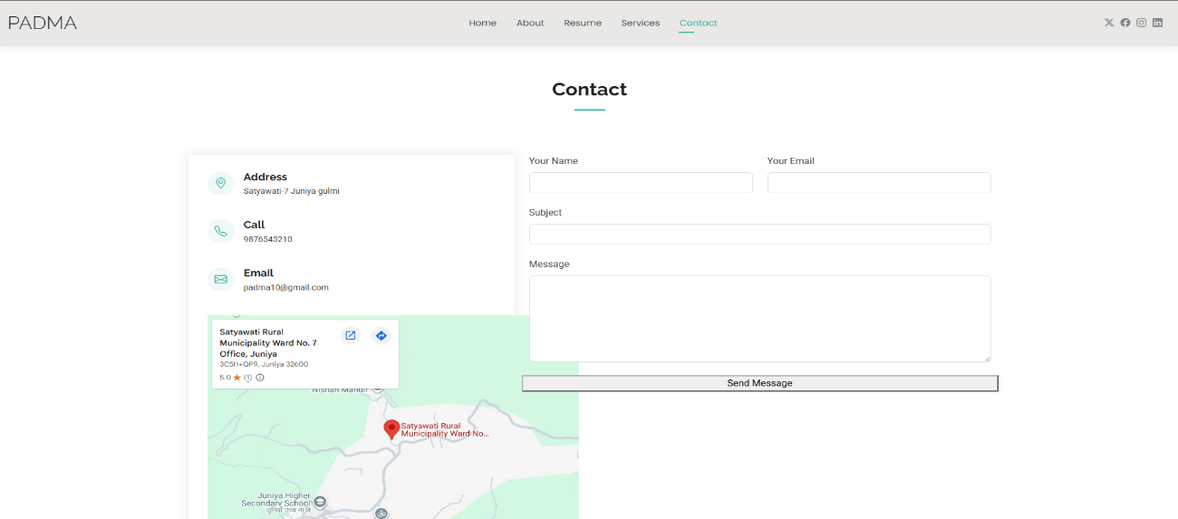

References I

- https://www.geeksforgeeks.org
- https://code.visualstudio.com
- https://docs.github.com
- https://www.youtube.com/watch?v=mEfTCGbTkHs

INTRODUCTION II

Hardware Repair and Maintenance is a practical technical field that we studied during our On-the-Job Training (OJT), with the primary goal of developing the skills required to diagnose, repair, maintain, and troubleshoot computer hardware systems. In many organizations, computers and other hardware devices are essential for carrying out daily activities, and hardware failures can cause delays, data loss, reduced productivity, and additional repair costs. Problems such as overheating, faulty RAM, damaged storage devices, power supply failures, loose connections, and malfunctioning peripheral devices can affect the proper operation of a computer system. Our project focuses on addressing these challenges by applying systematic hardware troubleshooting and maintenance procedures. It provides practical knowledge of identifying hardware faults, testing individual components, replacing or repairing defective parts, and performing preventive maintenance. This not only helps improve system performance and reliability but also extends the useful life of computer equipment and reduces unnecessary hardware-related expenses. Ultimately, this project provided a valuable hands-on opportunity to apply the computer hardware concepts learned during our studies to real-world technical problems.
The core objective of our OJT was to gain practical, real-world experience in handling and maintaining computer hardware systems. We started by learning about the major components of a computer and understanding their individual functions and relationships within the system. We then performed several practical activities, including assembling and disassembling computers, identifying hardware components, diagnosing common hardware problems, cleaning internal components, checking cables and connections, installing or replacing faulty components, and performing basic hardware testing. Proper safety procedures were followed throughout the maintenance process to prevent damage to components and ensure safe handling of equipment. The training also emphasized preventive maintenance practices, helping us understand how regular cleaning, inspection, and proper system usage can reduce hardware failures. This report provides a detailed account of the hardware repair and maintenance procedures performed during our OJT, explains the functions of major hardware components, describes the troubleshooting methods used, and documents the technical challenges and practical skills gained throughout the training.

PROJECT OBJECTIVE AND SCOPE II:

- To understand the basic components of a computer system and their functions.
- To develop practical skills in assembling and disassembling computer systems safely.
- To identify and diagnose common hardware problems systematically.
- To troubleshoot hardware faults and determine their possible causes.
- To repair or replace faulty hardware components when required.
- To perform regular cleaning and preventive maintenance of computer systems.
- To check and maintain proper connections between internal and external hardware components.
- To install and configure hardware components and their required drivers.
- To improve computer performance, reliability, and stability through proper maintenance.
- To extend the useful life of computer hardware and reduce unnecessary repair costs.

BENEFITS TO THE USER II

- The project covers the identification and study of major computer components such as the motherboard, CPU, RAM, storage devices, power supply, cooling system, monitor, keyboard, mouse, and other peripherals.
- It includes computer assembly and disassembly using appropriate tools and safety procedures.
- The project covers troubleshooting common problems related to power, display, storage, memory, overheating, connectivity, and peripheral devices.
- It includes cleaning internal and external computer components to prevent dust accumulation and overheating.
- The scope includes checking cables, ports, connectors, RAM, storage devices, cooling fans, and power connections.
- It covers the replacement of damaged or faulty hardware components where necessary.
- The project includes basic hardware installation and driver configuration.

Gaming Pc assembly

Gaming PC Assembly Documentary — Steps to Follow
1. Define the Purpose of the PC
First, decide what the PC will mainly be used for.
- Gaming only
- Gaming + streaming
- Gaming + video editing
- Competitive/esports gaming
- High-end AAA gaming
- General use + gaming
This determines which components deserve more of the budget.

2. Set and Divide the Budget 💰
Before buying anything, decide your maximum budget.
A simple approach is:
Component | Approx. Budget Priority
CPU | 15–20%
GPU | 30–40%
Motherboard | 10–15%
RAM | 8–10%
SSD | 5–10%
PSU | 7–10%
Case | 5–8%
Cooling | 3–7%
For a gaming PC, the GPU usually deserves the largest share, especially if gaming performance is the main goal.
Also keep some money aside for:
- Monitor
- Keyboard and mouse
- Headset/speakers
- Windows/software
- Extra case fans
- Future upgrades

3. Make a Parts Checklist
The basic components required are:
Essential PC components
- CPU (Processor)
- GPU (Graphics Card) — if the CPU doesn't have suitable integrated graphics
- Motherboard
- RAM
- Storage — preferably an SSD
- Power Supply Unit (PSU)
- PC Case
- CPU Cooler — depending on the CPU
- Case Fans — if the case doesn't have enough
Peripherals
10. Monitor
11. Keyboard
12. Mouse
13. Headset/speakers
14. Ethernet cable/Wi-Fi adapter if required

4. Check Compatibility Before Purchasing
This is one of the most important parts of the documentary.
Check:
- CPU socket ↔ motherboard
- Motherboard ↔ RAM type
- RAM capacity and supported speed
- GPU ↔ motherboard
- GPU length ↔ case
- CPU cooler height ↔ case
- CPU cooler mounting ↔ CPU socket
- PSU wattage ↔ total system power
- PSU connectors ↔ GPU/motherboard
- Storage interface ↔ motherboard
- Number of motherboard M.2/SATA slots
- Case ↔ motherboard form factor (ATX, Micro-ATX, Mini-ITX)
Never buy parts simply because each component is good individually. They must work together.

5. Purchase and Verify the Parts
When the parts arrive:
- Check the packaging for damage.
- Confirm the exact model.
- Check that all accessories are included.
- Check serial numbers/warranty information.
- Don't throw away boxes immediately.
- Keep invoices and warranty documents.
For your documentary, you could film this as the "Parts Fulfillment & Verification" stage.

🔧 6. Prepare the Workspace
Before assembling:
- Use a clean, large table.
- Have good lighting.
- Keep drinks away from components.
- Use a Phillips screwdriver.
- Keep motherboard screws/accessories organized.
- Ground yourself before handling components.
- Avoid touching electrical contacts/pins.
A useful documentary shot would be a top-down view of all components laid out before assembly.

🛠️ 7. Assemble the PC
A practical assembly sequence is:
Step 1 — Prepare the motherboard
Place the motherboard on its box or another non-conductive surface.
Step 2 — Install the CPU
Open the CPU socket and carefully place the processor according to the alignment marker.
Do not force it.
Step 3 — Install RAM
Open the appropriate RAM slots and install the memory modules firmly.
For two sticks, use the motherboard's recommended slots, commonly A2 and B2, but verify the motherboard manual.
Step 4 — Install the M.2 SSD
Insert the SSD into the M.2 slot and secure it with the appropriate screw.
Step 5 — Install the CPU cooler
Apply thermal paste if the cooler doesn't already have it.
Then mount the cooler according to its instructions.
Step 6 — Prepare the case
Install:
- Motherboard standoffs
- I/O shield if required
- Case fans if needed
Step 7 — Install the motherboard
Carefully place the motherboard into the case and screw it onto the standoffs.
Step 8 — Install the PSU
Mount the PSU in the designated position and route the necessary cables.
Step 9 — Install the GPU
Insert the graphics card into the appropriate PCIe slot and secure it to the case.
Connect the required GPU power cable.
Step 10 — Connect all cables
Important connections include:
- 24-pin motherboard power
- CPU/EPS power
- GPU power
- Front-panel power switch
- Reset switch if applicable
- USB
- Front audio
- Case fans
- SATA cables if applicable

⚡ 8. First Power-On
Before turning it on, perform a final inspection.
Check:
- Is the RAM fully inserted?
- Is the GPU fully inserted?
- Is the CPU cooler connected?
- Is the CPU power cable connected?
- Is the 24-pin motherboard cable connected?
- Is the GPU power connected?
- Are there loose screws inside?
- Are fans connected?
Then turn on the PSU and press the case power button.
If everything works, you should get a display and enter the BIOS/UEFI.

💻 9. BIOS/UEFI Configuration
Inside BIOS:
- Confirm CPU is detected.
- Confirm RAM capacity is detected.
- Confirm SSD is detected.
- Check CPU temperature.
- Enable the appropriate memory profile such as XMP/EXPO, if supported.
- Set the correct boot device.
Then install your operating system.

🎮 10. Install Drivers and Software
After installing the OS:
- Motherboard/chipset drivers
- GPU drivers
- LAN/Wi-Fi drivers
- Audio drivers
- Windows updates
- Gaming platforms such as Steam/Epic Games, if required
Then install your games.

🧪 11. Test and Benchmark
Don't consider the build finished immediately after Windows boots.
Test:
Hardware
- CPU temperature
- GPU temperature
- RAM stability
- SSD performance
- Fan operation
Gaming
Test several games and record:
- FPS
- Resolution
- Graphics settings
- CPU usage
- GPU usage
- Temperatures
This gives your documentary a strong "Before vs. After / Performance Results" section.

💰 12. Final Budget Analysis
At the end, calculate:
Total PC Cost = CPU + GPU + Motherboard + RAM + SSD + PSU + Case + Cooling + Peripherals
Then compare:
Planned Budget vs. Actual Cost
For example:
Planned budget: $1,000
Actual component cost: $950
Remaining: $50
You can then explain whether the money was spent efficiently.

📋 Documentary Structure
You could organize the documentary into these chapters:
1. Introduction
↓
2. Gaming Requirements
↓
3. Budget Planning
↓
4. Component Selection
↓
5. Compatibility Checking
↓
6. Parts Fulfillment/Purchasing
↓
7. Parts Inspection
↓
8. PC Assembly
↓
9. Cable Management
↓
10. First Boot & BIOS
↓
11. OS & Driver Installation
↓
12. Testing & Benchmarking
↓
13. Final Cost Analysis
↓
14. Gaming Performance & Conclusion
A successful gaming PC build isn't just about buying powerful parts. It requires proper requirement analysis, budget management, component compatibility, careful assembly, testing, and performance evaluation.

IFIXIT.com



OnePlus 5 Back Cover Replacement

This guide shows how to remove the back cover...
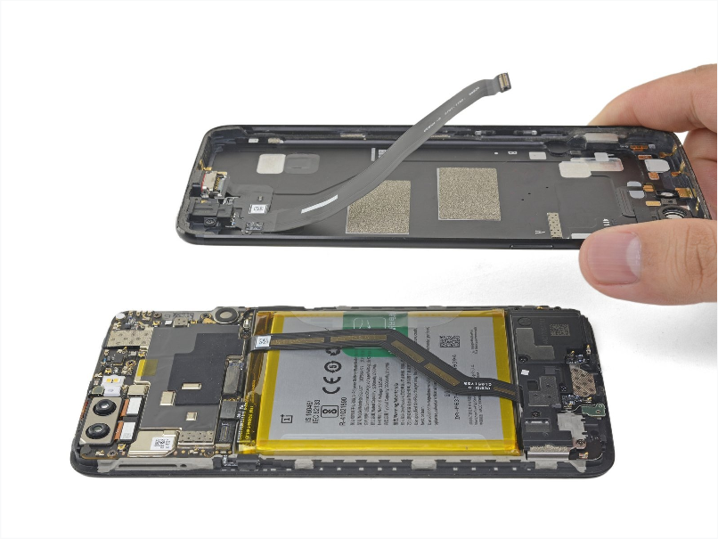

INTRODUCTION

This guide shows how to remove the back cover to access the OnePlus 5’s internals. The hardest part is getting the frame clips free. Once that is done, the cover comes off easily.

TOOLS:

SIM Card Eject Tool (1) T1 Torx Screwdriver (1) Suction Handle (1) iFixit Opening Tool (1)

Phillips #00 Screwdriver (1)

Spudger (1)

Tweezers (1)

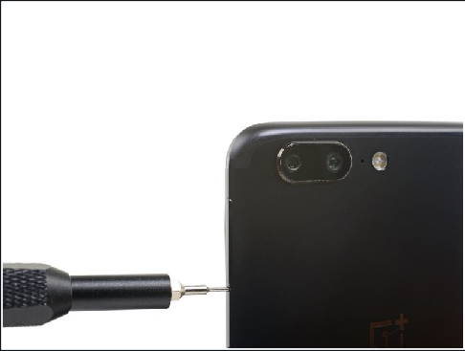
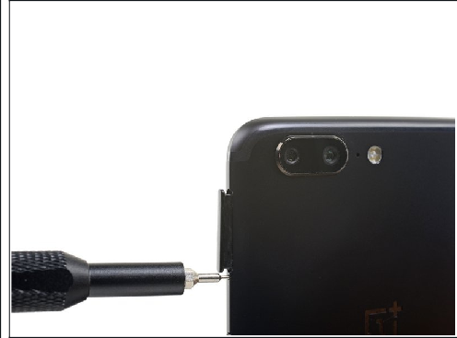
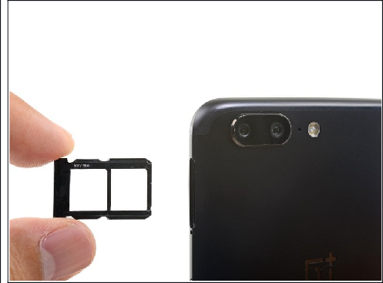
Step 1 — SIM Card Tray

Insert a SIM card eject tool, bit, or a straightened paperclip into the small hole below the SIM card tray, located near the rear cameras on the edge of the phone.

Press firmly to eject the tray.

During reassembly, be sure to properly orient the SIM tray you you insert it.

Step 2 — Back Cover

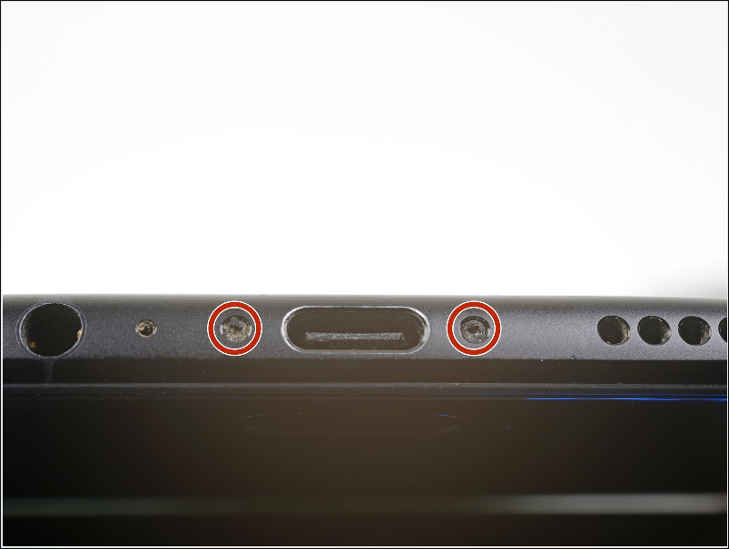
Remove the two 2.6 mm T2 screws straddling the USB-C port on the bottom edge of the phone.

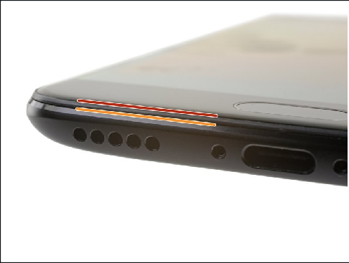
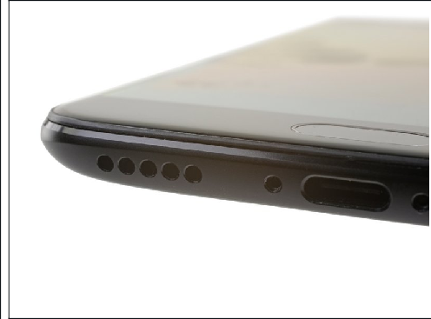
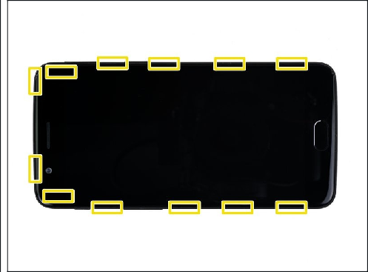
Step 3

There is a high risk of damaging the display panel if this opening procedure is improperly followed.

The following four steps show how to pry the rear case from the plastic frame. Read through the steps first before attempting the procedure.

There are two different seams between the body and the screen of the phone:

Display panel seam: This seam is part of the display assembly. Do not pry at this seam, or you will separate and damage the display panel.

Frame seam: This is where the plastic frame meets the back cover. Only pry at this seam.

There are twelve clips that hold the frame against the rear case. Be aware of their location as you pry the back cover off in the following steps.

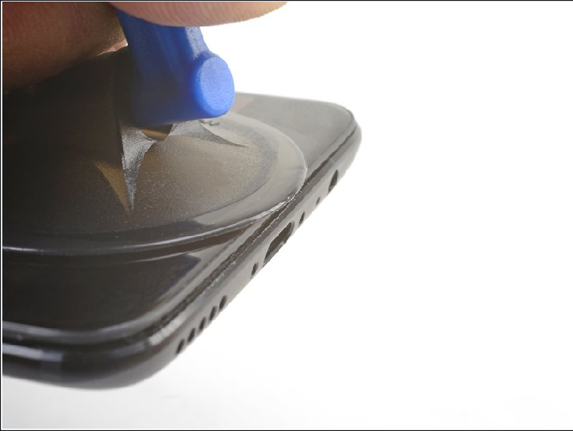
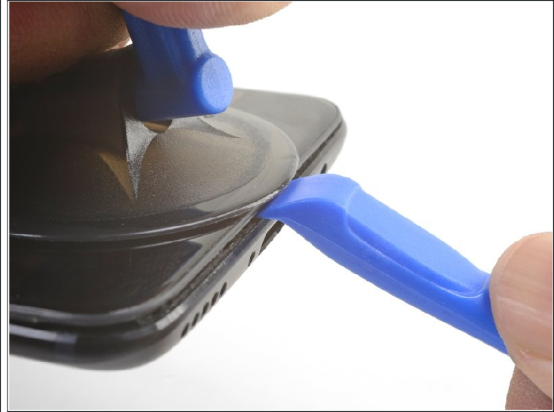
Step 4

As you work, try not to accidentally power on the phone. If you do, turn the phone off before resuming disassembly.

Place a suction cup near the bottom edge of the display.

Pull on the suction cup with strong steady force.

Press the edge of an opening tool straight into the frame seam near the suction cup until the edge wedges between the plastic frame and the back cover's lip.

Due to tight tolerances, this will take substantial force. Using a new opening tool with an unmarred edge will help with this step.

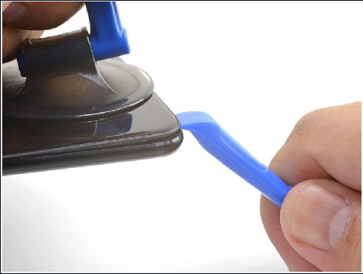
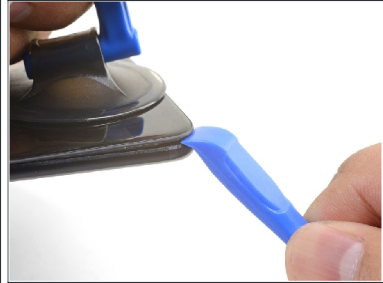
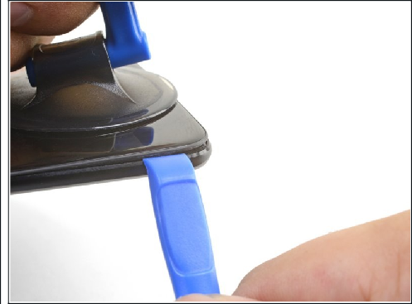
Step 5

Once the opening tool's edge is wedged in position, carefully slide the tool along the bottom edge of the phone.

Carefully guide the opening tool around the left corner of the phone while keeping the tool's edge within the seam.

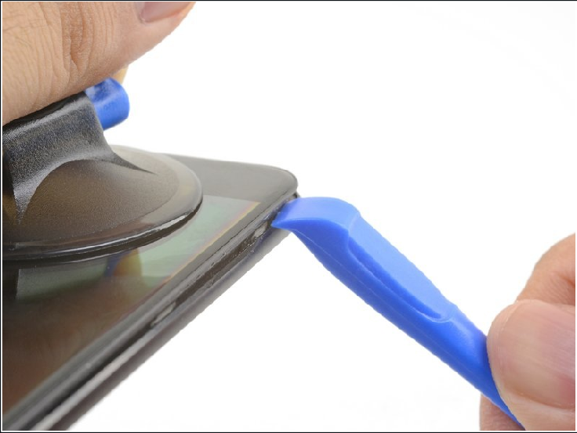
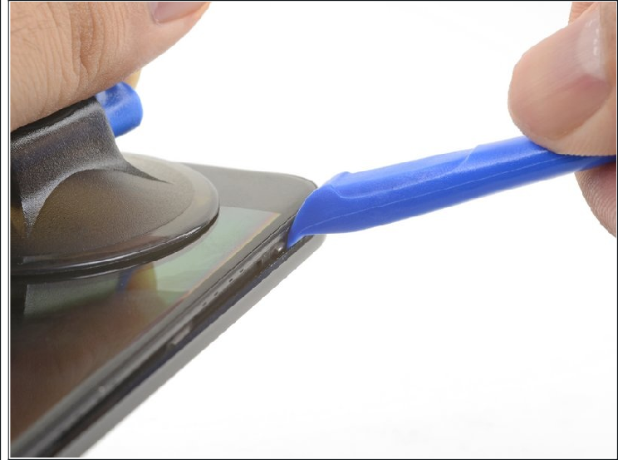
Step 6

Lever the opening tool to release the first clip from the frame.

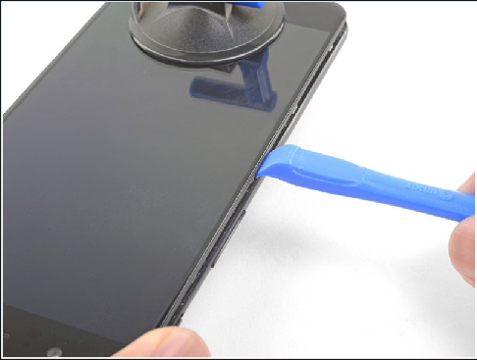
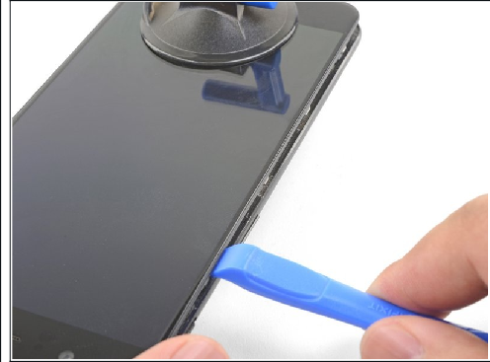
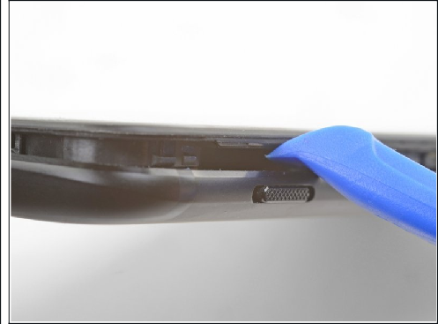
Step 7

Continue sliding the opening tool along the long edge, releasing the clips along the way.

The last clip in the top-left corner near the front-facing camera is recessed and can be difficult to release. Take your time and use the flat end of a spudger or an opening pick to help.

Step 8

With the bottom and left edge of the phone freed, gently wiggle the frame to release the top and right edge clips.

The frame is still connected to the back cover by a long flex cable. Do not remove the back cover.

During reassembly, pause here to test your phone's functionality before securing the back cover.

To reinstall the back cover:

Align the top edge of the frame to the back cover and ensure that the top clips slip into place.

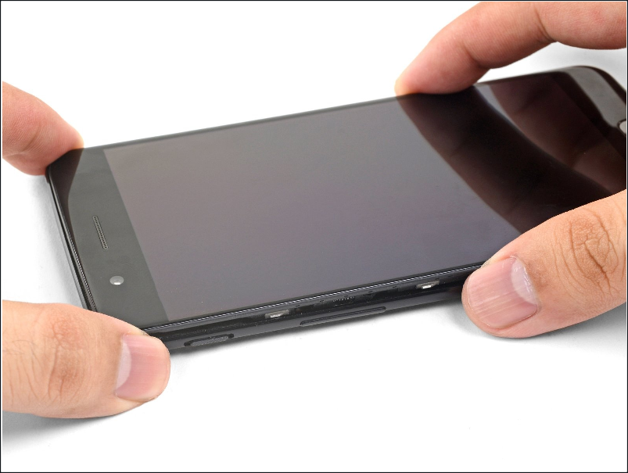
Squeeze along the long edges of the phone to snap the remaining clips into place.

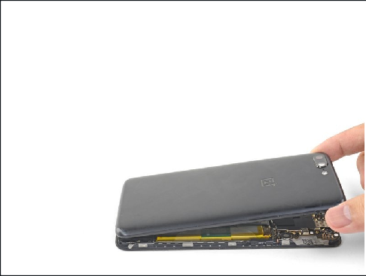
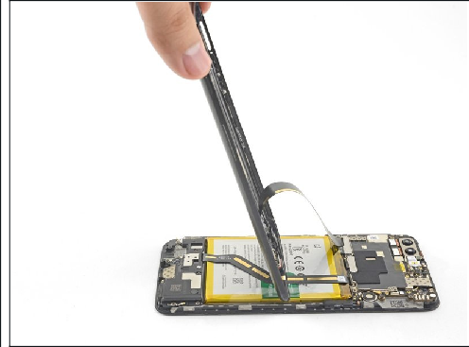
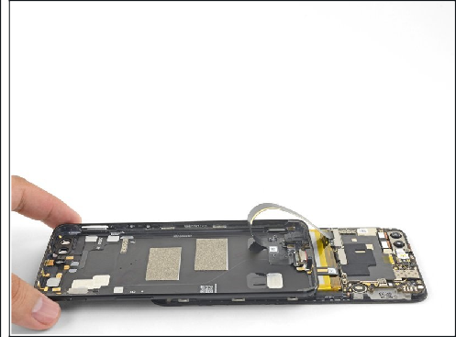
Step 9

With all the clips released, flip the phone over so that the display is face-down.

Swing the back cover around and rest it on top of the exposed frame.

Be careful not to stress the flex cable connecting the back cover and the frame.

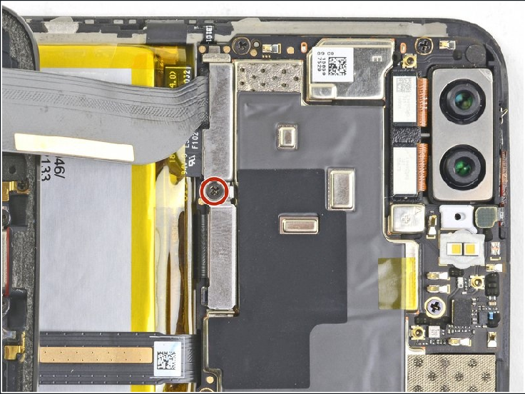
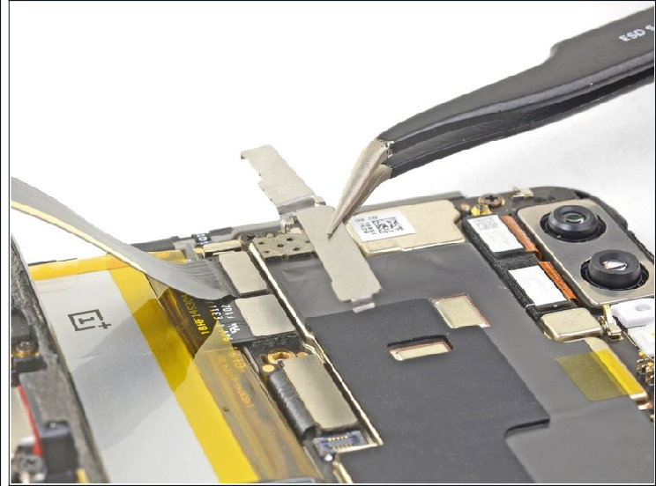
Step 10

Remove the 2.6 mm Phillips screw holding the cable bracket above the battery in place.

Lift up and remove the cable bracket.

To reinstall the bracket, position one end into place, and bend the bracket slightly to spring the other end into place.

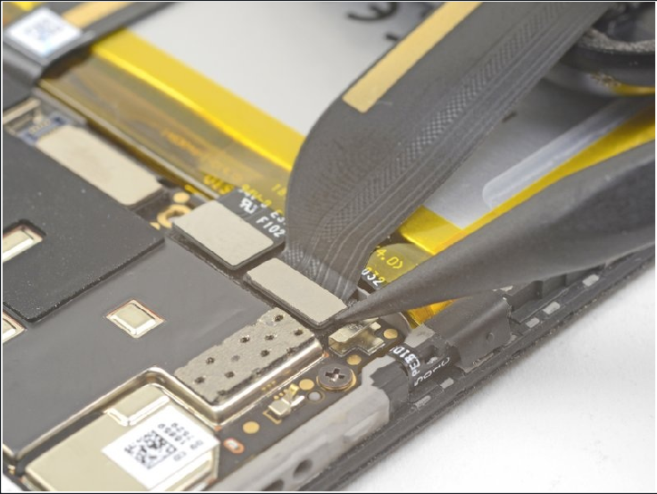
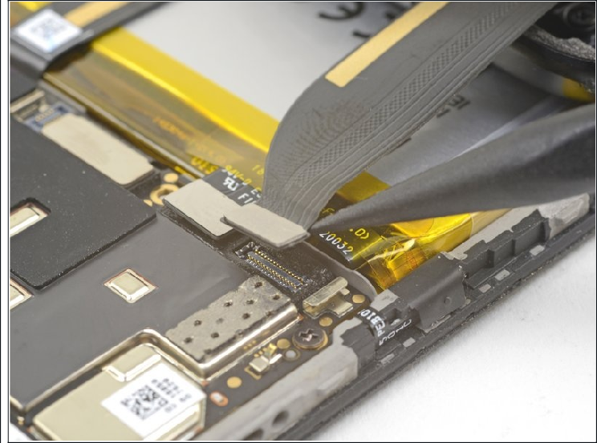
Step 11

Use the point of a spudger to pry up and disconnect the back cover flex cable from its socket.

To re-attach press connectors like this one, carefully align and press down on one side until it clicks into place, then repeat on the other side. Do not press down on the middle. If the connector is misaligned, the pins can bend, causing permanent damage.

Step 12

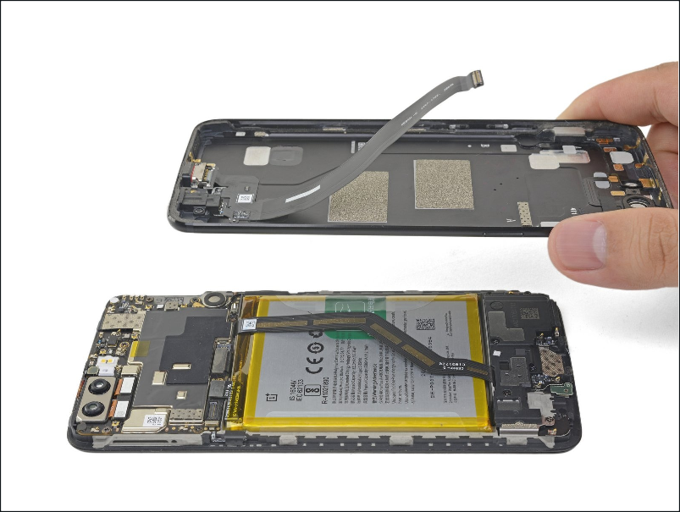
Remove the back cover.

To reassemble your device, follow these instructions in reverse order.

Repair didn’t go as planned? Check out our OnePlus 5 Answers community for troubleshooting help.

References II

- https://www.geeksforgeeks.org
- https://code.visualstudio.com
- https://docs.github.com
- https://www.youtube.com/watch?v=mEfTCGbTkHs

Medicat USB

How to Crack / Reset a Windows password using MediCatUSB — step-by-step guide

If you’ve locked yourself out of a Windows account on a PC you own (or have explicit permission to fix), MediCatUSB lets you boot the machine from a flash drive and use offline tools to reset or remove local account passwords. This guide walks you through the full process I demonstrated in the transcript — why it works, what to prepare, and exactly what to click and expect. Read the disclaimer and caveats first.
Disclaimer / legal note (please read)
Only use the instructions below on computers you own or where you have explicit, written permission from the owner to perform recovery actions. Intentionally accessing or modifying someone else’s computer without permission is illegal in many jurisdictions. This guide describes legitimate recovery techniques for local Windows accounts (not Microsoft accounts or encrypted drives). If the target PC uses full-disk encryption (BitLocker) or an online Microsoft account, the techniques here may not work and could risk data loss.

1 Why this works — a short explanation
Before we jump into the button-clicking, let’s pause for a second and understand the principle. Windows stores local user account credentials (hashed passwords and account flags such as “locked” or “disabled”) in a system file called the SAM (Security Accounts Manager) database. When you boot Windows normally, that file is in use and protected. But if you boot the PC from an external environment — a live USB like MediCatUSB — you can access the file offline (because Windows is not running and locking it). Offline password tools can open the SAM, edit or blank password hashes, and flip account flags (unlock, enable). After you reboot normally, Windows sees the updated SAM and accepts the new or blank password.
That’s the foundation. The rest is about safe, correct steps so you don’t accidentally harm data or trigger other protections.
2 What you need (Hardware & Conditions)
Let’s list what to have before starting. Take a moment to collect these — it saves time later.
- A USB flash drive prepared with MediCatUSB (the transcript uses an already-built MediCat live USB).
- The target Windows PC (desktop or laptop) that you want to recover access to. You must be able to change its boot order or use its boot menu (Esc, F2, F12, etc., depending on model).
- A keyboard (some laptops need an external keyboard for early boot keys).
- Physical access to the machine — you’ll be turning it off, inserting/removing the USB drive, and rebooting.
- Knowledge whether the locked account is a local account or a Microsoft account. (If it’s a Microsoft account tied to an email, offline reset methods will not change the online password — you’ll need Microsoft’s account recovery in that case.)
- IMPORTANT: if the disk is encrypted with BitLocker you’ll need the recovery key; offline SAM editing alone will not decrypt the drive.
If any of the above is missing (for example, BitLocker enabled and no recovery key), stop and get the recovery key or owner permission — continuing can lead to data loss or permanent lockout.

3 Prep: Get a MediCatUSB flash drive ready
The transcript assumes you already have a MediCatUSB live environment on a flash drive. The live environment boots into a portable toolkit (like a Linux/Windows PE environment) and includes many password tools. If you already have that USB, great — we follow the same flow. If you don’t, prepare a MediCatUSB or similar rescue USB on another machine before attempting recovery.
A couple of practical prep steps (non-technical summary):
- Verify the USB is bootable: plug it into another machine, force its boot menu and confirm the live environment starts.
- Label your flash drive physically so you don’t confuse it with ordinary storage.
- Have a separate storage backup available if your goal is primarily data rescue rather than password reset.
Wnat to know more how to create a MEDICAT USB refer to this link below:
Medicat USB (October 2025 Guide): The Ultimate PC Repair Toolkit with Hidden Features!

4 Booting the target PC from the MediCatUSB stick
Now for the hands-on part. The transcript gives a clear, chronological flow — I’ll turn that into a repeatable list with small extra notes. Intro text before steps: take a breath and make sure the target PC is off. You’ll be changing hardware state; a calm, stepwise approach prevents accidental power interruptions.
Steps:
- Power off the PC completely (shut down, not sleep).
- Insert the MediCatUSB flash drive into an available USB port.
- Power on the PC and immediately press the key for the boot menu repeatedly. On many ASUS laptops (as in the transcript) that key is Esc; on others it might be F12, F8, or F10 — check your model if you know it. If you don’t know, try Esc → F12 → F8 as soon as the machine powers up.
- The boot menu will show available boot devices. Use the keyboard to choose the USB flash drive entry (it will often mention the drive brand or “USB device”). Select it and press Enter.
- The machine will boot into the MediCat live environment (you’ll not be booting into Windows at this stage). Wait for the boot sequence to finish and for the MediCat desktop or menu to appear.
Notes:
- If the machine boots straight to Windows instead of the USB, power off and re-enter the boot menu; sometimes timing matters.
- If Secure Boot is enabled and blocks the USB, you may need to disable Secure Boot in the UEFI/BIOS temporarily (see section 9 on UEFI/Secure Boot caveats).

5 Finding and loading the offline password tools inside MediCatUSB
Once the live environment is up, you’ll have access to a collection of password tools. The transcript demonstrates a practical sequence:
Intro before the next list: think of this step as browsing a toolbox. The live stick contains several utilities — pick the one you’re comfortable with. If one fails, try another.
Typical flow (based on the transcript):
- From the MediCat menu, navigate to the password / account recovery section (tools labelled with names like lockpick, NTPWEdit, Lazesoft, bypass-windows-password, etc.).
- Select the tool you want to try. Many of these tools will automatically search the system disk(s) for the SAM file (the Windows account database). If the tool finds the SAM file, it lists all local accounts present on the machine (Administrator, guest, and any user accounts).
Important concept: these tools operate offline by accessing the SAM and SYSTEM registry hives directly from the Windows disk. That lets them change password hashes or clear the password field.

6 Two tested tools: NTPWEdit and Lazesoft — exact steps
I’ll provide step-by-step instructions for each, plus what to expect.
6.1 NTPWEdit (A Popular SAM Editor)
NTPWEdit is broadly used because it offers a direct view of Windows local accounts and allows you to set a new password or blank the password field. It’s simple and effective for local accounts on systems without extra encryption.
Steps (based on transcript + safe practice):
- Launch NTPWEdit from the MediCat menu (sometimes the tool is invoked via the ntpwedit entry or through a menu item labelled similarly).
- The tool will scan mounted partitions and find the Windows SAM file (commonly under C:\Windows\System32\config\SAM). If it finds the file, it will show the available accounts: Administrator, Guest, and user accounts (e.g., Monkey C, Jules, Vincent).
- Select the account you want to modify (for example Monkey C).
- Click Change password or the equivalent action. Enter the new password you want (the transcript sets monkeydo as an example). Consider using a temporary password you will change again immediately after logging in.
- Hit OK or Save, and ensure the tool writes the change successfully. The tool will generally prompt that the SAM has been updated.
- Exit the utility and close any open MediCat windows. Choose to shut down the live environment (do not hibernate).
- Remove the MediCatUSB and reboot the machine normally into Windows (or just restart and let it boot to internal disk).
- On the Windows login screen, type the new password you set and sign in.
Important notes:
- If the tool reports an error locating the SAM or cannot write the file, check whether you selected the correct partition.
- If the account is a Microsoft account (uses an email login), NTPWEdit cannot change the online password — it only affects local SAM accounts.
6.2 Lazesoft (Another Recovery tool)
Intro before steps: Lazesoft often provides a GUI that shows account lock status and lets you clear or blank passwords. The transcript shows it successfully clearing Vincent’s password.
Steps:
- Launch Lazesoft from the MediCat menu. It will scan and detect the Windows installation and SAM file.
- The interface lists accounts and may show indicators: locked/unlocked, password present or blank.
- Choose the account you want to reset. Lazesoft often provides two options: bypass password or remove/blank password. Removing the password sets it to blank so you can sign in without entering anything; bypass can sometimes set temporary bypass tokens.
- Execute the reset and wait for confirmation “reset successfully” (as the transcript showed).
- Exit Lazesoft and shut down the live environment. Remove the USB and boot normally.
- On the Windows login screen click the user (e.g., Vincent) and press Sign in — when the password field is blank, just press Enter.
Important follow-ups:
- After you get back into the account, add a real password and review account security settings (see section 10).

7 After the change: rebooting and logging in
Intro before steps: this is the satisfying part — check that the edits wrote correctly and you can access the account cleanly.
Procedure:
- Ensure you close all tools and choose shutdown from the live environment. Some utilities will prompt “remove flash drive before reboot” — follow their guidance.
- Remove the MediCatUSB and power on the PC. Let it boot into the internal Windows installation.
- On the Windows sign-in screen, select the account you changed (e.g., Monkey C) and enter the new password you set (or press Enter if you blanked the password).
- If login is successful, immediately open User Accounts or Settings → Accounts and set a secure password and, if appropriate, enable password recovery options. If the account is local and you prefer it to remain local, consider adding security measures like a PIN or an offline password manager.
If login fails:
- Double-check spelling and caps lock.
- If still failing, reboot and try another tool from MediCatUSB — sometimes one tool writes differently or a different account flag was set. See troubleshooting next.

8 Troubleshooting & common hiccups
Let’s address the things that can go wrong and how to respond.
- Tool can’t find the SAM file: Make sure you selected the correct disk/partition. Some machines have multiple drives (SSD + HDD) or the Windows partition may not be C: from the live environment perspective. Explore mounted partitions to locate Windows\System32\config\SAM.
- Tool finds SAM but cannot write: The partition might be marked read-only. Try remounting as read/write if the environment supports it, or try a different tool.
- Windows still requires previous password: If the account is a Microsoft account (online), changing the local SAM won’t change Microsoft’s servers. Use Microsoft account recovery or convert the account to local if you can access the Microsoft account email.
- Account still locked or disabled: Some tools also change account flags (unlock/enable). Look for an option to toggle Account is disabled or Account is locked.
- Automatic reboot / boot order changed: If you forget to remove the USB, the machine may boot back to MediCat. That’s harmless — just remove the USB and boot normally.
- Live environment fails to boot: Try another USB port (use USB-2 vs USB-3) or rebuild the rescue USB and re-try.
If nothing works, stop and consider data recovery/uploading your drive to a safe location first instead of repeated destructive edits.

9 Important caveats: BitLocker, Microsoft accounts, UEFI/Secure Boot
Before you proceed in desperation, double-check these blockers:
- BitLocker (full disk encryption): If the Windows drive is encrypted with BitLocker and you do not have the recovery key, offline SAM edits won’t help because the disk contents are encrypted at rest. You’ll need the BitLocker recovery key to mount or decrypt the drive.
- Microsoft online accounts: If the Windows user is linked to a Microsoft account (email/password), the cloud password is authoritative. The local SAM may still have a cached credential, but changing the local SAM often won’t allow you to sign back in as that Microsoft account — you’ll need Microsoft’s account recovery.
- UEFI / Secure Boot: Some modern PCs block unsigned boot media under Secure Boot. If MediCatUSB is blocked by Secure Boot, you may need to disable Secure Boot temporarily in the UEFI settings or sign the media (advanced). Be careful — changing UEFI settings can have consequences; if you’re unsure, ask an experienced friend or technician.
- Hardware TPM interactions: Some devices use TPM to protect credentials; tampering with the SAM may trigger additional protections.

10 Best practices after recovery (security checklist)
Once you regain access, don’t leave the account insecure. Here’s a short checklist of sensible steps:
- Immediately set a strong password (use a passphrase or long random password; avoid simple words like monkeydo).
- Enable Windows Hello PIN or biometric login if available. PIN is tied to the device and is often easier and secure for local access.
- If your account was local and you prefer it online, consider converting to a Microsoft account only if you want cloud recovery features — otherwise keep a local account but ensure a secure password.
- Check BitLocker status. If it was disabled previously, consider enabling BitLocker after ensuring you have the recovery key stored safely.
- Review Event Viewer and Security logs if you suspect unauthorized access.
- If this machine is used in a corporate environment, report the recovery action to your IT department per policy.
- Consider enabling a password manager and storing credentials there — it prevents future lockouts due to forgotten passwords.

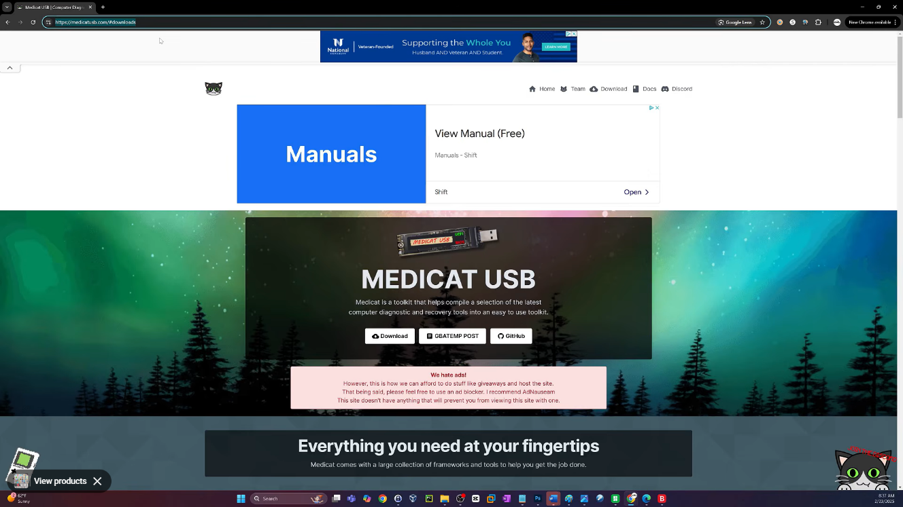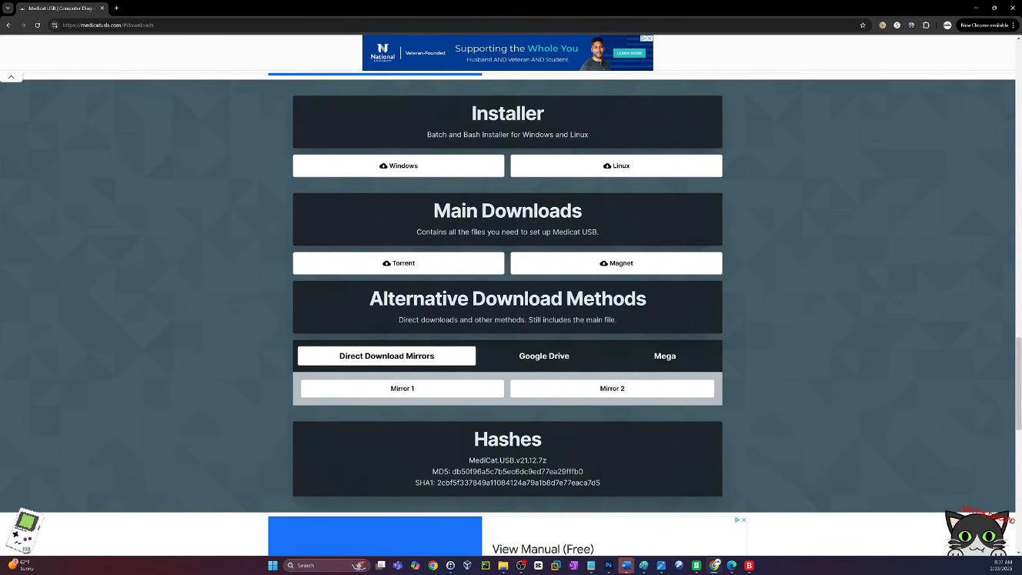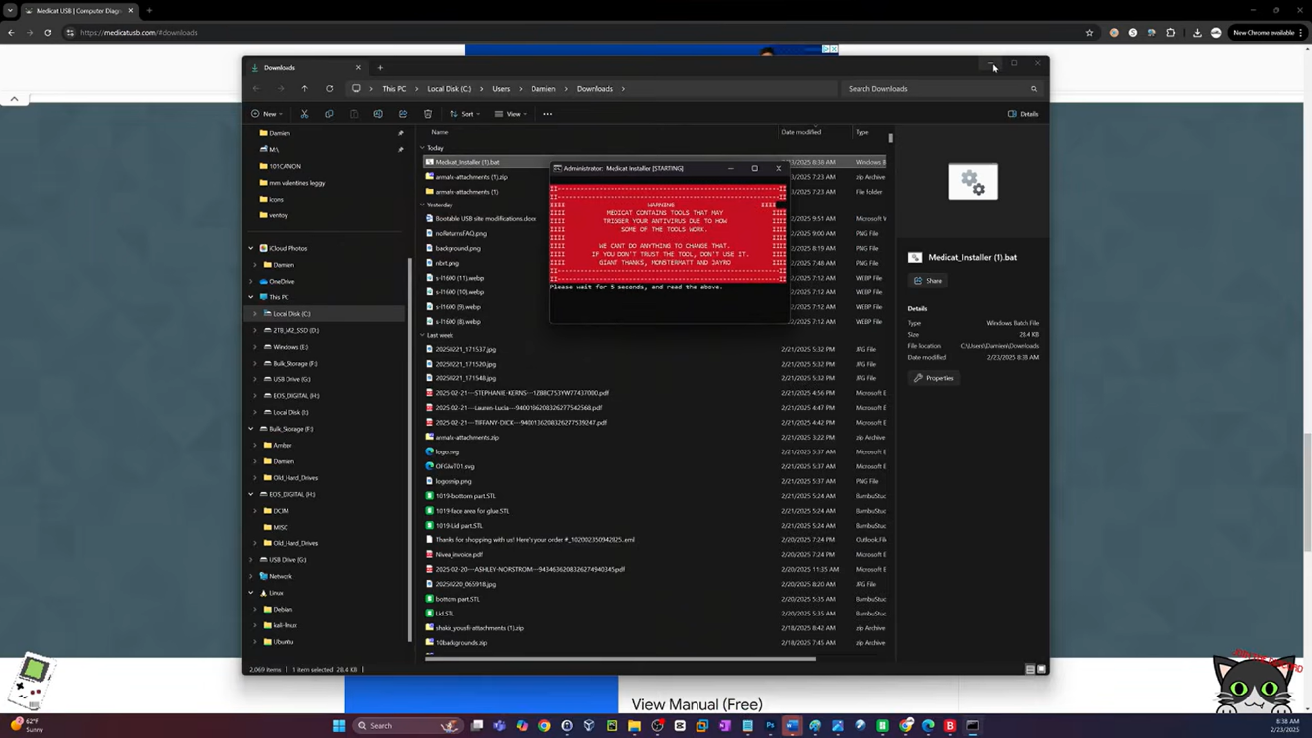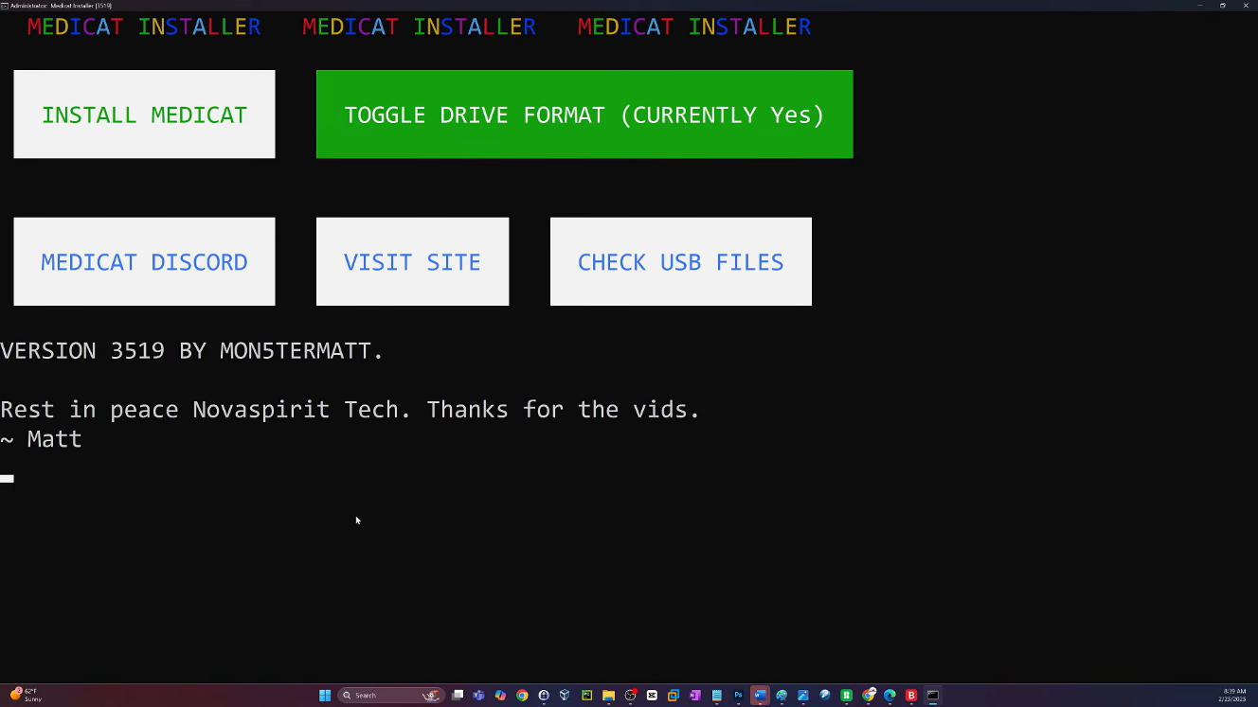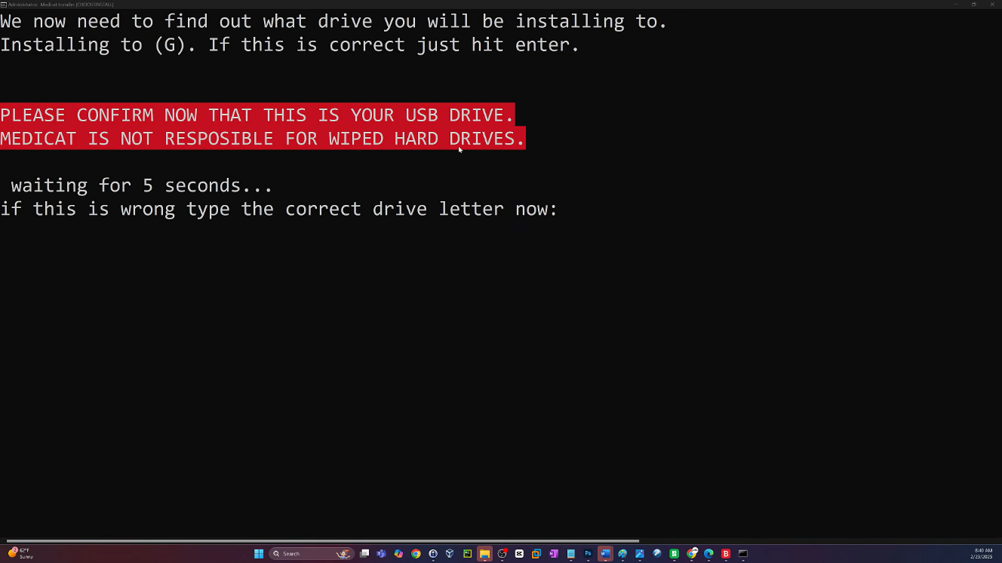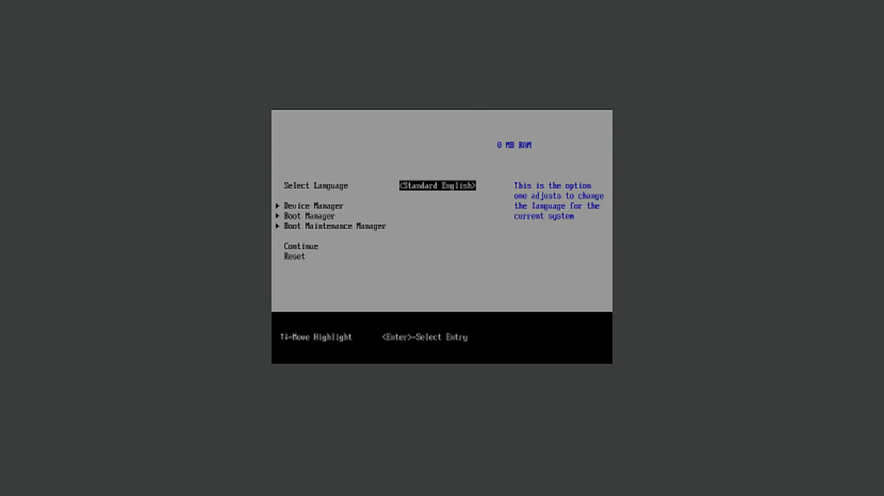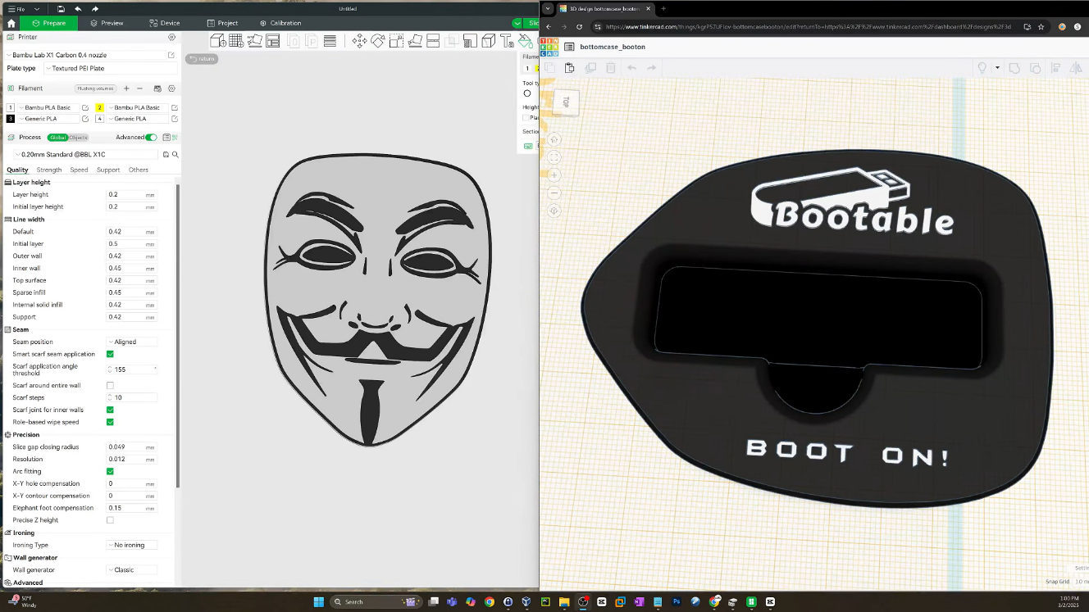

LAN File-Sharing Server

Simple LAN File-Sharing Server
A beginner-friendly step-by-step guide for sharing files between computers on the same local network.

- What you need
  - Two computers connected to the same Wi-Fi or wired LAN.
  - Python 3 installed on the computer that will act as the server.
  - A folder containing the files you want to share.
  - Permission to use the local network.

- Create a folder for sharing
Create a folder, for example C:\\SharedFiles, and copy the files you want to share into it.

- Open Command Prompt in that folder
Open the folder in File Explorer. Click the address bar, type cmd, and press Enter. A Command Prompt window should open with that folder as the current directory.
- Start the simple server
Run this command:
python -m http.server 8000
If the command works, Python starts a small HTTP server on port 8000. Keep this Command Prompt window open while sharing the files.
- Find the server computer's IP address
Open another Command Prompt window and run:
ipconfig
Look under the active Wi-Fi or Ethernet adapter for IPv4 Address. It may look similar to 192.168.1.10. Use the actual address shown on your computer.
- Connect from the second computer
On the other computer, open a web browser and enter:
http://SERVER-IP:8000
For example, if the server's IPv4 address is 192.168.1.10:
http://192.168.1.10:8000
The browser should display a directory listing containing the files in the shared folder. Click a file to download it.
- If the page does not open
  - Confirm both computers are connected to the same local network.
  - Confirm the Python server is still running.

  - Confirm you used the server computer's IPv4 address, not the client's address.
  - Check that port 8000 is allowed by the Windows firewall. For a documentary/demo, allow access only on a trusted private network.
  - Make sure the server computer is not connected through a network that blocks device-to-device communication.

- Stopping the server
Return to the Command Prompt running the server and press:
Ctrl + C
The server will stop, and the files will no longer be available through that address.

- How the process works

Step | What happens
1 | Computer A contains the files and runs the Python HTTP server.
2 | The server listens for browser connections on port 8000.
3 | Computer B connects using Computer A's local IP address.
4 | The server sends the selected file to Computer B over the LAN.
5 | Computer B saves/downloads the file.

- Important security note
This basic server is intended for simple local-network demonstrations. It does not provide user authentication or encryption by default. Only place files in the shared folder that you are comfortable exposing to other devices on the same network. Stop the server when you are finished.
Quick command summary
# Start the server inside the folder you want to share python -m http.server 8000

# Find the computer's local IP address ipconfig

# Open this address from another computer http://SERVER-IP:8000

# Stop the server Ctrl + C

Connection of RJ45 to Pc

How to Connect an RJ45 Ethernet Cable to a PC
A simple step-by-step guide for connecting a computer to a network using an Ethernet cable.

- Turn on the PC
Start the computer and wait until Windows has completely loaded.

- Get an Ethernet cable
Use a standard Ethernet cable with an RJ45-style connector at both ends.

- Locate the Ethernet port
Find the LAN/Ethernet port on the back of a desktop PC or on the side of a laptop. It may be labeled Ethernet, LAN, or marked with a network symbol.
- Connect the cable to the PC
Insert one RJ45 connector firmly into the PC's Ethernet port. Push it until the locking clip clicks into place.
- Connect the other end
Connect the other end of the cable to a router, network switch, modem/router, or other appropriate network device.
- Check the connection lights
Look at the LEDs near the Ethernet port. Blinking or illuminated LEDs generally indicate a physical network link and/or activity.
- Check Windows network status
Open Settings Network & Internet Ethernet. Windows should display the Ethernet connection and its status.
- Test the connection
Open a web browser and visit a website. You can also use Command Prompt and run the following command:
Command Prompt Test
ping 8.8.8.8

Basic Connection Diagram

PC |  | RJ45 Ethernet Cable |  | Router / Switch |  | Network / Internet

References II

- https://www.geeksforgeeks.org
- https://code.visualstudio.com
- https://docs.github.com
- https://www.youtube.com/watch?v=mEfTCGbTkHs

INTRODUCTION III

Social Engineering is an important area of cybersecurity that focuses on the use of psychological manipulation, deception, and human interaction to obtain confidential information or influence people into performing actions that may compromise security. Unlike attacks that directly target computer hardware or software, social engineering primarily targets the human element of an information system. Attackers may use techniques such as phishing, pretexting, baiting, impersonation, and other deceptive methods to gain a victim’s trust and obtain sensitive information such as passwords, account details, or organizational information.
The main purpose of studying social engineering during our On-the-Job Training (OJT) was to understand how these attacks occur, identify their warning signs, and learn effective methods of prevention. During the training, we studied different social engineering techniques and examined how attackers exploit human behavior, trust, curiosity, fear, and urgency. We also learned the importance of security awareness, strong passwords, multi-factor authentication, careful verification of suspicious requests, and avoiding unknown links or attachments. Security-awareness tools can be used in controlled and authorized environments to demonstrate these risks for educational purposes. This report provides a detailed overview of social engineering, its common techniques, potential risks, preventive measures, and the practical knowledge gained during our OJT.

Project Objective and Scope III
- To understand the basic concepts and principles of social engineering and human-based cybersecurity threats.
- To study common social engineering techniques such as phishing, pretexting, baiting, and impersonation.
- To understand how attackers manipulate human behavior to obtain sensitive information or influence users to perform unsafe actions.
- To identify common warning signs of social engineering attacks.
- To develop awareness about suspicious emails, messages, links, attachments, and requests for confidential information.
- To study the use of security-awareness tools in controlled and authorized environments for educational purposes.
- To learn effective methods for preventing and responding to social engineering attacks.
- To promote safe practices such as strong authentication, information verification, and careful handling of suspicious communications.

Social Engineering and Safety Measures

Social Engineering & Phishing Awareness
1. What Is Social Engineering?
Social engineering is the manipulation of people — rather than the exploitation of software vulnerabilities — to get them to take an action that compromises security. Instead of breaking through a firewall, an attacker convinces a person to open the door. It works because it exploits predictable human tendencies: the desire to be helpful, respect for authority, fear of getting into trouble, curiosity, and the pressure of urgency.
Most large-scale breaches begin with a social engineering step — a phishing email, a phone call impersonating IT support, or a fake login page — because it is often far easier to trick a person than to defeat modern technical security controls.
Psychological Levers Attackers Use
- Authority: Impersonating a boss, IT admin, police officer, or government agency to pressure compliance.
- Urgency / Fear: “Your account will be suspended in 1 hour” — pushing the target to act before thinking.
- Trust / Familiarity: Spoofing a known contact, vendor, or brand the target already trusts.
- Curiosity: “See who viewed your profile” or an enticing attachment/link.
- Reciprocity / Helpfulness: Asking for a small favor that leads to a bigger compromise, or posing as someone who needs help.
- Social Proof: “Everyone on your team already filled this out” to normalize compliance.
2. Common Categories of Social Engineering Attacks
Type | Description
Phishing | Mass fraudulent emails/messages impersonating a trusted source, aiming to get victims to click a link, open an attachment, or enter credentials on a fake page.
Spear Phishing | Highly targeted phishing that uses personal or organizational details (name, role, recent events) to appear far more credible.
Whaling | Spear phishing aimed specifically at senior executives or high-value targets.
Vishing | Voice phishing — phone calls impersonating IT support, a bank, or an executive to extract information or push urgent action.
Smishing | Phishing delivered via SMS/text message, often with a shortened malicious link.
Pretexting | Inventing a false scenario (e.g. “I’m from payroll, I need to verify your account”) to extract information.
Baiting | Offering something enticing — a free download, a USB drive left in a parking lot — to deliver malware or steal credentials.
Quid Pro Quo | Offering a service or benefit (e.g. “free IT support”) in exchange for credentials or access.
Tailgating / Piggybacking | Physically following an authorized person into a restricted area without their own access credentials.

3. Anatomy of a Phishing Attack (High-Level)
Understanding the general stages of a phishing attack — at a conceptual level — helps defenders know what to look for and where to intervene. This is not a how-to; it is the pattern that awareness training and technical controls are built to interrupt.
- 1. Reconnaissance — The attacker gathers information about the target — job titles, email formats, org charts, recent news — often from public sources like LinkedIn or a company website.
- 2. Pretext Design — A believable scenario and sender identity is crafted (e.g. impersonating a vendor, executive, or IT department).
- 3. Delivery — The lure is sent — an email, text, or call — usually containing a link to a fake login page or a request for sensitive information/action.
- 4. The Hook — If the target clicks and enters credentials on a look-alike page, or replies with sensitive data, the attacker captures it.
- 5. Exploitation — Captured credentials or access are used to log into real accounts, pivot further into the network, or commit fraud (e.g. wire transfer requests).

4. Red Flags: How to Recognize Phishing
- Mismatched or look-alike sender domains (e.g. “support@paypa1.com” instead of “paypal.com”)
- Urgent or threatening language pressuring immediate action (“Act now or your account will be locked”)
- Generic greetings (“Dear Customer”) instead of your actual name, in a message that claims to know you
- Requests for passwords, OTPs, or payment details via email, text, or phone — legitimate organizations rarely ask this way
- Links that don’t match the text shown, or shortened URLs hiding the real destination
- Unexpected attachments, especially .exe, .zip, .scr, or macro-enabled Office files
- Poor grammar, spelling errors, or inconsistent formatting/branding
- A request that bypasses normal process (e.g. “skip the usual approval, just wire this now”)
- Pressure to keep the request secret or avoid verifying with a colleague/supervisor
5. Building Defenses
Technical Controls
- Multi-factor authentication (MFA) — ideally hardware security keys (FIDO2/WebAuthn), which resist phishing even if a password is stolen
- Password managers — they won’t auto-fill credentials on a spoofed look-alike domain
- Email filtering and anti-phishing gateways (SPF, DKIM, DMARC configured on your domain)
- Endpoint protection and regular patching to limit damage if a malicious link/attachment is opened
- Least-privilege access, so a single compromised account has limited blast radius
- Network segmentation to slow lateral movement after an initial compromise
Human / Process Controls
- Regular, realistic security awareness training — ideally with authorized simulated phishing campaigns run by your organization (e.g. via GoPhish or KnowBe4) with clear consent and no punitive “gotcha” culture
- A clear, easy “report suspicious email” process (e.g. a button in the mail client) so staff report instead of ignoring or deleting
- Verification-by-second-channel for sensitive requests — e.g. a call to a known phone number before wiring funds or changing payroll details, regardless of how official the email looks
- Clear policies stating IT/finance will never ask for passwords or OTPs over email or phone
- Executive and finance staff receive extra training, since they are common whaling targets
- Incident response plan so staff know exactly what to do if they suspect they clicked a malicious link or entered credentials

If You Suspect You’ve Been Phished
- Change the affected password immediately from a trusted, uncompromised device
- Revoke active sessions/tokens for the affected account where possible
- Enable or verify MFA is active on the account
- Report the incident to your IT/security team right away — early reporting limits damage
- Watch for follow-on fraud (e.g. unauthorized transactions, unusual login alerts) for several weeks
Best Defense Against Phishing Attacks
1. Invest in Advanced Email Security Solutions
Email remains the primary channel for phishing. Businesses must use tools that identify and block malicious emails before they reach employees.
Key Features to Look For:
- AI-Powered Threat Detection: Identifies phishing patterns in real-time.
- Anti-Spoofing Mechanisms: Ensures email authenticity with DMARC, SPF, and DKIM protocols.
- Phishing URL Protection: Blocks malicious links automatically.
2. Conduct Regular Employee Training
Humans are often the weakest link in cybersecurity. Empower your workforce with knowledge to spot phishing attempts.
Training Focus Areas:
- Recognizing phishing emails (e.g., suspicious links and attachments).
- Reporting suspected phishing attempts.
- Avoiding common traps like urgency cues or too-good-to-be-true offers.
3. Deploy Two-Factor Authentication (2FA)
Even if credentials are compromised, 2FA adds an extra layer of protection.
Implementation Tips:
- Use app-based authenticators like Google Authenticator or Microsoft Authenticator.
- Encourage employees to avoid SMS-based 2FA for critical accounts.
4. Utilize AI-Driven Anti-Phishing Tools
AI has revolutionized the way businesses defend against phishing attacks.
Benefits of AI in Phishing Defense:
- Behavioral Analysis: Detects unusual activities or email patterns.
- Real-Time Alerts: Notifies security teams about potential threats immediately.
- Continuous Learning: Adapts to emerging phishing tactics.
5. Conduct Regular Phishing Simulations
Simulated phishing exercises test your organization’s preparedness.
Key Objectives of Simulations:
- Assess employee awareness levels.
- Identify training gaps.
- Strengthen organizational readiness.
6. Create a Strong Cybersecurity Culture
Building a culture where cybersecurity is a shared responsibility ensures long-term resilience.
Steps to Foster a Cybersecurity Culture:
- Celebrate employees who successfully report phishing attempts.
- Make cybersecurity discussions part of regular meetings.
- Reward compliance with cybersecurity policies.
7. Employ a Comprehensive Endpoint Security Solution
Endpoints are often targeted in phishing attacks.
Features to Look For:
- Anti-malware and ransomware protection.
- Real-time file scanning for malicious downloads.
- Secure browsing extensions for employees.
8. Monitor and Secure Cloud Platforms
As businesses migrate to the cloud, phishing attackers exploit weak configurations.
Steps to Protect Cloud Environments:
- Restrict access with role-based permissions.
- Enable cloud-native threat detection tools.
- Conduct regular audits to identify and fix vulnerabilities.
9. Implement Comprehensive Incident Response Plans
Despite robust defenses, no system is 100% foolproof. A strong incident response plan minimizes damage.
Key Elements of an Incident Response Plan:
- A well-defined chain of command.
- Clear guidelines for reporting incidents.
- Steps to isolate affected systems and recover safely.
Best Defense Against Phishing Emails
Phishing emails remain the most common vector for attacks.
Checklist for Securing Emails:
- Use encrypted email services for sensitive communication.
- Set up spam filters to block known phishing domains.
- Verify senders before opening attachments.
- Regularly update your email client and security tools.
Best Defense Against Spear Phishing
Spear phishing is more targeted and sophisticated, requiring an equally advanced defense.
Key Measures:
- Conduct regular employee awareness sessions for executives.
- Use behavioral AI tools to monitor for anomalies in executive communications.
- Avoid sharing too much personal information publicly.
Company Defenses Against Phishing
For enterprises, phishing defense requires collaboration across teams.
Enterprise-Grade Solutions
- Managed Detection and Response (MDR) services.
- Security Information and Event Management (SIEM) tools.
- Real-time threat intelligence feeds.
Policy Recommendations
- Enforce strict email usage policies.
- Limit administrator-level access to critical systems.
- Conduct regular security audits.
Comprehensive Phishing Defense
Combining human vigilance and technology creates the strongest defense.
Key Components of a Comprehensive Strategy:
- Technological Layers: AI, firewalls, and secure web gateways.
- Human Layers: Awareness training and incident reporting.
- Process Layers: Policies, simulations, and continuous improvement.

The Backdoor Factory and Its Prevention

- Introduction
The Backdoor Factory (BDF) is a security-testing tool historically associated with modifying executable files so that additional code could be introduced into them. The same general concept can be abused by attackers to turn a legitimate-looking program into a carrier for unauthorized code. This makes executable integrity an important cybersecurity concern.

- What Is The Backdoor Factory?
The Backdoor Factory is designed around executable modification. At a high level, it analyzes a supported executable and can alter its structure so that additional functionality can be introduced while attempting to preserve the program's normal operation. It is therefore relevant to penetration testing, malware research, and defensive analysis.
Important: This documentary guide intentionally does not provide commands, payloads, backdoor-building instructions, persistence methods, or deployment steps.

- Why Is It a Security Risk?
  - A modified executable may appear to be the original legitimate application.
  - Users may execute the altered file without realizing that its contents have changed.
  - Unauthorized code may run with the same privileges as the affected application.
  - A compromised program can potentially become an entry point for further attacks.
  - Organizations that do not monitor file integrity may miss subtle modifications.

- High-Level Concept

Legitimate executable |  | Unauthorized modification |  | Suspicious/altered executable
Known-good file |  | Integrity is changed |  | Requires detection and response

- Prevention
Prevention focuses on ensuring that software comes from trusted sources and that important executable files cannot be silently replaced or altered.

Prevention measure | Purpose
Use trusted software sources | Download applications from official vendors or approved organizational reposi
Verify digital signatures | Check whether executable files have a valid and expected publisher signature
Use file-integrity monitoring | Monitor important application files for unexpected changes.
Use endpoint security | Modern antivirus and EDR solutions can identify suspicious files and behavior

Prevention measure | Purpose
Apply least privilege | Avoid giving ordinary users unnecessary administrator privileges.
Keep systems updated | Regular operating-system and application updates reduce exposure to known
Use application allowlisting | Restrict execution to approved applications where appropriate.
Educate users | Teach users not to run unknown executables or software received from untrus

- How to Detect a Potentially Modified Executable
  - Compare the file's cryptographic hash with a trusted known-good hash.
  - Inspect the file's digital signature and publisher information.
  - Investigate unexpected changes in file size, timestamps, or location.
  - Watch for unusual child processes or unexpected network connections.
  - Use endpoint-security alerts and centralized logging to identify suspicious behavior.
  - If a file is suspected, isolate it and investigate rather than repeatedly executing it.

- What to Do If Tampering Is Suspected
  - Isolate: Prevent the affected system or file from communicating unnecessarily with other systems.
  - Preserve: Keep relevant logs and evidence for investigation.
  - Verify: Compare the suspected executable against a trusted original.
  - Remove and restore: Replace compromised software using a trusted source after appropriate investigation.

- Safe Documentary Demonstration
A safe classroom or documentary demonstration can show executable integrity without creating a working backdoor. Use a disposable virtual machine and a harmless test file. Record its original hash and signature, demonstrate that a controlled change produces a different hash, and then show how integrity monitoring or security software can flag the change. Do not use a real person's system or an executable you do not have permission to test.

- Key Takeaways
  - The Backdoor Factory is historically associated with executable modification.
  - Executable tampering can make trusted software unsafe.
  - File hashes and digital signatures are useful for establishing software integrity.
  - Endpoint protection, application control, least privilege, and monitoring reduce risk.
  - If tampering is suspected, isolate, preserve evidence, verify, restore from trusted sources, and investigate.

- Conclusion
The main defensive lesson from The Backdoor Factory is the importance of software integrity. Organizations should assume that a legitimate-looking executable must still be verified, monitored, and protected against unauthorized modification. Combining trusted software sources, digital signatures, integrity monitoring, endpoint security, least privilege, and user awareness provides a strong defense against this class of threat.

References III

- https://www.geeksforgeeks.org
- https://code.visualstudio.com
- https://docs.github.com
- https://www.youtube.com/watch?v=mEfTCGbTkHs

